PHASES OF MATTER: Phase Changes and Vapor Pressure

A SPECIAL CASE: WATER
Water’s unique properties are a result of _________________________.
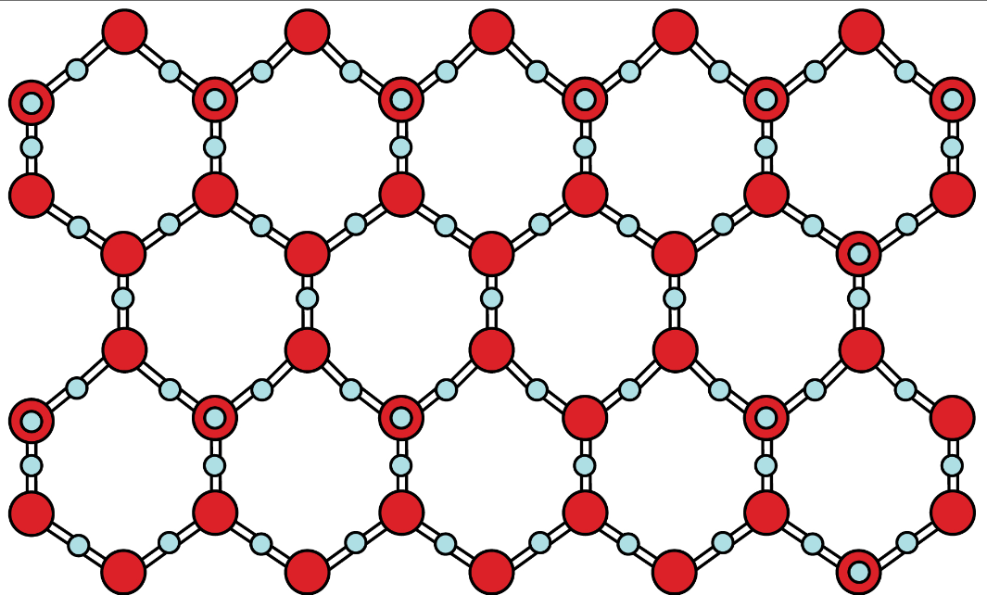
- Solid water’s open structure
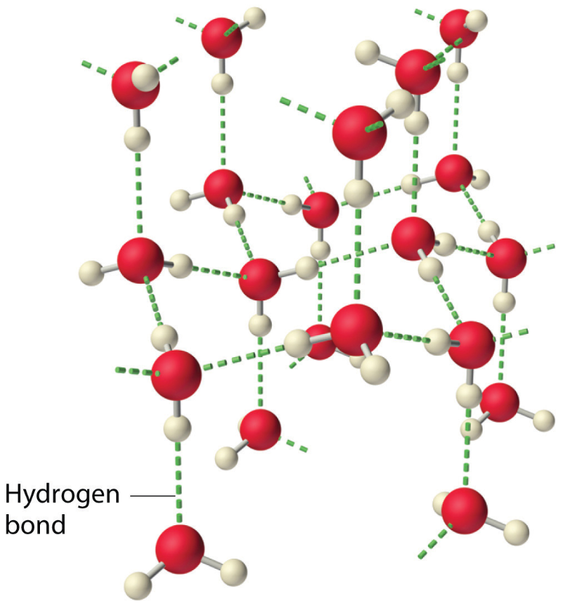
- Liquid water’s collapsed structure
Phases of Water:
- __________________: Each hydrogen is bonded to four other water molecules in an open crystalline shape.
- __________________: The solid crystal lattice collapses; the liquid molecules __________________________ to each other and the liquid is __________________________ than ice. Ice floats!
Surface Tension:
- Particles in the interior of the liquid are subjected to attractive forces in ______________________. Molecules at the surface have a new inward attraction that results in surface tension. Liquids form ________________________ when dropped because spheres have the least amount of surface area.
Capillary Rise (action):
- This is the rise of a liquid in a tube of small diameter. An attractive force, _____________________________, between the tube wall and the liquid will cause the liquid to rise. The same process is the reason why water is taken up by a paper towel.

PHASE CHANGES
- Heat is ______________________ that causes the particles of matter to move ________________ and _____________________________. Therefore, particles can then change phases of matter.
- Adding heat increases temperature.
- Phase changes are accompanied by an ______________________________________________, but ______________________________________.
- Heat energy is used to ____________________________________________ that hold the particles together. Phase changes produce changes in ____________________________________________.

Phases changing | Phase Change Name | Energy Change
Solid Liquid | melting | endothermic
Liquid Gas | vaporization | endothermic
Solid Gas | sublimation | endothermic
Gas Liquid | condensation | exothermic
Liquid Solid | freezing | exothermic
Gas Solid | deposition | exothermic

- Substances are made to change phase by adding or taking away ______________________.
- When undergoing a phase change, the _________________________________________ and ____________________________. Thus, ____________________________.

VAPOR PRESSURE
- Vapor pressure is the ______________ ___________________________ (gas) in equilibrium with its _____________________. The vapor pressure is caused by the gas molecules hitting the _________ of the liquid.
- ______________________________________________ (IMF) determine vapor pressure. (Remember IMF - the forces of attraction between neighboring molecules).
- The ___________________ the vapor pressure, the _________________________ the IMF.
- The ___________________________ the IMF, the harder it is for the liquid to become a gas, therefore the vapor pressure is ___________________________.
- What is a vapor? How does a vapor differ from a gas?

VAPORIZATION AND CONDENSATION
- Vaporization is the change in state from a ________________________________.
- Includes ____________________________ and ______________________________.
- Evaporation occurs when a liquid molecule gets enough _______________________________ to ____________________ the surface of a _______________________ liquid. It gets enough energy to overcome the ___________ within the liquid. Example: leaving a glass of liquid water out on a counter top and it eventually all turns into a gas.
- Condensation is the change in state from a ______________________________. The IMF ____________ any particle colliding with the surface of a liquid.
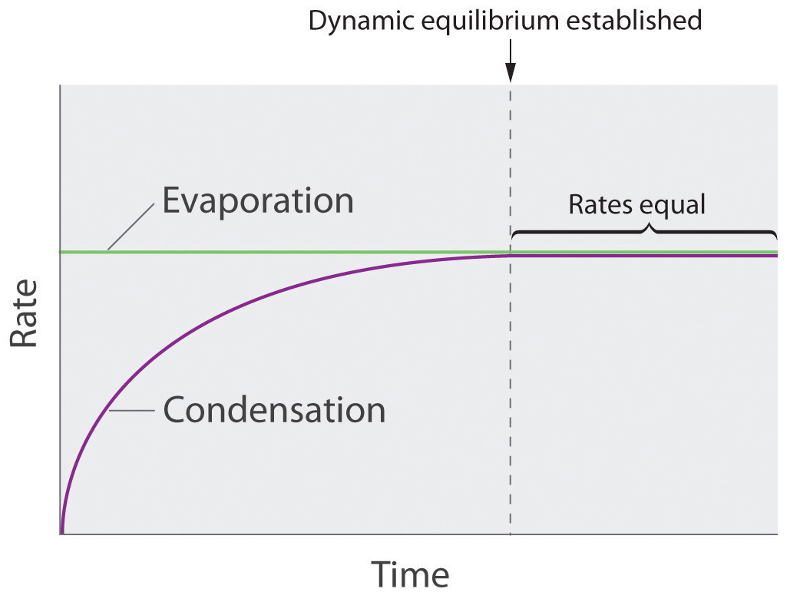

Liquid-Vapor Equilibrium
- In a ______________________ container half-filled with a liquid, the liquid will ________________ into the space above the liquid. Soon, molecules will also ______________________ back to the surface of the liquid.
- In a closed system, a liquid and its vapor will reach an ___________________________ at a specific pressure for a particular temperature - all particles have the same average kinetic energy.
- The rate of vaporization is ______________ to the rate of condensation. A state of ________________ _____________________________ is reached.

- ______________________ is still going on, but the overall effect ____________________________.
- Why is it called dynamic equilibrium?

Equilibrium Vapor Pressure
- The molecules in dynamic equilibrium exert a pressure called ________________________________ ________________________ - the pressure exerted by a vapor in equilibrium with its liquid.
- Vapor pressure will __________________ steadily as temperature _______________________. This indicates there are a ___________________ number of molecules present as a ________________.
- _____________________ vapor pressure is determined by the ____________________________.
- Examples of substances’ initial vapor pressure are: Mercury - 0.0002 kPa, Water - 3.167 kPa, Acetone - 30.8 kPa.
- Substances with _____________ vapor pressures have ______________________ IMF. (Ionic compounds have very low vapor pressures.)
- Substances with _____________ vapor pressures have __________________ IMF.
- Examples:
  - Mercury is a very dense liquid with high IMF. It has a very low initial vapor pressure.
  - Acetone is a __________________________ liquid – it changes into a vapor very easily and has low IMF. Therefore, its initial vapor pressure is high (more molecules are in the vapor state).

Boiling Point
- As temperature _____________________, the vapor pressure of the liquid ____________________ because the kinetic energy of the molecules _________________________.
- When _____________________________ increases enough to overcome the ___________________ pressure of the liquid caused by the pressure of the atmosphere on the liquid’s ___________________, the molecules collide violently enough to push each other apart.
- When the ___________________________________is _______________ to __________________ ___________________________, the liquid _________________.
- ___________________________ form due to this pushing apart and they ____________ to the surface. (They are less dense than the liquid) and the liquid boils. Boiling takes place ______________________________ the liquid.
- The _____________________________________________ is the temperature at which the vapor pressure is equal to ________ atmosphere (101.3 kPa).
- Boiling point is a _______________________________________________. The lower the pressure is, the lower the boiling point is.

MELTING AND FREEZING
- Freezing and melting require ______________________________ in energy than vaporization and condensation.
- WHY? The atoms/molecules are already _______________________________.
- The Freezing point / Melting point is the temperature at which the vapor pressure of the solid and the vapor pressure of the liquid are ___________________. It is not affected much by a change in _________________________________.
- It is dependent upon the ______________ of the substance. A weak IMF means a low melting point.

SUBLIMATION AND DEPOSITION
- Solids with a _________________________ vapor pressure (at room temperature) go straight from ____________________________________, bypassing the liquid phase. This is called _______________________________.
- The opposite change from a ________________________________ is called ____________________________.
- Give three examples of substances that sublime readily.

SUMMARY

Nonvolatile | volatile
low evaporation rates | high evaporation rates
high boiling point | low boiling point
low vapor pressure at room temperature | high vapor pressures at room temperature
Example: | Example:

