POROSITY AND PERMEABILITY
How water infiltrates and percolates through the ground

WATER FLOW IN GROUNDWATER
- _______________________________ – when the water enters the soil surface after falling from the atmosphere.
- _______________________________ – the downward movement of water from the land surface into soil or porous rock.
POROSITY
- The percent of rock or sediment that consists of open space is _________________________.
- Groundwater moves through the _____________ between soil particles.
- These spaces are called ___________.
PORE SPACE
Porosity:
- determines the ______________________________ of water a material will hold.
- depends on the _________________ and ____________________________ in soil.
  - __________________ soils drain well but do not retain water.
  - __________________ soils hold water but do not drain easily.

PERMEABILITY
The ease with which water passes through a porous material is _____________________________.
Factors affecting permeability include:
- how _____________________________ in the substance are.
- how well the particles ______________________________.
The size and sorting of the particles composing the rock or sediment will affect its permeability.

PARTICLE SIZE AND PORE SPACE
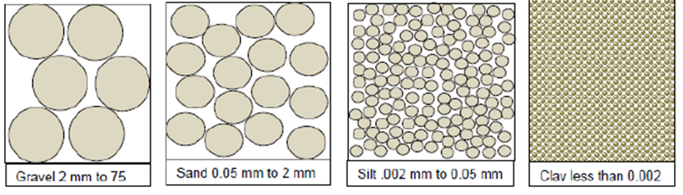

IMPORTANCE AND APPLICATION
Porosity and Permeability are important because they:
- Determine _______________________________________ through material.
- Tell _________________________________________________ in material.
Applies to rock and soil.

