RADIOACTIVITY NOTES
FUSION: ELEMENTS FORMED IN STARS
- Universe is __________ billion years old.
- Original composition was ___________________________ and _____________________ only.
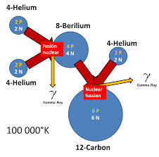
- Heavier elements were formed by nuclear fusion in ____________________.
  - _____________________ smaller atoms together to make larger atoms.
  - Fusion in stars makes elements up to ____________________ (#26).
  - Temperatures greater than _________ million °C required for fusion to start.
  - Supernova explosions create _______________________ elements over #26.
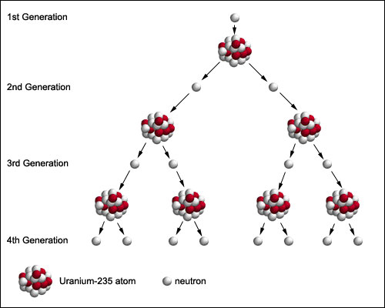
FISSION: BREAKING UP ATOMS
- _____________________ larger atoms to make smaller ones.
- Created by a ________________________ being absorbed by a nucleus.
RADIOACTIVE DECAY
- When the nucleus of atom is ____________________ and breaks ______________________ releasing energy.
- __________________________ atoms form from bigger ones.
- A natural process that releases _____________________________.
- Radioactive decay occurs at a constant rate and is random.
- We can measure time with radioactivity. A ______________________________ is the time it takes for half of a radioactive sample to change into a more stable atom.
- __________________________ can change the half-life time.
- Different isotopes have ______________________________________ half-lives.
- Radiometric dating of rocks reveals Earth is __________________________ years old!
METEORITES TELL STORIES
- Rocks fall to Earth and some are from ______________________________.
- Asteroids are original rock from the ______________________________ of the Solar System – they never became part of a planet.
- Once they fall to Earth, they are called ________________________________. They are the oldest rocks found.
- These provide clues to the early Solar System and its formation.
- _____________________________________ dating is used to determine age.
- ________________________ composition tells us what material was in the original formation.
- Moon rocks brought back are approximately ___________ billion years old.
HOW DO WE DATE THEM? Radiometric Dating using Radioactive Decay
- ________________________ atoms that eject particles and the atom loses energy.
- New atoms are ___________________ stable.
- Process of dating involves comparing ratios of ____________________________ atoms to _________________________ atoms in a sample.
Only works for certain types of rocks: The rocks must contain ______________________________ _____________________________ that have half-lives that can be measured.
RADIATION TYPES
ALPHA PARTICLES:
- Made of ________ neutrons and _________ protons.
- ejected from the ________________________ of an atom.
- The daughter nucleus becomes a _________________________ element
BETA PARTICLES:
- an ___________________________ is emitted from the nucleus of a radioactive atom.
- It is the result of a ________________________ splitting into positive and negative particles and ejecting the negative particles at high speeds.
- The neutron becomes a proton, so the atom is now a ____________________________ element.
GAMMA RADIATION
- No change in ____________________________.
- When an atom ejects an alpha or beta particle, the nucleus is often left in an over-energized state.
- Excess energy is released as a gamma photon - a form of ________________________________ radiation.
- Extremely high energy radiation and ______________________________.

HALF-LIFE
Half-life describes the time it takes for ____________________ of the atoms in a sample to change, and _____________________ to remain the same. Can accurately measure ____________________ __________ of a rock.
- When a radioactive nucleus changes, the remaining nucleus (and atom) is not the same as it was - it changed its ____________________________
  - Shorter half-life = ____________________________ stable
  - As a radioactive isotope decays, the amount of radiation _________________________ but the half-life of the sample remains the same.
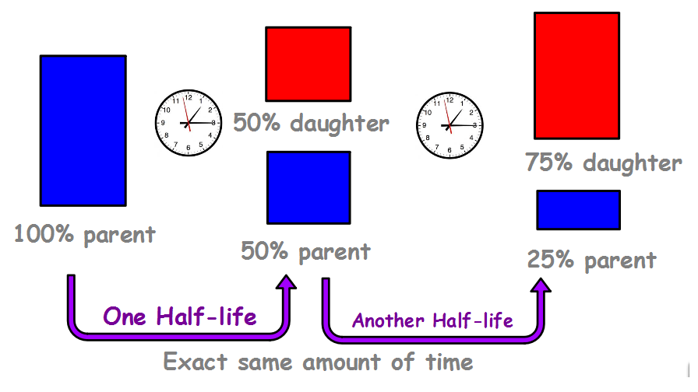
- A sample containing carbon -14 has been through 2 half lives. How old is the sample?

- A mineral sample was found to contain uranium - 238. Analysis shows it has been through 1 half life. How old is the sample?

- Challenge: A rock sample was analyzed for potassium - 40. In the sample, there was 10 micrograms of potassium - 40 and 30 micrograms of argon - 40. How old is the rock sample?

