RIVERS AND RIVER LANDFORMS NOTES

LAB: SORTING AND SEDIMENTATION
- The __________________________ rate depends on ______________________________, ______________, and ___________________ as well as on the __________________ of the river.
- _________________________: the cloudiness or haziness of a fluid caused by large numbers of particles as water settles.
- As the ______________________________, both the __________ of particles in suspension _______________________ and the _______________________ of material in suspension ___________________________ (faster moving water holds more and bigger sediment).

STREAMS FLOW INTO RIVERS
- ________________________ - narrow depressions that streams follow as they flow downhill.
- _______________________________ – smaller streams or rivers that feed into a larger one.

PARTS OF A RIVER
- ________________________ – where it begins.
    - _________________________ – winding pattern of curves in a river.
    - ____________________________ – valley floor around rivers that flood.
    - _____________________ – sediment deposits along banks of a river .
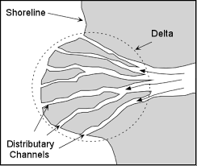
    - _____________________ - part of a river where it flows into the sea, river, lake, reservoir or ocean.

RIVER DELTAS
- A ______________ is where stream empties into large body of water.
  - ___________________ in velocity (speed).
  - Load (sediment it is carrying) ___________________________.
  - _____________________________ shaped.
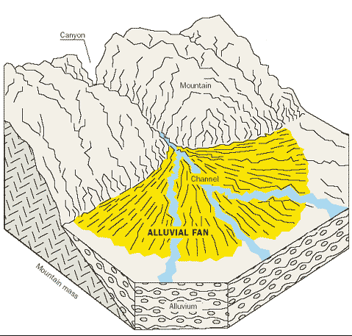
  - Formed ___________________________________ from erosion and deposition.

ALLUVIAL FANS
- _________________________________ forms where streams descend steep slopes onto a flat plain.
  - Often formed with temporary streams.
  - Made up of ___________________________________________.
ALLUVIAL FAN VERSUS DELTA
- A delta forms in _______________ and an alluvial fan forms on ________________.

RIVER EROSION
- Water moves _______________ on the inside of ________________________ curves – increases ________________________.
- Water moves ____________________ on ___________________ curves – greater ____________________.
RIVERS CHANGE OVER TIME
- Over time, rivers become _________________________________.
- Stages:
- Youth Early mature Mature Old Age

OXBOW LAKES
- The __________________________________________________ cause the formation of _______________________________
- Differences in speed:
  - Outside curve – faster speed – ________________________.
  - Inside curve– slower speed – ____________________________.
LAKE
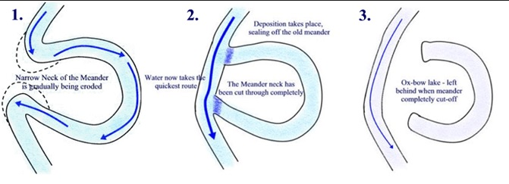
- Begin to form when ____________________________ ______________________________
- Most are:
- Short-lived in geologic terms (temporary).
- At high latitudes.
- Form from precipitation and melting ice/snow.

SEDIMENTATION AND SORTING
- Rivers deposit sediment _________________________ and _____________________________.
- As water slows down, the ________________________ particles (sediment) are _______________________________
- _____________________________ is process by which particles having a particular size or characteristic are concentrated.
ROCKS FROM DEPOSITION AND SEDIMENTATION
Rock eventually forms based on sediment, providing clues to past environments:
- ______________________ – rounded (river) stones
- ______________________ – angular fragments
- ______________________ – sand
- ______________________ – silt and/or clay

