SEAFLOOR SPREADING
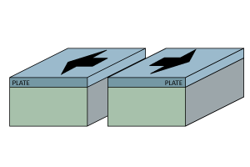
DIVERGENT PLATE BOUNDARIES REVIEW
- Plate ____________________; tension stress; normal fault
- Landforms Created:
  - Rift Valleys
  - Fault-block Mountains
  - Mid-Ocean Ridges
- Constructive Force – creates ____________ plates where magma rises.

PLATE TECTONICS THEORY REVIEW
Alfred Wegner
Not fully accepted until 1960’s!
- Theory of Plate Tectonics
- Early 20th Century
Evidence
- ________________________________________
- _________________________
- ______________ formations

HESS: MAPPING THE OCEAN FLOOR
Harry Hammond Hess provided ________________________ to support the theory.
Echo Soundings Revealed:
- Central Mountain Ranges
- Trenches
- Mid-Atlantic Ridge
- Lava at center of ridge.
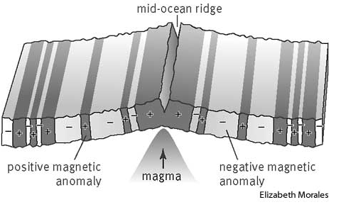
- Younger rock near ridge.
- Older rock outward.
- Sediments deeper farther out from ridge.

GEOMAGNETIC REVERSALS
- _____________ record of Earth’s magnetic pole reversals.
- As rocks solidify ___________________ align with poles.
- When poles reverse, alignment ______________________.

EARTH’S MAGNETIC FIELD
- Caused by _________________________ of conducting material inside Earth's core.
- Creates _________________________________ around planet (magnetosphere).
- Protects from _______________________________.
- Creates magnetic poles (North and South).

GEOGRAPHIC VERSUS MAGNETIC POLES
- _________________________ pole: Center of rotation – shown on maps.
- _________________________ pole: the point where the planet's magnetic field points vertically downward – where a compass points.
- These locations __________________________________.

POLE REVERSALS
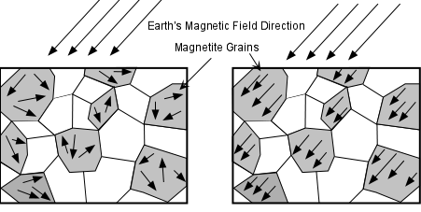
- North and South poles flip.
- This is a __________________________ occurrence.
- It happens ____________________________.
- Pattern about every 200,000 to 300,000 years.
- Last pole reversal approximately 780,000 years ago.

RECORD OF MAGNETIC POLES IN ROCK
- Some rocks have iron-bearing minerals that act as tiny ______________________.
- As magma or lava cool, these minerals begin to form.
- Magnetic minerals in the molten rock become _____________________ to the magnetic field.
- When the rock solidifies, minerals lock in the magnetic field like many tiny _________________________.


MAGNETIC REVERSALS RECORDED IN ROCK
- Rocks formed over long periods of time retain _____________________ of pole reversals.
- Record of pole reversals can appear in:
  - Mountain building
  - Sea Floor spreading

POLE WANDERING
- Magnetic poles ________________________.
- Thought to be caused by __________________________ in Earth’s molten outer core.
- Current North pole moving toward Siberia at about 40 miles per year.
- Moving faster than before – 100 years ago only moving 10 miles per year.

