SEDIMENTATION AND SEDIMENTARY ROCKS NOTES

THE ROCK CYCLE
____________________________: Formed by fire – from magma or lava.
____________________________: Formed from heat and pressure deep within Earth’s crust.
____________________________: Formed at or near surface from products of weathering and erosion.
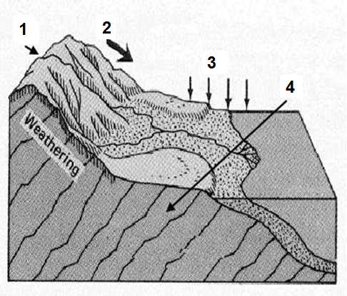
FORMATION PROCESS
- ___________________________
- ___________________________
- ___________________________
- ___________________________
- Comes from Compaction and Cementation

WEATHERING AND EROSION
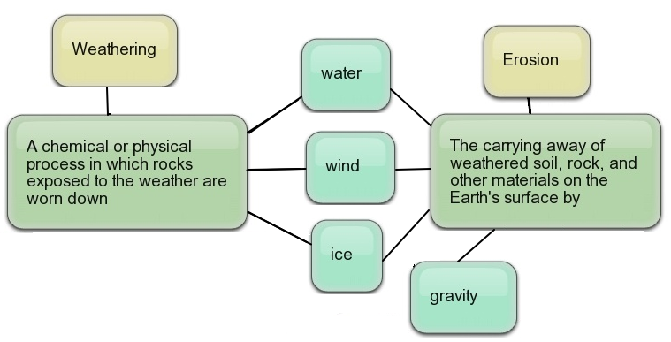

EROSION AND SEDIMENTATION

AGENTS OF EROSION
Agent of Transport | Energy of the Agent of Transport | Degree of Sorting | Size of the Particles
 | Highest | Poor | Largest – all sizes mixed
 | High-medium | Good | Medium – sandy gravels, sand, and silt
 | Lowest | Best | Smallest – dust or clay

- Sorting and size of particles provide clues to agent of transport.

DEPOSITION AND SORTING
_______________: Rock fragment
Sediment is deposited based on how _________ and ___________ it is ___________________________.
________________________________ and ___________ of sediment tells about the ________________ rocks formed in.

Lithification: Compaction and Cementation
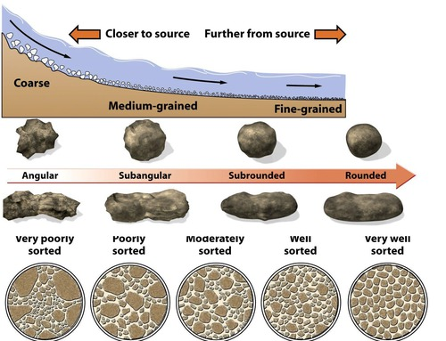
- _____________________________ from increasing pressure.
- _____________________________ from dissolved minerals.

TYPES OF SEDIMENTARY ROCK
- _________________:
Accumulations of _____________ (little pieces of broken up rock) which have piled up and been ______________________ by compaction and cementation.
- Sandstone, conglomerate
- ____________________________:
Forms when standing water ________________________, leaving dissolved minerals behind.
- Gypsum, halite
- ____________________________:
An _____________________________________ of sedimentary _________________ caused by organic processes; shells, bones, plant matter, etc.
- Coal, limestone
ROCKS FROM CLASTS (CLASTIC)
High energy environments
- _____________________ - Angular Clasts – very little weathering with minimal transport
- _____________________________ - Rounded Clasts transported farther with more weathering
Lower energy environments
- ____________________ - Rough, gritty feel; deposited from current transport; tend to be porous
- ________________ - Smallest particles – formed in water calm enough for clay particles to settle

ROCKS FROM EVAPORATES (CHEMICAL)
- ______________________ - Forms when oceans and seas dry up; Natural Rock salt and Calcium Chloride (NaCl)
- ______________________ - Deposited rom lake and sea water; Contains calcium, sulfate, and water; Crystal formations called “Desert Rose”
- __________________ - Microcrystals of silicon dioxide grow within soft sediments that will eventually become limestone

Rocks from Organics (Organic)
- ______________ - Swamp and Marsh Environments
- ______________________ - Remains of marine animals, coral, and shells
- ______________________ - Remains of shells – forms near shore – well sorted by waves

DEPOSITION ENVIRONMENTS
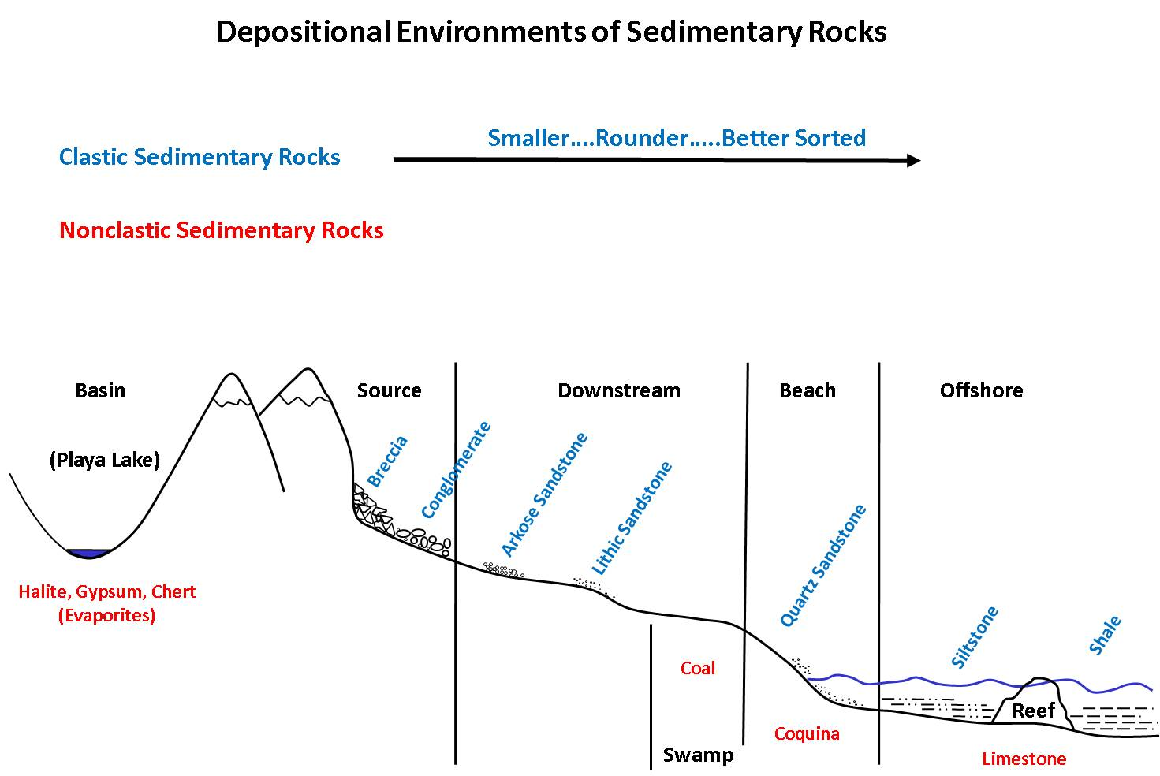

Environmental Clues from Sediment Size

