ORIGIN OF OUR SOLAR SYSTEM NOTES

SOLAR SYSTEM ORIGIN
_____________________________ Hypothesis
A nebula is an interstellar rotating cloud of gas and dust.
Energy, pressure, and gravity in the center of the nebula formed our _______________.
When it got hot enough in the center, our sun formed.
The planets form in the outer regions in a process called accretion.
______________________________ is the gradual accumulation of layers of dust and gas to form planetesimals or small bodies.
Clues from:
- Our Solar System
- Observing other systems in different stages of formation
Age: _________ Billion Years
Evidence: Radioactive decay
CLUES BASED ON DISTANCES
Sun-Earth distance = 93 million miles = _______ Astronomical Unit (AU)
- Sun = 0 AU
- Inner Planets = about 1 - 2 AUs
- Asteroid Belt = about 3 AU
- Outer Planets = about 5-40 AU
- Kuiper Belt = about 30 to 50 AU
- Oort Cloud = about 50,000 AU

CLUES BASED ON ________________________
Mercury Venus Earth Mars
All the planets:
- Orbit the Sun in the same direction
- Spin generally in the same direction they orbit (except Venus and Uranus).

CLUES BASED ON COMPOSITION
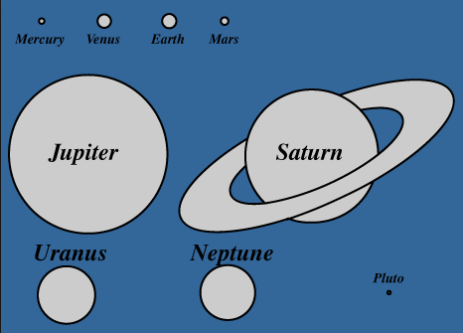
________________________ Planets:
- rocky and SMALL!
- No or few moons
- No rings
________________________ Planets
- gaseous and BIG!
- They have rings
- Have many moons
Asteroids, Kuiper Belt Objects
- Rocky, small

CLUES BASED ON “LEFTOVERS:”
Kuiper Belt
Uranus Neptune Pluto
- “Small objects” like dwarf planets, short period comets
- Thousands of objects
Oort Cloud
- Less known about it; probably millions of objects
- Long Period Comets (period more than 200 years)
PROCESS: GRAVITATIONAL COLLAPSE OF NEBULA
- Shock wave starts nebula spinning.
- Star forms at center from light material (H and He) falling “in”.
- Fusion of Sun begins at 18,000,000°C.
- Solar wind blows away remaining matter.
- Material spins faster and faster as it gets closer to the center (spinning dancer).
- Disk begins to flatten (like pizza dough).
- Materials in cloud begin to collide.

ACCRETION OF PLANETS
Accretion: The process by which small ‘seeds’ grew into planets.
- Near the Sun, temperature is ________, metals and rocks condense.
- Small pieces collide and stick together, form planetesimals.
- Collisions continue.
- Larger planetesimals become spherical due to ____________________.
- Only small planets can be formed inside frost line due to limited supply of material.

INNER PLANETS: ______________________________
Made of a large percentage of heavy elements.
- The ___________________________ sink to center of protoplanets.
- Layers form.
- Less dense matter on surface.
- Lighter gases blown away by solar wind.
These are the rocky inner planets with a metal core.
Mercury - Closeness to Sun makes it difficult to explore/observe
Venus - Rotates (spins) “backwards” possibly due to early impact; rains H₂SO₄ (Sulfuric Acid)
Earth’s Moon (Luna) - Formed from possible impact on Earth; no atmosphere
Mars - Largest volcano in System but inactive – Core has cooled; polar ice caps CO₂ ice

OUTER PLANETS: _______________________ WORLDS
- Beyond the frost line.
- ________________________ materials for cores.
- Large planetesimals attract materials around by pull of gravity.
- Large supply of gases allows for large planets.
- Heat and pressure in the middle melts ices to form liquid gases.
- Jovian planets were not massive enough to trigger nuclear fusion at their core.
Jupiter - Size 11 times larger than Earth; composition similar to Sun; rings - dark - made of dust
Saturn - Density is less than 1 – could float on water; 7 Rings
Uranus - 84 year orbit; Rotates on side; Rings – darker, more like Jupiter – thinner
Neptune - 165 year orbit; rings – some of weakest
Kuiper Belt Objects (KBOs) - Icy chunks; size varies from snowballs to planet-size; largest considered Dwarf Planets

ORIGIN OF ASTEROIDS
Rocky leftover planetesimals; most lie between Mars and Jupiter; near frost line; not enough matter for planet or moon. Jupiter’s gravity affects asteroid orbits – can kick them out of path.
Total 100,000 +/-
Couldn’t become planet: Too close to Jupiter and not enough mass
Some have moons
Ceres – biggest & spherical – Dwarf Planet (1 of 5)

ORIGIN OF COMETS
- Icy leftover planetesimals of the outer solar system; highly elliptical orbit.
CONDENSATION OF THE SOLAR NEBULA
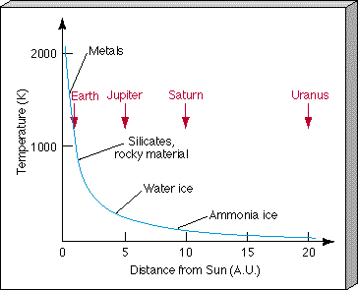
- Cooling disk.
- Materials collide and condense into planetesimals.
- Planetesimals attracted by __________________ and make planets.
- Temperature of nebula determines what kind of material condensates.

CONDENSATION OF THE SOLAR NEBULA
________________________ lies between the orbit of Mars and Jupiter.
_____________________ temperatures inside – rock and metal.
_____________________ temperatures outside – gases stay frozen (solid).

EARTH FROM THE INSIDE OUT NOTES

EARTH BASICS
- 3rd planet from the Sun; oblate spheroid (slightly flat); circumference about 40,000 km; diameter 12,756 km.

TERRESTRIAL WORLDS
- ___________________________: outer layers compress inner layers – produce heat
- Dense metals _________________ to core
  - Iron density 7.86 g/cm³
- Lighter rock material _________________ to form crust
  - Average rock density 3.5 g/cm³

EARTH’S LAYERS
Inner core:
- __________________ iron and nickel; 7,200 °C plus; Heat from ________________________
Outer core:
- _____________________ Iron and nickel; 4,300 °C
Mantle:
- Dense, hot layer of ________________________ rock (iron, magnesium, and calcium); 3,700 °C.
Crust:
- Silicate rock materials; ____________ percent of the earth
- Lower boundary - Mohorovicic discontinuity (Moho)
- Asthenosphere – lower, plasticy part
- Lithosphere – top, solid part

EVIDENCE FOR EARTH’S LAYERS
One: __________________________________________
- Caused by either by earthquakes or by massive man-made explosions.
- Measured as they pass through the Earth.
- When they encounter different materials, they change in important ways, becoming longer, shorter, faster, or slower.
- Waves travel through different materials at different speeds.
- P (primary) waves _____________________________ in liquids.
- S (secondary) waves can only travel through ______________________.

Two: ____________________________________
- Leftovers and pieces of other worlds
- Three types
  - Chondrites (Stony-Iron) – mixed rocky & metal materials
  - Stony – lighter, rock materials
  - Iron - metals, mostly iron and nickel
- Composition of Earth believed to be ________________________

Three: _____________________________
- They transport materials from upper ________________________ to surface.
- They do not provide information about deep layers

Four: _________________________________________________
- Earth’s liquid, metallic outer core spins.
- ____________________ creates magnetic field.
- Magnetosphere protects Earth from solar wind.
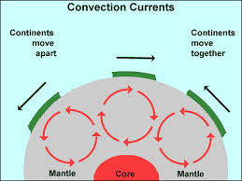

TRANSFER OF HEAT FROM CORE
- Heat is a form of energy and causes by vibration of atoms and molecules
- Greater energy = faster vibration = more heat
- Heat moves in three ways:
  - Conduction – ______________________________
  - Convection – travels in currents
  - Radiation – travels through space

CONVECTION: TRANSFER OF HEAT ENERGY
- __________________ material near core becomes less dense and ___________________.
- _______________ material near crust is cooler and _____________________.
- Movement of heated material from core to crust is process called convection.

CONVECTION: MOVES EARTH’S CRUST
- Crust is broken into ____________________, convection currents in mantle moves crust.
- Changes Earth’s surface __________________ over time.
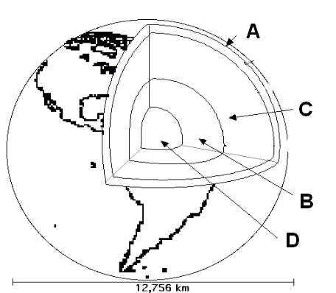

Match each of Earth’s Layers:
- Inner Core
- Outer Core
- Mantle
- Crust

