UNIT 12 NOTES: SOLVATION

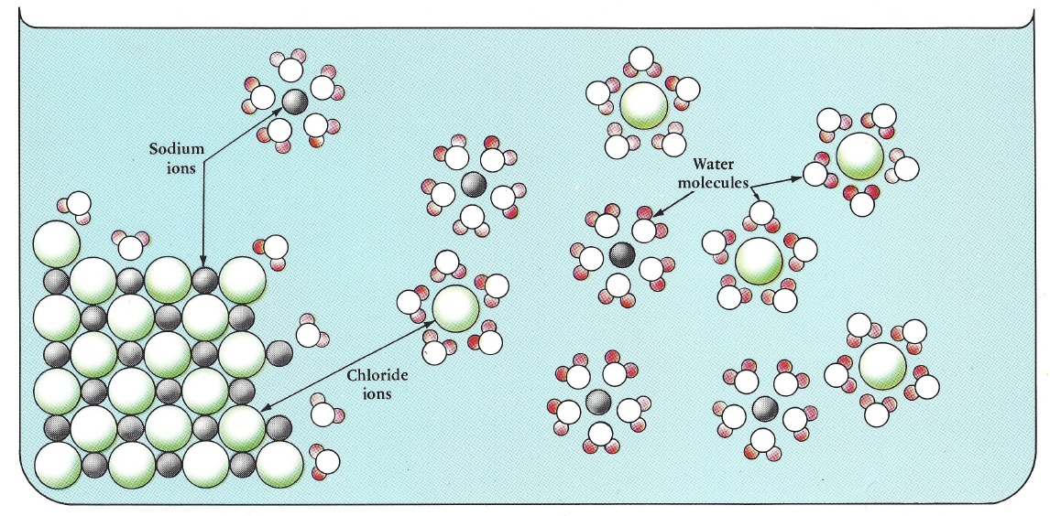

VIDEO: Solutions
- What are ion-dipole attractions?

- During the process of solvation, how do ion-dipole attractions compare to the ionic bonds inside an ionic crystal?

- Describe the processes that are balanced when solubility equilibrium has been reached.

- If more solute is added to a solution in equilibrium, will this always result in more dissolved solute particles in the solution? Explain.

- How does a solution become supersaturated?

- After crystals precipitate out of a supersaturated solution, would you still call it supersaturated? Explain.

THE DISSOLVING PROCESS: How a solution forms
- Dissolving occurs when the solute is ____________________________ by the solvent.
- This takes place at the _____________________ of the solute.
- The solvent ________________________ the solute.
- This process of surrounding the solute is called ___________________________.
- When the surrounding is done by water, this is called __________________________, a particular type of solvation.
- When ionic compounds separate into their ions in a solvent, _______________________ occurs.

SOLUTE SOLVENT COMBINATIONS
- Combinations of solute and solvent are based on the properties of each. There are four main types:
- ____________ Solvent – ____________ Solute:
The polar solvent is attracted to the polar solute. The solvent gradually surrounds the solute. The particles attach themselves due to polar attraction. ____________________ ___________________. Like dissolves like.
- ____________ Solvent – _________________ Solute:
Polar solvent particles are attracted to each other and not the solute. ________________ does not occur and a solution is ___________________.
- _________________ Solvent – ____________ Solute:
Nonpolar solvent particles have little attraction to the polar solute. _________________ does not occur and a solution is _____________________.
- _________________ solvent – _________________ solute:
Random motion of solute particles causes them to leave the surface of the solute and become evenly dispersed in the nonpolar solvent. ______________________________. Like dissolves like.

VIDEO: Polar and Nonpolar Solvents
- How would you predict whether carbon tetrachloride is a polar or nonpolar solvent? What evidence have you observed that supports your prediction?

- Based on chemical formula alone, can you tell whether iodine, I₂, is a polar or nonpolar solute? What evidence have you observed that supports your prediction?

- Based on the chemical formula alone, can you tell whether copper (II) chloride, CuCl₂, is a polar or nonpolar solute? What evidence have you observed that supports your prediction?

