STREAM EROSION NOTES

MOVING WATER TRANSPORTS SEDIMENT
- ___________________________ is the process by which weathered materials are carried away.
- Moving water ____________________ and __________________________ sediment.
- Over time a large amount of material can be moved _____________________________________.

PARTS OF A RIVER SYSTEM
  - Main stream and tributaries.
  - _________________________ separate watershed.
  - __________________________ - narrow depressions that streams follow as they flow downhill.
  - __________________________ – part of channel below the water level.

WATERSHEDS
- A ________________________________ is the area of the land that is drained by a river system.
- _____________________ is the force that causes water to move.
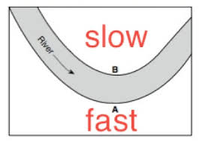
- Our watershed: ______________________________.

STREAMFLOW VELOCITY
- ______________________________________ = how fast water is moving.
- Sediment _____________________ depends on ________________________ of water in stream.
  - __________________ moving water: holds _______________ and smaller sediments.
  - __________________ moving water: Transports ______________ and bigger sediments. Erodes the river channel ____________________________ than slower water.

STREAM LOAD
- _______________________________ is the materials carried by a stream.
- _______________________________ – particles of sand and silt – carried by velocity.
- ________________________ – larger sized sediment – gravel and pebbles – moves by sliding and jumping.
- ___________________________ – transported in liquid solution.

STREAM DISCHARGE
- _________________________________ is the volume of water moved by a stream in a given time.
- ____________________________ in all sections of a stream or river.
  - ______________________________ of water flows through narrower and shallower sections in same time as through deeper and wider sections.
  - So the stream must move ____________________ in narrow, shallow sections.
  - When more material carried in a stream, __________________________________.

WINDING STREAM EROSION
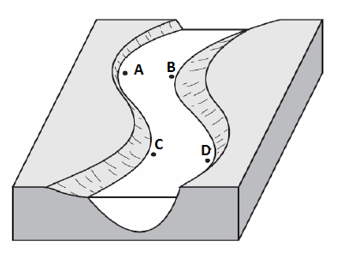
- Streams _____________________ material on the ___________________ of bends or curves in streams where water must move _________________ to keep up.
- Faster water has _____________________________, carries larger, _____ particles.
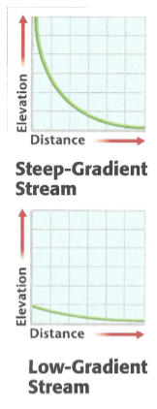
- Streams _____________ material on the ______________________ of bends or curves in streams where water can move ___________________.
- Slow water has ________________________, _________________ its load.

STREAM GRADIENT
- The _______________________________ is the change in elevation of a stream over a given horizontal distance.
- _____________________ gradients = _____________________ gravity = _________________ velocity.
- _________________________ – beginning of gradient – generally steep – higher velocity – causes rapid channel erosion.
- ____________________ – where stream enters larger body of water – generally flatter – less erosion.

SEDIMENTATION AND SORTING
- Rivers deposit sediment along ________________ and in ____________________.
- As water slows down, ___________________ particles/sediment dropped _________________.
- _______________________: process by which particles having a particular size or characteristic are concentrated.
- Role of ENERGY
  - ________________ energy – carries ________________ sediment.
  - As energy is ___________________ (speed slower), particles begin to drop – _____________________, then ____________________________ and smaller.
