UNIT 7 NOTES: UNCONFORMITIES

SES4. Students will understand how rock relationships and fossils are used to reconstruct the Earth’s past.
a. Describe and apply principles of relative age (superposition, original horizontality, cross-cutting relations, and original lateral continuity) and describe how unconformities form.

REVIEW
- Law of Superposition - In an ______________________ rock column, the layers on the ____________________ will be the ___________________ and the _____________________ rocks will be on the ___________. Provides ____________________________ (older, younger).
- Principle of Original Horizontality
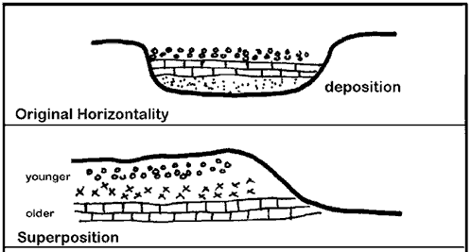
- Sedimentary particles _______________ from fluids under the influence of ____________________.
- Generally form in _______________________ layers.
- Sediments deposited in layers that were nearly __________________________ and
________________________ to the __________________ on which they were _______________________________.

UNCONFORMITIES
- Sometimes there are “____________ and _____________” in the geologic record – boundary or break area.
- Called an ____________________________.
- An unconformity is a _______________ in a ______________________________________ resulting from a change.
- Deposition _____________ for a period of time.
- ____________________ and erosion occur.
- _____________ of geologic/fossil _________________________ – there is a ____________ in record.

TYPES OF UNCONFORMITIES
Development of a Disconformity
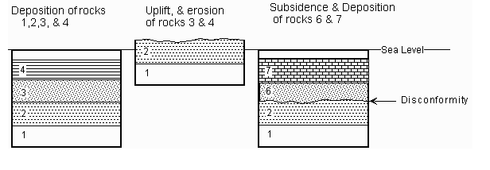
- DISCONFORMITY
- Erosion _____________________ two layers of sediment.
- Possible period of _________________________.
- Part of a layer is _____________________.
- Can be difficult to identify.
- Missing fossils often provide a clue to a disconformity.

- ANGULAR UNCONFORMITY
- ___________ layer is ____________, ________________, then a ______________________ layer forms ________________.
Development of an Angular Unconformity
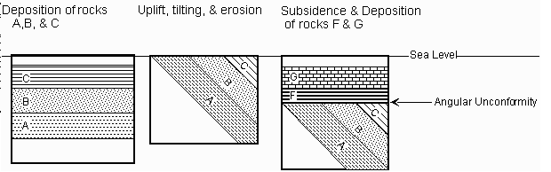
- First: deposition forms rock layer(s).
- Second: rocks are uplifted and tilted.
- Third: erosion removes the uplifted rock.
- Fourth: new deposition occurs on top the previous land surface.

- NONCONFORMITY
Development of a Nonconformity
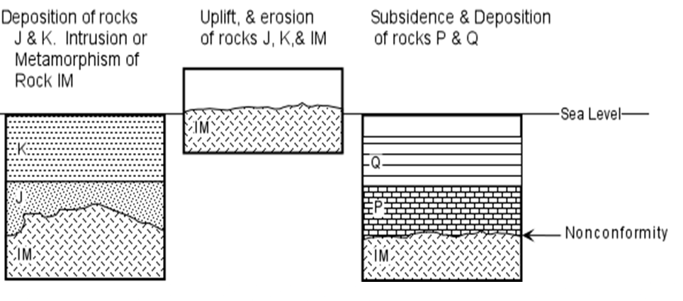
- Where igneous or metamorphic rock is ____________________ and ______________________, then sedimentary rock _________________ _______________ it.

- PARACONFORMITY
- __________________________ Unconformity or Non-depositional unconformity.
- Little or _____________________________________________ because the layers are _______________________ and some are _______________________.
- Period of ____________________________.
- Difficult to detect.

REVIEW
