UNIT 8 NOTES: UNEVEN HEATING AND
COOLING OF LAND AND WATER

WATER REFLECTS SOLAR ENERGY
- Much of the solar radiation that reaches the ocean is ____________________________ back to the _________________________________.

WATER MIXES SOLAR ENERGY
- Water has a ______________________ heat capacity than land - it takes ______________________ to raise the temperature of one gram of water by one degree than it does to raise the temperature of land.
  - 1 calorie of solar energy will warm one gram of water by 1°C.
- Energy that is ___________________________ by water at the surface is _____________________ ________________________.
- Heat is _________ through __________________________.
- Water ____________________ solar energy _____________________.
- Water ____________________ thermal energy _________________________.

LAND ABSORBS AND RADIATES SOLAR ENERGY
- __________________________________ solar energy than water during the _________.
- Land has a _____________________ heat capacity than water - it takes _____________________ to raise the temperature of one gram of land by one degree than it does to raise the temperature of land.
  - 0.20 calorie of solar energy will warm one gram of granite by 1°C.
- _____________________ energy – stays at __________________ (doesn’t mix with deeper layers).
- Heat is _________________ from ____________________________.
- Land ________________ heat during ______________.
- Land ________________ heat more quickly at __________________.

CONVECTION CURRENT FROM DIFFERENTIAL HEATING AND COOLING
- SEA BREEZES
- Air over the __________ is _____________________ than air over the _________________.
- ____________ pressure __________________ over the land.
- Air ________________ over the land.
- ___________________ form.
- Air is _________________________________ from water – sea breeze.
- Convection current.
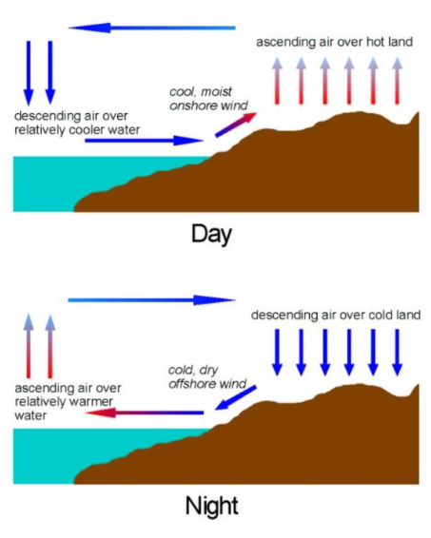
- Occurs in the ___________________ in ________________________.
- Daytime __________________ are on the _____________________ where low pressure forms.

- LAND BREEZES
- Air over the __________________ is __________________ than air over the ______________.
- __________ pressure ____________________ over the water.
- Air _____________________ over the water.
- ________________________ form.
- Air is _______________________________________ from land – land breeze.
- Convection current.
- Occurs in the ______________________________ in the ______________________.
- Nighttime ______________________ are over ____________________ where low pressure forms.

- LOCAL CIRCULATION PATTERN
- Convection current.
- _________________________ winds.
- Works like Global Winds but on a smaller scale.
- Same pattern can be seen around _______________ that _________________________ in the ___________________________.

- WINTER CIRCULATION
- Where large bodies of water hold onto their _______________________________ and cool slowly, the _________________________ pattern can emerge.
- Water _______________________________________.
- _________________ pressure forms over ________________________.
- Air __________________ over __________________________ during day.
- ________________ breeze forms during ______________.

