VOLCANOES

VOLCANOES
- A _____________________________, typically conical, having a crater or vent through which ________________, rock fragments, hot vapor, and ____________ are being or have been _____________________ from the Earth's crust.
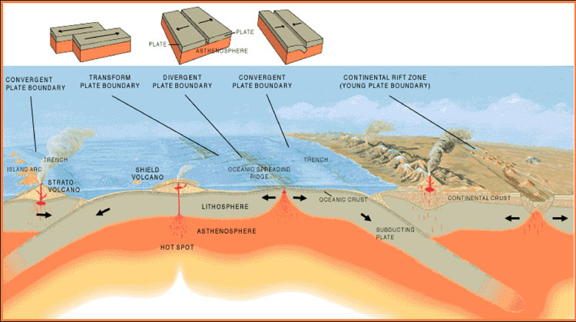

WHERE DO VOLCANOES FORM?
Volcano Zones
- ___________________________ zones
- Ocean _____________________
- Tectonic ________________ boundaries
- Mid-ocean ____________________
Fun fact: Ancient volcanoes existed in Georgia when Appalachian Mountains formed.
Pacific ___________________________: Belt of volcanoes that encircles the Pacific Ocean

HOT SPOTS
- Areas of volcanism __________________ tectonic plates.
- Mantle _______________________ develop.
- Hot spots form _______________________ plumes.
- Rock ______________, lava ___________________.
- Some not associated with plate boundaries.
- Plates ____________________, carrying cooled volcanoes.
- Some of the hot spots around the world:
- Most are _____________ at plate boundaries.

TYPES OF VOLCANOES
Composite
- Built with ________________ of lava flows.
- _______________________ and _________________________________ cones
- _____________________________ eruptive explosions and quieter lava flows.
- Also called a ______________________________.
- Example: Mount St. Helens
- ___________ – an opening in a volcano connecting the magma to the surface.
- __________________ - magma reaching the surface through another opening.
- _______________________________ or Chamber - large underground pool of molten rock sitting underneath the Earth’s crust
- ______________________ – a bowl shaped area that forms around a volcano’s central opening
- ________________________ – magma that flows onto Earth’s surfaces.
- _________________________ or Pipe – the channel from the magma chamber to the vent to bring the magma to the surface.
Cinder Cone
- From _______________________ eruptions.
- Made of ___________________________ materials.
- ____________________ sides and a bowl-shaped crater.
- Most __________________________ type of volcano.
- Example: Paricutin in Mexico.
Shield
- Built from _________________ lava flows
- Gently _____________________________ sides
- _________________ base
- Example: Hawaiian Islands

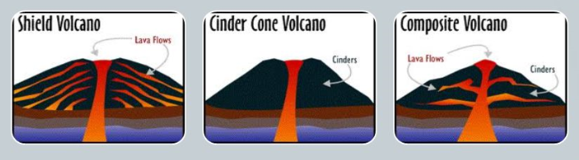

CALDERAS
- Large, basin-shaped ______________________.
- Formed by the __________________________ of a volcanic cone.
- Can fill with _____________________.

FORMATION OF MAGMA
Produced by partial _______________________ of Earth’s mantle and crust.
Three conditions:
- ________________________ of rock _____________ above melting point.
- ______________________ removed, melting point decreases.
- ____________________________________ (water) can decrease melting point.
Gases in Lava:
- _______________ vapor and ________________________________ are the most common.

COMPOSITION OF MAGMA
- ___________________________ is rich in magnesium and iron and generally dark in color - most common.
- ___________________________ is rich in feldspar and silica.

TYPES OF LAVA FLOWS
- _________________________ - rapidly cooled and forms underwater at mid-ocean ridge.
- ______________________ - smooth, billowy, or ropy surface, relatively thin – cools and moves quickly.
- ____________ - rough, jagged surface, thicker – cools and moves slowly.
- ______________ - surface of large angular blocks, higher silica content.

PYROCLASTIC MATERIALS
Cloud of ash, lava fragments and vapor from a volcanic explosion.
- Volcanic _________ – less than 0.25mm; smallest particles thrown into the air during an eruption
- Volcanic _________ – 0.25-2mm; Tiny particles of crushed volcanic rock and glass
- ______________ – Rounded or spindle shaped pebble sized rock; falling out of the air.
- Volcanic _____________ – Large blobs of lava ejected from a volcano

ERUPTIONS
- The amount of ______________________________ in magma provides the driving force for explosive eruption.
- More gas = more explosive eruption.

LASTING EFFECTS OF VOLCANOES
Volcanic eruptions can ______________ the climate of the Earth.
- Particles __________________ sunlight.
- Cause ______________________ as cloud circles planet.
Examples:
- Pinatubo eruption in 1991 cooled Earth by about 1°F for 1 - 2 years.
- Tambora in Indonesia- eruption in 1815 - global temperatures fell by about 2°F for 1 - 2 years caused crop failures in northeastern USA.

VISCOSITY OF LAVA
Property of fluids:
- _________________________ = resistance to flow
- Liquid ____________________ is another way to describe it.
More viscous lavas:
- ______________________ silica content.
- More __________________________ eruptions
- Flow ____________________ and _________________________
- A’a lava
- Felsic composition
Less viscous lavas:
- ________________ silica content.
- Lava tends to _______________ out.
- Flow __________________ and ___________________________.
- Pahoehoe lava
- Mafic composition
Lava viscosity determines the ___________________ of a volcanic eruption!

