UNDERSTANDING THE HYDROLOGIC CYCLE

EARTH’S WATER SUPPLY
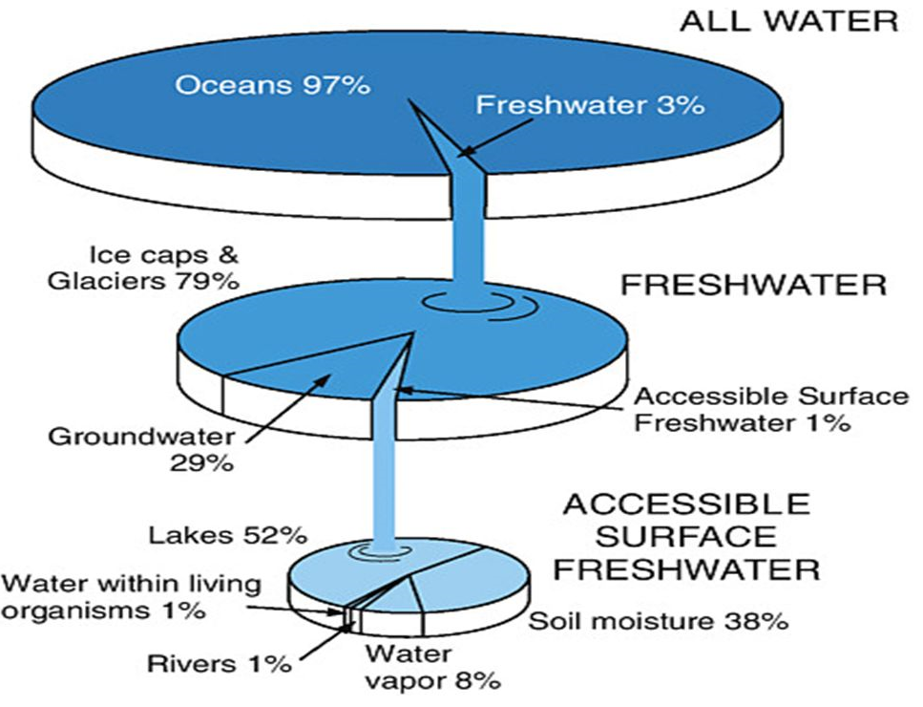
- About ______ percent of the Earth's surface is water-covered.
- The oceans hold about _______ of the planet’s water.
- Freshwater is _______ and includes water in:
  - Glaciers and ice caps (2%)
  - Rivers and lakes
  - Groundwater and soil moisture
  - Aquifers
  - Water vapor in the air
  - Plants and animals
- Almost a ___________________ system.
- Little loss to _________________.
- Some cycling with Earth’s ______________________ in the _______________________ zones.
- Some outgassing at ____________________________ and ________________________________.

Hydrologic (Water) Cycle
Biogeochemical cycle that transports ________________ through Earth’s systems.
- The __________: Source of energy
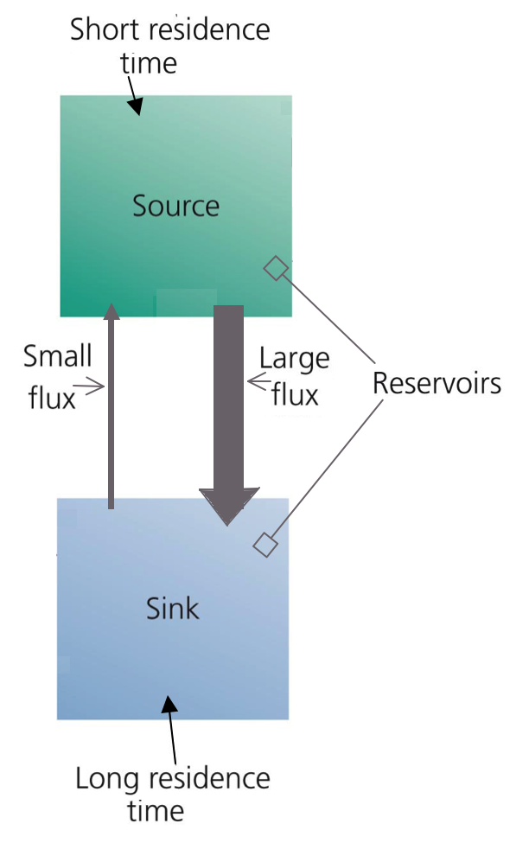
- ____________________:
- Major force acting on water.
- Moves all transformations except _______________________________.

Cycles Have Reservoirs and Transformations
- _____________________________ = where water accumulates or are held for a long period of time
  - ____________________ = water stored here but moves through quickly
  - ____________________ = water is held for long periods
- _________________________________ = transport pathways that move materials between reservoirs
  - ____________________ = the rate at which materials move between pools

Reservoir
1. ____________________________________ is about 97 percent of all water.
- 97% of all Earth’s Water is found in the ____________________________.
- It is _______________ and ___________________________________ for human consumption.
- Oceans supply about __________ of the evaporated water that goes into the water cycle.
Changing Oceans
- Amount of water ________________ over time
- During ice ages, water ____________________________ as ice and lessens in other parts of the water cycle.
  - During the last ice age, the oceans were about 400 feet (122 meters) ____________ than today.
- _________________________ is true during warming periods.
  - 125,000 years ago, the seas were about 18 feet (5.5. meters) ____________________.

Reservoir
2. _______________________________________________ are about 2% of all water.
- Almost _________ of all Earth’s total water supply is tied up in ice and glaciers.
- _________ of Earths’ freshwater is ice.
- Glacial ice covers ______________________ of all land.
- ________ of ice mass in Antarctica

Reservoir:
3. _______________________________ is about 1% of all water.
- Water that is stored _____________________ the surface - more like water in a sponge than a “river”
- _____________________________________: upper layer of soil – water is present but soil not “soggy”
- ____________________________________: cracks and spaces between rock particles hold water
- ________________________________: underground storage

4. ___________________________________ is about 0.008% of all water.
- Water on the surface - _________________________________________________
- Amount of water in rivers and lakes is always ___________________________ due to inflows and outflows.
- __________ of all unfrozen surface water is in Lake Baikal in Siberia (638 km long, 80 km wide, 1,620 m deep) – deepest and oldest lake on Earth
- Another _________ is in the Great Lakes

Reservoir:
5. ___________________________________________________ is about 0.001% of all water.
- Form of water vapor or ice crystals in air
- The __________________________________ that moves water around the globe.
- Rising air cools and ________________________________ into clouds.
- Winds move the clouds until water falls as _________________________________________.

Transformation:
- ______________________________________
- Process which changes water from a _________________ to a ________ (vapor).
- The primary pathway that gets water into the ________________________________.
- ________________________ comes from the Sun
- Process works against _______________________
- Provides approximately ________ of the moisture in the atmosphere.
- Evaporation depends on ___________________________________________________.

Transformation:
- ___________________________________
- The _______________________________________ from parts of the plant, mainly the leaves.
- Provides about ________ of the moisture in the atmosphere.

Transformation
- _____________________________________
- The process by which water vapor in the air is _______________________ into liquid water
- Forms as air containing water vapor ___________ and __________________.
- Energy ___________________________ during evaporation is _______________________ at condensation as latent heat.
- An average cloud, 1 km in diameter and 100 meters thick, has a mass equivalent to one B-747 jumbo jet, but doesn’t sink because it is less dense than the air

Transformation
- _____________________________________
- Water released in the form of _________, freezing rain, sleet, __________, or ___________.
- ___________ precipitation falls as rain.
- ________________ is the force that moves water .

Transformation
- Surface Runoff
- Precipitation _______________ over the landscape
- Meteorological factors affecting runoff:
- __________ of precipitation (rain, snow, etc.)
- Rainfall ______________________, amount & duration
- __________________________ of rainfall over the region
- Direction of storm movement
- Precipitation that occurred earlier and resulting ________________________________.
- Physical characteristics affecting runoff:
- __________________________________
- _______________________________
- Soil type
- Drainage area, shape and elevation
- ____________________________, especially land slope
- Drainage network patterns

Transformation
- Groundwater
- _____________________________________________: How aquifers are replenished
- _______________________________: Water absorbed into ground
  - Affected by porosity and permeability of the surface
- _______________________________: Water movement though ground layers
  - Moved by gravity
- _________________________: Water rises to surface
- ________________________________: Water that flows underground and discharges into stream or other water body

WATER AND ROCK CYCLES INTERACT

