UNIT 10 NOTES: WATER RESOURCES

EARTH’S WATER SUPPLY:
- About _______ of the Earth's surface is __________________________________.
- _______________ hold about ________ of the planet’s water.
- ______________________________ is _______ and includes:

  - Glaciers and ice caps (2%)
  - Rivers and lakes
  - Groundwater & soil moisture
  - Aquifers
  - Water vapor in the air
  - Plants and animals

WATER ON THE SURFACE
- Lakes, Swamps, and Rivers
- Amount of water in rivers and lakes is ____________________________________ due to inflows and outflows.
- ________ of all ________________________ surface water is in ________________________ in Siberia (638 km long, 80 km wide, 1,620 m deep) – deepest and oldest lake on Earth
- Another _______ is in the ___________________________.

WATER FROM THE GROUND
______________________________________: Water that is stored beneath surface - more like ___________________________________________________ than a “river”.
- ____________________________ zone: upper layer of soil – water is present but soil not “soggy”
- ____________________________ zone: cracks and spaces between rock particles hold water
- ____________________________: underground storage

AQUIFERS STORE GROUNDWATER
Aquifers:
- ________________________________________ of rock that are saturated with water.
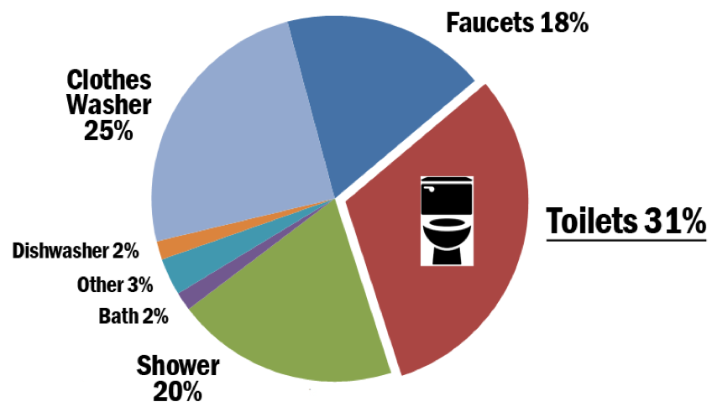
- Can be brought to the surface through natural ________________ or by ____________________.
- _________ of all drinking water comes from aquifers.

TOO LITTLE FRESHWATER
- About ________ of the world’s population does not have enough freshwater.
- Many parts of the world are experiencing:
- Rivers ____________________________________.
- Lakes and seas ______________________________.
- ______________________________________________ from over pumped aquifers.
GROUNDWATER WITHDRAWALS
- Groundwater use is growing - mostly from _________________________________.
- Industry and mining also use water.

GROUNDWATER DEPLETION
- _________________________________________: long-term water-level declines caused by sustained pumping.
- Leads to:
- ________________________________ water tables (water is harder to get to).
- ________________________________ cost for consumers.
- Land ______________________________ – loses support sinks.
- __________________________________ of water quality.
- ______________________________ intrusion near coasts.

SALTWATER INTRUSION
- Occurs where ____________________________ near the coast _________________.
- _______________________________ for freshwater along a coast _________________ groundwater _______________ toward coastal area.
- Saltwater then is ___________________________________ the freshwater zones in the aquifer.
- Saltwater intrusion _______________________ freshwater _________________ in the aquifers.

GROUNDWATER CONTAMINATION
- _______________________________________________: When man-made products (gasoline, oil, road salts, chemicals, etc.) get into the groundwater and cause it to become unsafe for human use.
- Sources include:
  - _____________________ tanks
  - _____________________ tanks
  - ______________________________
  - _________________________________________ waste
  - __________________________ discharge

DIVERTING WATER
- _______________________________ water can make unproductive areas more _________________________ but can cause environmental ______________.
  - _________________________ investment, jobs, and strong economy.
  - It encourages ____________________________ use of water in areas water is not naturally supplied.

STORING WATER IN DAMS
Benefits:
- Produce _______________ electricity
- _______________ water for drinking
- Provide ______________________ water for irrigating cropland
- Holds _______________ runoff
- Slowly release the water for several days
- _______________ flooding downstream
- Recreation and fishing uses
Problems:
- ___________________ people
- ___________________ ecosystems to build dams
- ___________________ aquatic systems
- Risk of failure
- Life cycles of some fish species disrupted
- Downstream estuaries and cropland robbed of nutrients

