UNIT 10 NOTES: WATER TREATMENT

WATER POLLUTION
- ____________________________________________ is the contamination of bodies of water.
- It can come from discharges of ___________________________________________________ _________________________________________.
- It is a _______________ problem in developing countries – few regulations.
- Polluted __________________________________ is difficult to clean because the _____________________ process of groundwater can take _________________________ or __________________________________ of years.
- Remember that groundwater is ________________ the surface.

SOURCES OF WATER POLLUTION
- Most water pollution comes from _____________________________________________.
- __________________________________: specific locations
  - Factory waste, sewage treatment plants, mines, etc.
- __________________________________: cannot be traced to a single site of discharge
  - acid rain, runoff, seepage into groundwater
- _______________________ is largest source of water pollution in the U.S.

WATER POLLUTION AND DISEASE
- ____________________________: organisms that produces a disease - an _________________ pollutant.
- Can be bacteria, viruses or parasites
- Includes: E. coli, Cholera, Typhoid fever, dysentery, giardiasis, hemolytic uremic syndrome .
- __________________________ often include explosive emissions from either end of the digestive tract.

WATER POLLUTION
Affecting Health
- _________________________________________ like bacteria and viruses – comes from sewage, human and animal excrement.
- _________________________________________ like pesticides, plastics, detergents, and oil – comes from agricultural, industrial, and domestic wastes.
- _________________________________________ like acids, salts, and metals – comes from industrial and domestic effluents.
- _________________________________________ like uranium, thorium, radon, etc. – comes from mining, power plants, and other natural sources.

Affecting Ecosystem
- _________________________________________ like nitrates, phosphates, etc. – comes from chemical fertilizers, sewage, and manure.
- __________________________ like silt and soil – comes from soil erosion.
- _________________________________________ – comes from industries and power plants.
- _________________________________________ like agricultural wastes and manure – comes from sewage, and agricultural runoff.

THERMAL POLLUTION
- _____________________________________ is the harmful release of __________________ liquid into a body of water or heat released into the air as a waste product of a business.
- Happens when industries and power plants ____________________________________ into the environment.
- Effects:
  - ____________________________________ in temperature
  - __________________________ dissolved oxygen
  - Changes to reproductive cycles of plants and animals
  - __________________________ susceptibility to disease
  - Economic and environmental ____________________________

DRINKING WATER QUALITY
- ____________ of the world's drinking water is ____________________________________ and poses serious health threats.
- Most drinking water is ______________________ by ________________________ in reservoir (suspended matter settles), and _________________________ by sand filters, activated charcoal, and addition of chlorine.
- Many use bottled water and home filters; __________________________ water is often _____________ contaminated than tap water.

MUNICIPAL WATER COMES FROM WATER PURIFICATION PLANTS
- Initial Treatment
- _______________________ - the removal of any coarse floating objects, weeds, etc. from the water.
- _______________________ - dissolving oxygen into the water to remove smell and taste, promote helpful bacteria to grow, and precipitate nuisance metals like iron and manganese.
- ______________________________ - preparing for coagulation and to help precipitate metals.
- Major Clean Up
- _________________________________________________________ – Settles out suspended particles by adding a coagulating agent (usually alum) to help form a __________.
- _______________________________ - Floc settles out and is scraped and vacuumed off the bed of large sedimentation tanks. process.
- _______________________________ – chlorine added to kill algae and bacteria
- Sand ______________________ the water
- Final Touches
- ____________________________ - water completely free of suspended sediment is treated with chlorine then ammonia (chloramine), or ozone.
- ____________________________ – to meet desired range of 6.5 to 8.5 pH units
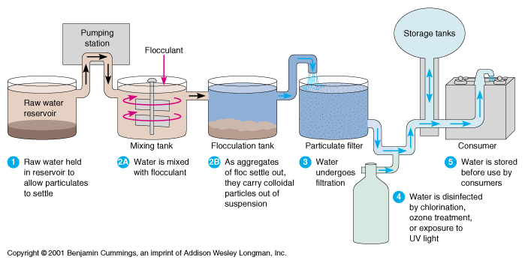

WHERE DOES WASTEWATER GO?
- ____________________________________________________________________ take human and industrial liquid wastes and make them __________ enough to return to the environment.
- Wastewater treatment systems use the ___________________________________ of purification that would occur in a __________________ aquatic system only they do it ______________ and in a controlled situation.

WATER TREATMENT STAGES
- Depending on the type of treatment plant and the quality of raw water, treatment generally proceeds in the following sequence of stages:
- _____________________________
- _____________________________________________________________
- __________________________
- As required, adsorption or other advanced process will be added, depending on the chemistry of the treated water.

DISINFECTION AND RELEASE
Methods of Disinfection:
- ___________________________________ (or other oxidizing chemicals such as bromine, iodine or hydrogen peroxide, bleach/sodium hypochlorite, chloramines)
- _________________________________________ (UV)
- _________________________________ (using ceramic filters)
- _______________ treatment
- __________________________________________
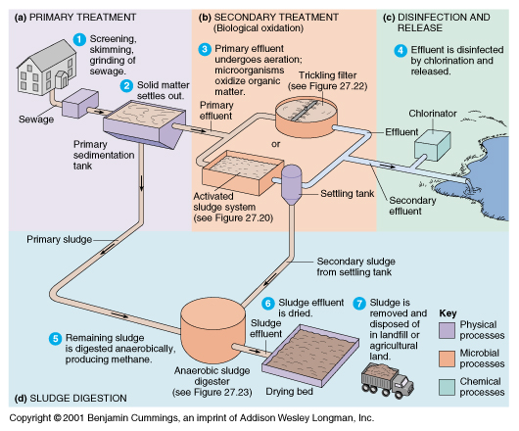

WHERE DOES IT GO?
- ________________________________ (sludge) separated during primary and secondary treatment is disposed of elsewhere.
- _______________________ is wastewater that is cleaned and released into the environment (rivers/streams).

SEPTIC TANKS
- _______________________________: a tank, typically underground, in which sewage is collected and allowed to decompose through bacterial activity before draining by means of a leaching field.
- ______________________________ when no wastewater treatment facility available.

