UNIT 8 NOTES: WEATHER STATION MODELS:
REPORTING WEATHER DATA

MEASURING LOWER-ATMOSPHERE WEATHER
Weather Condition | Instrument to Measure it

STATION MODELS
A __________________________________ is a _____________________________________ that show _________________________________________.
Weather conditions:
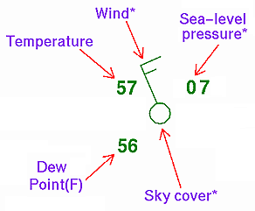
- _________________________________
- _________________________________ and __________________
- ______________________________
- ___________________________ (temperature at which air is saturated or would be at 100% humidity)
- ___________________________
________________________ Data: NOT predictions

WEATHER STATION DATA: TEMPERATURE, DEW POINT AND PRESSURE
Normal range is 980 to 1050

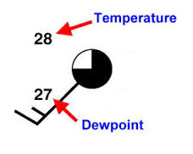
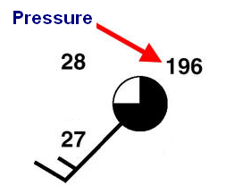

The ________________________________ in the air, the __________________________________ and ____________________________ are – the more likely there is __________________________.
Temperature – top left Dew Point – bottom left Pressure – top right
Pressure Information:
- Drop the “9” or “10” at the beginning.
- Two digits – whole number or Three digits – 1 decimal place
WEATHER STATION DATA: CLOUDS AND WINDS
- Barbs tell wind direction, Flags tell Wind Speed
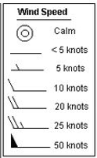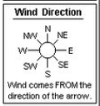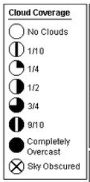

WEATHER STATION DATA: CURRENT CONDITIONS
- Shown between Temperature and Dew Point.
- Shows precipitation.
- Not always indicated.

