WEATHERING LANDFORMS
Weathering by Groundwater

Chemical Weathering:
- Process where ___________________________________________ down minerals in rock.

Carbonation:
- Type of ________________________ Weathering
- Carbonic acid ______________ when _____________ passes through ________________.
  - _________________________ minerals in rock.
  - Chemically weathers rock.
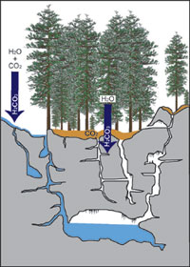
Calcite and Weathering
- _____________________: Common mineral
  - ___________________________, chalk
  - ____________________ – remains of shells and skeletons
  - Sedimentary rock
  - CaCO₃
- Weathering from __________________________.
  - Carbonic acid

Caves and Caverns
Formations:
- ____________: a natural opening, usually in rocks, that is large enough for human entry.
  - _______________________ – most common _________ for cave formation.
- __________________: consists of connecting caves.

Cave and Cavern Features
Formations from water containing dissolved __________________________________ include:
  - _________________________ – suspended deposit
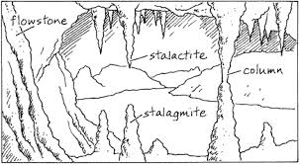
  - _________________________ – deposits that build up from the floor
  - _________________________ – calcite deposit formed when a stalactite and stalagmite meet

Sinkholes
- A _________________________ is a circular depression that forms when rocks dissolve.
- Sediment ___________ existing cavity, or caves / caverns _________________________.
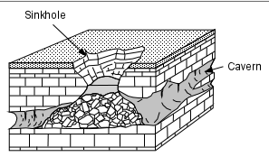

Karst Topography
_________________________________________ is landscape that is characterized by numerous caves, sinkholes, fissures, and underground streams.
  - Generally forms in __________ areas.
  - Caused by chemical weathering of limestone by __________________________.
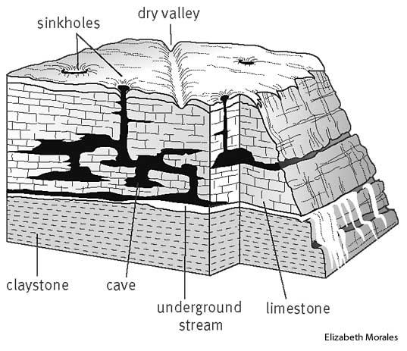
  - ___________________________ sinkholes and caverns.
  - ___________________ often disappear underground and emerge elsewhere.

Coastal Weathering
- ___________________________________ is weathering by wind and water create landforms at coastal regions.
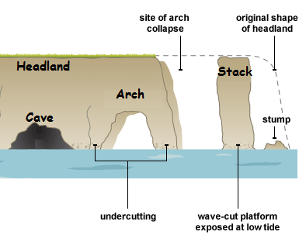
- Type of ______________________________ Weathering.
- _____________________________ formations occur because of ________________________________ weathering – different materials in rock.
- ______________________________ into coastal headlands to form:
  - Arches
  - Stacks
  - Caves
- Sea Cliffs are produced by ________________________________________.

