WIND DEPOSITION AND LANDFORMS NOTES

WIND DEPOSITION
- Obstacles ______________ wind. Example: a rock or tree
- Like ___________________:
  - When wind slows down, it drops the sediment it is carrying
  - As the wind slows, it deposits the largest particles first.
- ________________________________________ (sand, silt, clay) affects what forms.
WIND DUNES

- A ____________ is a pile of wind-blown sand.
- Formation:
  - Wind _______________ obstacle.
  - Obstacle causes wind to ___________________________.
  - Sand (load) is ________________________.
  - Dune ______________ and grows.
  - The more sand deposited, the bigger the obstacle, the more sand is dropped.

DUNE SHAPES
- A sand dune has a ______________ slope on the side the wind blows ____________ – _______________________ side.
- The opposite side has a ______________ slope called the slip face – __________________ side.
- Five types of dunes.
BARCHAN DUNES
  - ____________________________ – “C” shape with wind on crescent side.
  - Also called Crescent Dunes – _______________________________________ mounds.
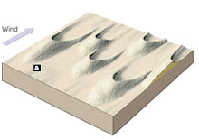
  - Needs _______________________ wind in same direction.
  - Generally are wider than long.
  - Form where there is a limited supply of sand and relatively flat ground.
PARABOLIC DUNES
  - Always in _______________ environments.
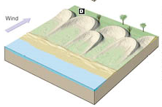
  - Also called “_______________________” dunes.
  - Common on ______________________.
  - _____________________ winds.
  - Always associated with ____________________________.
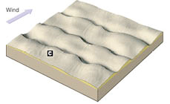
  - Vegetation anchors ends while center moves forward.
TRANSVERSE DUNES
  - Long _______________________________ dunes.
  - Form at ________________ angles to the wind direction.
  - ______________________ supply of sand.
  - Relatively ______________ winds.
  - __________________ slip face.
  - A group of transverse dunes resembles sand ripples on a large scale.
LONGITUDINAL DUNES
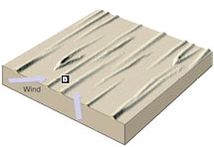
  - _________________________ sand.
  - __________________ cross winds converge from at least two directions.
  - Sand pushed into ___________________________ or ridges.
  - Crests or summits often straight or slightly wavy.
  - Slip faces on ____________________ side.
  - Can reach more than 655 feet (200 meters) in height and 62 miles (103 kilometers) in length.
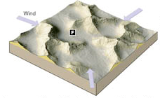
STAR DUNES
  - ______________________ winds.
  - ___________________ directions.
  - Three or more arms.

DUNE CONCERNS
- A major concern near coastal areas is that dunes are being ______________________ and ___________________________.
- The removal and disturbance of coastal dunes leads to:
  - Increased beach ________________________
  - Near shore _______________________
  - ________________ of habitat

DUNE MIGRATION
- _______________________________________ is the erosion and deposition of an entire dune due to the ____________________________ of the wind.
- They can cover roads, houses or other structures

LOESS
- A ______________________ of ______________________________ sediments deposited by the wind.
- Extremely ______________________ and provide excellent soil.
- Ex. Midwestern United States- along the eastern border of the Mississippi River Valley

