Name _____________________________________________ Period ________
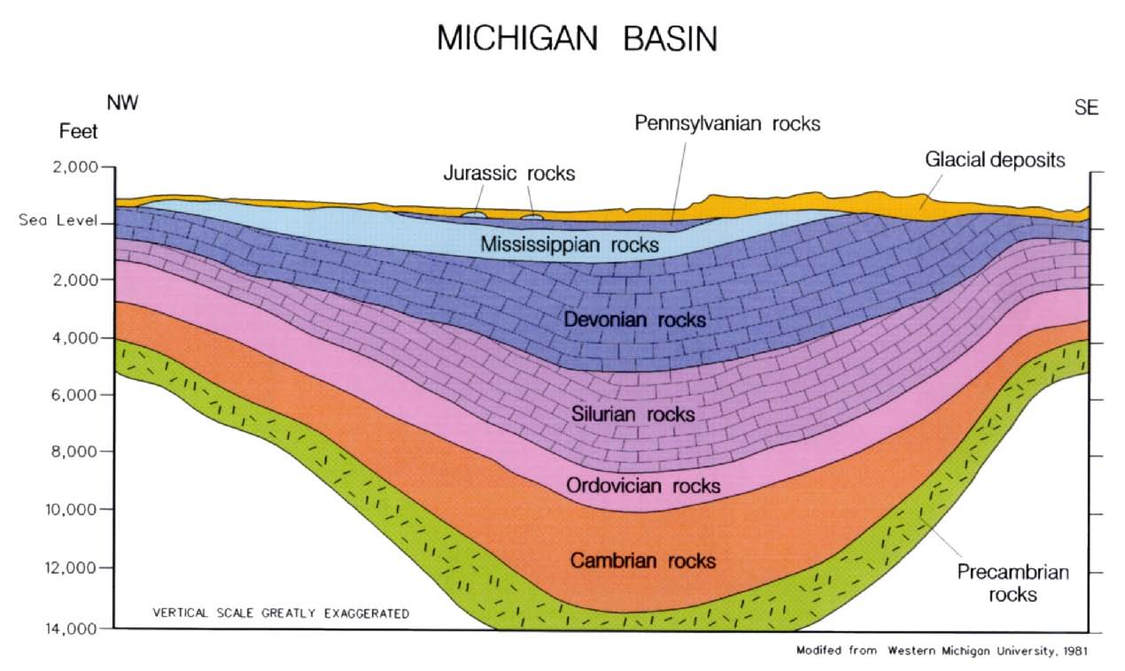

PRACTICE: EXAMINING A CROSS SECTION
Examine the drawing of the Michigan Basin and answer these questions.
- Why is this area described geologically as a basin?

- Does this cross section show the Law of Superposition? Explain.

- Does this cross section show the Law of Original Horizontality? Explain.

- Does this cross section conform to the Law of Lateral Continuity? Explain.

- Describe the stratigraphic location of the angular unconformity.

