Name _____________________________________________ Period _____

REVIEW #5

- Leaf Margin Analysis-- A way of telling average _____________________________ by looking at the shape of leaves.
- Warm tropical areas, higher PERCENTAGE of plants have _____________________ edges.
- Cooler environments higher PERCENTAGE have leaves with more ______________________ edges.
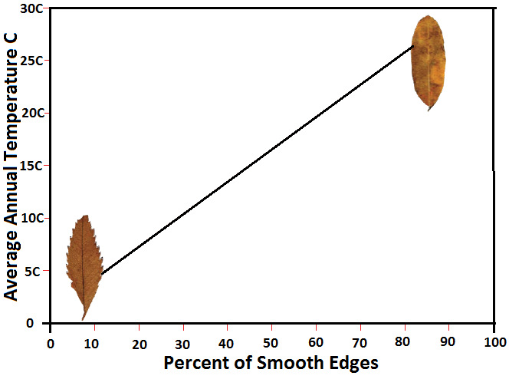
- Using the diagram to the right, answer the following questions.
  - If 30% of all fossil leaves in an area are smooth and 70% are toothed, the past climate was most likely what approximate temperature? _______ °C
  - A rock layer near the bottom of a geologic column had 75% of the leaf fossils with toothed leaves while in an upper layer of rock the leaf fossils were 30% smooth. Was there a change from one climate to another?

Did it get NO CHANGE / WARMER / COLDER (circle one) as the rocks got older?

Name _____________________________________________ Period _____

REVIEW #5

- Leaf Margin Analysis-- A way of telling average _____________________________ by looking at the shape of leaves.
- Warm tropical areas, higher PERCENTAGE of plants have _____________________ edges.
- Cooler environments higher PERCENTAGE have leaves with more ______________________ edges.
- Using the diagram to the right, answer the following questions.
  - If 30% of all fossil leaves in an area are smooth and 70% are toothed, the past climate was most likely what approximate temperature? _______ °C
  - A rock layer near the bottom of a geologic column had 75% of the leaf fossils with toothed leaves while in an upper layer of rock the leaf fossils were 30% smooth. Was there a change from one climate to another?

Did it get NO CHANGE / WARMER / COLDER (circle one) as the rocks got older?

