Name _________________________________________________ Period ______

REVIEW #7
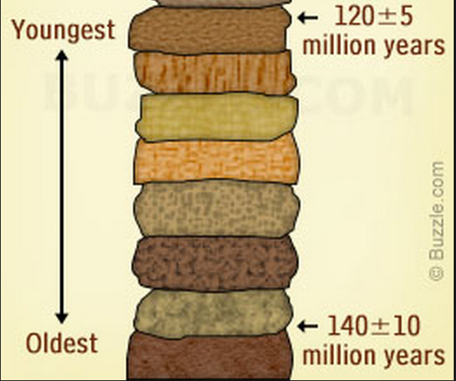

- State the Law of Superposition.

- What is the geologic time scale based on?

- Look at the rock column to the left. Which side (left or right) shows Absolute Age? __________
Which side shows Relative Age? ___________
- Looking at the six rock layers below, put them in the correct order if E is the bottom layer and the oldest.

__E__ ______ ______ ______ _______ _______
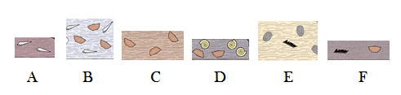

Name _________________________________________________ Period ______

REVIEW #7

- State the Law of Superposition.

- What is the geologic time scale based on?

- Look at the rock column to the left. Which side (left or right) shows Absolute Age? ___________
Which side shows Relative Age? __________
- Looking at the six rock layers below, put them in the correct order if E is the bottom layer and the oldest.

__E__ ______ ______ ______ _______ _______

