Name: ______________________________________________________ Period _____

Unit 3: Changing Lithosphere, Earthquakes and Volcanoes Study Guide

Earthquakes
- Elastic energy is energy stored in rocks in the form of _______________________________________.
- __________________________________ is the sudden return of elastically deformed rock to its undeformed shape.
- Earthquakes happen because rocks ___________________ along fault lines and there is a sudden release of ___________________
Earthquake waves:
- Earthquakes occur in the _______________ of the Earth and are associated with _______________
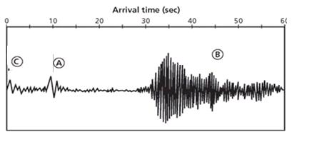
- In the seismogram to the right, label the P-waves, the S-waves, and the surface waves.
  - _______________ Waves (P Waves) - primary or compression waves. They are the _______________ waves of an earthquake to be detected. They move in a back and forth motion parallel to the waves and can move through solids, liquids and gas.
- _______________ Waves (S Waves)- secondary or shear wave. They are the _______________ of the waves of an earthquake to be detected. They cause rock particles to move in a side-to-side direction perpendicular to the direction the wave is traveling. These travel ONLY through _______________.
- _______________ waves—seismic waves that travel along the surface of a medium and arrives after the P and S waves.
- _______________ Waves - Side-to-side - not vertical. Ground twists.
- _______________ Waves - Rolling motion
- _______________ are the MOST destructive.
- A ______________________ is a gigantic succession of ocean waves formed after a volcanic eruption, submarine earthquake or landslide—not a tidal wave.
The scales to classify earthquakes are:
  - _______________ -a measurement system that bases earthquake strength on ground motion
  - Moment Magnitude scale increases by _______________ for every increase in level.
  - _______________ -a measurement system that expresses earthquake intensity in Roman numerals and describes the ______________________________. Be able to use the Mercalli Scale (to the right) to determine the proper classification for an earthquake scenario.
- Define
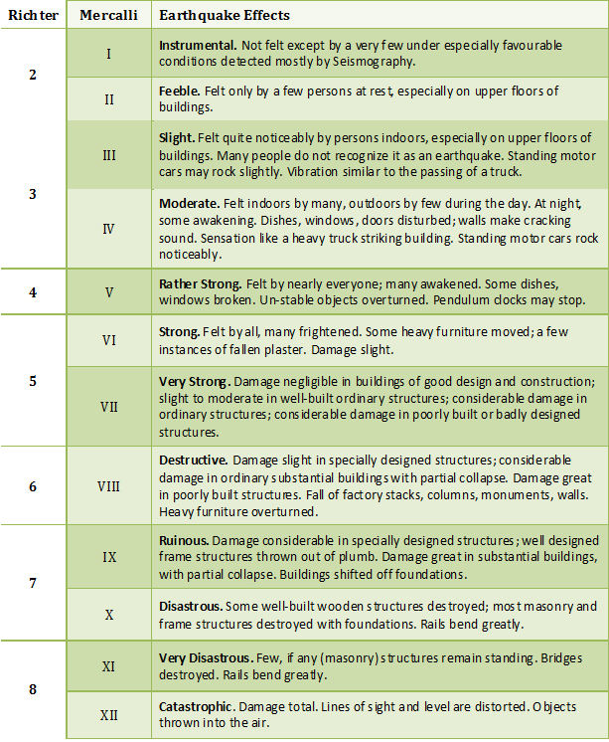

  - Intensity =
  - magnitude =
- Be able to use the figure below to interpret the distance of the epicenter
from the stations.
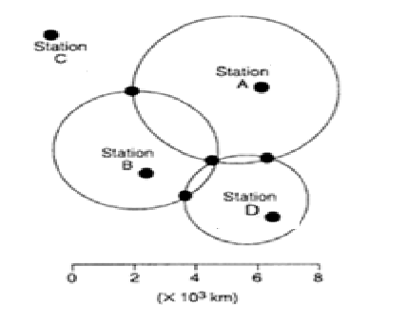
Which is farthest?

Which is closest?

Where is the epicenter? Put a triangle around it

- Define
  - Focus =

  - Epicenter =
- Hazards associated with an earthquake include
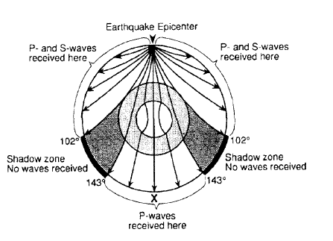

- Using the figure to the right to interpret how seismic waves travel throughout the Earth.
- Shade the part where both types of body waves are received.
- Why don’t S waves show up at station X?

- Can P and S waves be felt everywhere, every time an earthquake happens? Why or why not?

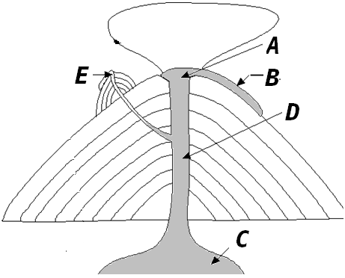
- Label each part of the volcano using the word bank below. Also, define the terms.
- Side vent =
- Magma Chamber =
- Conduit or Pipe =
- Crater =
A
- Lava Flow =
- The partial melting of the mantle and crust will produce the _______________ that forms volcanic mountains on the Earth’s surface
- __________________________ ____ are large depressions formed by the collapse of a volcanic cone
- __________________________ ____ are areas of volcanism within plates and away from the plate boundaries
- ___________________________ ___ -volcanic belt in Pacific

FELSIC VOLCANIC ROCK CLASSIFICATION
Rock Name | Volcanic Breccia | Ash Flow Tuff | Air Fall Tuff
Rock  Description | Pumice and large volcanic bombs and blocks. Exhibit mixture of large and small grains. Welded | Pumice and some sand sized crystals  And rock fragments.  Welded | Pumice and a few crystals and mostly dust.  Chalky.
Particle Size | Large | Medium | Small
Distance to Volcano | Very close  (Few kilometers) | Near  (within 20 kilometers) | Far  (Many kilometers away)
Stickiness of Magma | Very | Some | None
Formation  Temperature | Temperature DECREASING  (HOT-----------------------------------------------------------COOL)

- According to the table above:
  - List the rocks in order from farthest from volcano to closest to volcano:
  - List the rocks in order from hottest to coldest:
  - List the rocks in order from those containing smallest to largest crystals:
- Use the diagram at the right to compare/contrast obsidian and pumice.
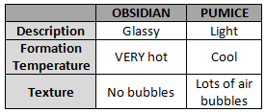

  - _______________ —Glassy, formed in _______________ temperatures with _______________ bubbles
- _______________ -Light, formed in _______________ temperatures with _______________ bubbles
Composition of magma:
- Most common gases in magma are _______________ and _______________.
- Higher silica content means higher _______________.
- Higher viscosity of magma results in more _______________ eruptions.

