Name __________________________________________

REVIEW #3
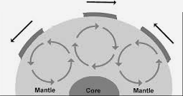
- ___________________ drives plate tectonics.
    - in the graphic to the right, the circular arrows indicate _____________________________________
    - Heat inside the Earth is from ___________________ decay
    - Understand the difference between conduction and convection
      - ___________________ — the passage of energy, by direct contact
      - ___________________ - the transfer of energy through fluids in which heat rises and cool material sinks.
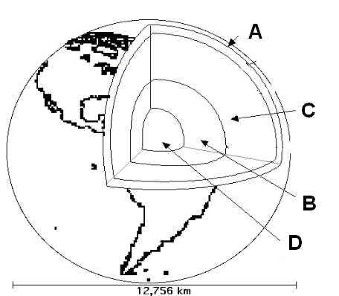
- Scientists have learned about Earth’s composition by:
    - Using ___________________ waves data - recordings of seismic waves show waves travel through layers at different speeds
    - Earth’s ________________________________ is evidence for its spinning, liquid metal outer core
    - ___________________ – composition similar to Earth – three types of meteorites match the density of Earth’s three layers.
- ___________________________ – material comes from the upper mantle to the crust.
Be sure you can name the layers using the diagram to the right.

Name __________________________________________

REVIEW #3

- ___________________ drives plate tectonics.
    - in the graphic to the right, the circular arrows indicate _____________________________________
    - Heat inside the Earth is from ___________________ decay
    - Understand the difference between conduction and convection
      - ___________________ — the passage of energy, by direct contact
      - ___________________ - the transfer of energy through fluids in which heat rises and cool material sinks.
- Scientists have learned about Earth’s composition by:
    - Using ___________________ waves data - recordings of seismic waves show waves travel through layers at different speeds
    - Earth’s ________________________________ is evidence for its spinning, liquid metal outer core
    - ___________________ – composition similar to Earth – three types of meteorites match the density of Earth’s three layers.

- ___________________________ – material comes from the upper mantle to the crust.
- Be sure you can name the layers using the diagram to the right.

