Name __________________________________________
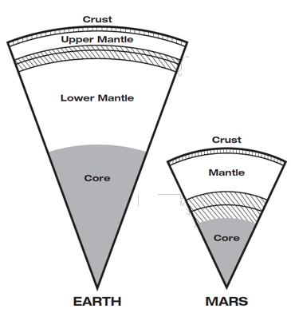

REVIEW #4

- There are four terrestrial planets in our solar system
Mercury, ___________________, ___________________, ___________________
- Earth’s layers are similar to those of ___________________ yet Mars is no longer geologically active.
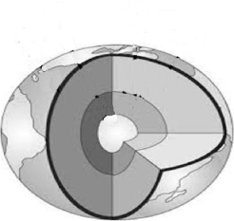
It is smaller and cooled much ___________________ .
- Earth’s layers include: ____________________ core, ____________________ core, mantle, ____________________
- Be able to label the diagram to the right.
- Formed by _______________________________________ – process of settling by density
- Radioactive decay occurs when the nucleus of an atom is ___________________ and it breaks apart releasing ___________________

Name __________________________________________

REVIEW #4

- There are four terrestrial planets in our solar system
Mercury, ___________________, ___________________, ___________________
- Earth’s layers are similar to those of ___________________ yet Mars is no longer geologically active.
It is smaller and cooled much ___________________ .
- Earth’s layers include: ____________________ core, ____________________ core, mantle, ____________________
- Be able to label the diagram to the right.
- Formed by _______________________________________ – process of settling by density
- Radioactive decay occurs when the nucleus of an atom is ___________________ and it breaks apart releasing ___________________

