Name ___________________________________ Period _____ Date ___________________

REVIEW
Scientific Method, Metric System, Lab Safety

1. Be able to identify the steps involved in the scientific method.
State the problem Gather information State a hypothesis Test the hypothesis Record and analyze data Form a conclusion
2. Identify the basic parts of the metric system. Know the definition, unit, and how each is measured:

MASS VOLUME LENGTH TEMPERATURE
3. Know how to measure mass, volume of a liquid, volume of a regular and irregular solid
4. Know accepted safety practices and be able to list the available safety equipment.
5. Know how to handle laboratory equipment correctly and safely.
6. Be able to do basic metric conversions with or without the factor label method.
7. Be able to determine significant figures in a number and in a calculation.
8. Be able to correctly round numbers and to convert numbers to and from scientific notation.
9. Be able to discuss accuracy and precision and calculate percent error.

Review Worksheet
I. Read the following statements and then answer the questions.
A. Ms. Brim notices that her pendulum-powered clock is running fast. She wants to know why.
B. Since she misplaced the clock’s instructions, she goes to the media center and reads books on clocks.
C. The scientist learns that the swinging pendulum controls how quickly the clock hands move. The faster the pendulum swings, the faster the hands go.
D. In light of this information, the scientist guesses that if the pendulum were longer, it would not swing so fast.
E. Ms. Brim goes to her classroom lab to test her idea. She does the following:
1. suspends a string 1 meter long from the ring of a ring stand
2. ties a washer to the end of the string.
3. raises the washer to a 45° angle and lets it go.
4. records in her notebook the time it takes the washer to make each of the first five swings.
5. repeats the procedure using a string 0.5 meters long and 0.25 meters long.
F. She writes in her notebook, “The meter-long pendulum swings two times slower that the 0.25 meter-long pendulum and about one and a half times slower than the 0.50 meter-long pendulum.”
G. Ms. Brim finishes her report saying, “It appears that a longer pendulum swings more slowly. Therefore, if I length of the pendulum on my clock, the pendulum will swing more slowly and the clock will not run fast.”

Questions: Place the letter corresponding to the correct statement in the blank.

1. Which statement contains the CONCLUSION? ____________________

2. Which statement refers to GATHERING INFORMATION? ____________________

3. Which statement contains the HYPOTHESIS? ____________________

4. Which statement contains the TEST OF THE HYPOTHESIS? ____________________

5. In which statement is the PROBLEM defined? ____________________

6. Which statement contains the DATA in the experiment? ____________________

7. What is the independent variable? _________________________________________

8. What is the dependent variable? __________________________________________

9. Name at least two things she should have controlled for in her experiment.

_______________________________ _______________________________

10. List at least four pieces of lab equipment needed by Ms. Brim to perform her experiment.

II. Lab Safety and Equipment. Look at the following pictures and state at least one unsafe laboratory procedure:
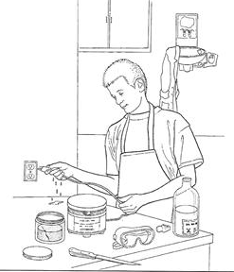
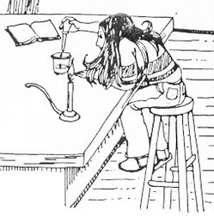
11. 12.

13. Name four pieces of lab safety equipment in your science classroom.

14. Name the following pieces of lab equipment. Put the name next to the letter that matches the picture.
- 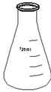 b. 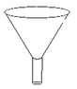 c. 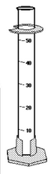

d. 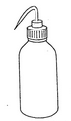 e. 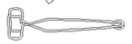 f. 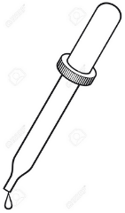

III. Metric System and Calculations.
Fill in the table below.
 | DEFINITION | UNIT | EQUIPMENT USED TO MEASURE IT
15. MASS

16. VOLUME

17. LENGTH

18. TEMPERATURE

Metric Conversions

19. 10 cL = ______________ mL 22. 25 kg = ______________ g

20. 5 g = _________________ mg 23. 1mL = ________________ cL

21. 1 cL = _______________ dL 24. 1 dL = _______________ L

Solve the following using the FACTOR LABEL method. You must show your work.

25. 0.23 km = ___?____ m

26. 3300 cL = ___?___ kL

27. king asked Archimedes to find out whether his new crown was made from pure gold. The density of gold is 19.32 g/cm³. Archimedes got the density of the crown to be 16.8 g/cm³. Calculate the percent error showing all work and correct units. Is the crown gold?

How many significant digits are there in each of the following quantities?

28. 50 kg _______ 31. 33 m _______
29. 0.0085 g _______ 32. 0.010 s _______
30. 87,052 g _______ 33. 30.4°C _______
Solve the following problems using the correct number of significant digits.
34. 8.20 m x 1.217 m = ____________ 36. 18.007 cm
+ 114.195 cm

_______________

35. 4.01 g = 37. 38.12 m
0.22 L ____________ - 12.174 m

_______________

Round the following numbers to three significant figures.
38. 14.375 _______________ 40. 201.45 _______________
39. 0.002133 _______________ 41. 4001 _______________

Convert the following numbers into standard notation or scientific notation.
42. 44,500 ______________________ 44. 5.78 x 10⁴ ______________________
43. 0.000643 ______________________ 45. 5.18 x 10⁻² ______________________

46. Imagine a basketball player shooting baskets. Explain what a player who is accurate looks like and a player who is precise looks like.

