Name ______________________________________________ Period _______

UNIT 13 – KINETICS: TEST REVIEW

Objectives to Review:
- Define Kinetics.
- Discuss the collision theory.
- List the factors (nature of reactants, concentration, temperature, surface area, and catalysis) that effect reaction rates and explain them according to collision theory.
- Identify the parts of a potential energy diagram including activation energy, E_{a}, transition state, energy of reactants, energy of the activated complex, energy of products, and heat of reaction.
- Identify a potential energy diagram for an exothermic reaction and an endothermic reaction.
- Know what a catalyst is and how it affects a potential energy diagram.
- Describe reaction mechanisms for simple reactions and identify the parts of the multiple steps as well as determine the final balanced equation.

Review Questions:
Write T for True and F for false. If the statement is false, replace the underlined word or phrase with one that makes that statement true and write your correction in the blank provided.

__________________________ 1. A reaction goes to completion if at least one of the reactants is used up.

__________________________ 2. The rate of a reaction from left to right is the rate at which the product disappears.
__________________________ 3. Heat, a flame, or a spark may supply the activated complexes needed for a reaction to take place.
__________________________ 4. The energy required to form an activated complex is called kinetic energy.

__________________________ 5. Increasing the reaction rate means that the reaction is happening slower.

__________________________ 6. A catalyst works by raising the activation energy of a reaction and so the reaction happens faster.
__________________________ 7. At the given temperature, the total number of molecules having the required activation energy at 125°C would be the same as the total number of molecules having the required activation energy at 100°C.
__________________________ 8. A substance that affects reaction rate without being chemically changed at the end of the reaction is an inhibitor.

For the following reaction, circle INCREASE if the given change is an increase in the reaction rate, DECREASE if there is a decrease in the reaction rates, or STAYS THE SAME if the reaction rate remains the same.
Limestone (calcium carbonate) reacts with hydrochloric acid in an irreversible reaction, to form carbon dioxide and water as described by the following equation:

CaCO_{3 (cr)} + 2HCl _{(aq+)} CaCl_{2 (aq)} + CO_{2 (g)} + H₂O _{(l)}

Circle the correct effect for each change.

INCREASE DECREASE STAYS THE SAME 9. The temperature is lowered?

INCREASE DECREASE STAYS THE SAME 10. The volume of the reaction vessel is increased?

INCREASE DECREASE STAYS THE SAME 11. Limestone chips are used instead of a limestone block?

INCREASE DECREASE STAYS THE SAME 12. The pressure inside the reaction vessel is increased?

INCREASE DECREASE STAYS THE SAME 13. A more dilute solution of HCl is used?

Write the letter of the graph(s) below that match the following descriptions and answer the questions.

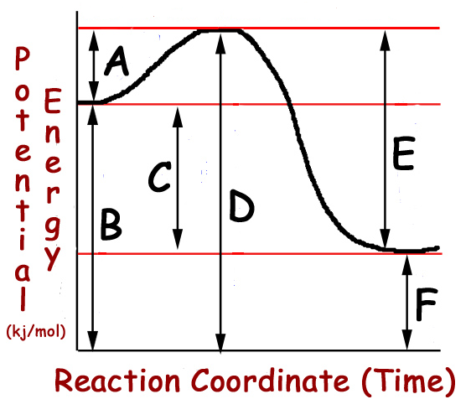
14. Indicate below what each letter tells you about this potential energy graph.

A:

B:

C:

D:

E:

F:

Endothermic or exothermic? (Circle one.)
15. Indicate below what each letter tells you about this potential energy graph.

A:

B:

C:

D:

E:

F:

Endothermic or exothermic? (Circle one.)

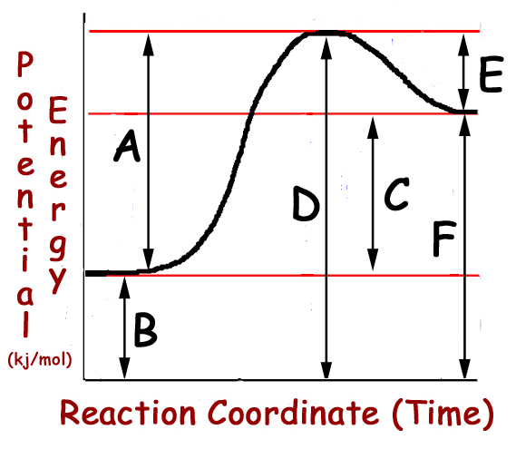

- Nitrogen dioxide and carbon monoxide react to form nitrogen monoxide and carbon dioxide in a two-step reaction mechanism. Look at the steps below and determine the missing chemicals.
NO₂ + CO NO + CO₂

Step One: NO₂ + NO₂ NO + ___________ SLOW

Step Two: NO₃ + _________ __________ + CO₂ FAST

Now, add up all the reactants and products, crossing out the intermediate products and catalysts and write the final equation:

Intermediate Products: _______________________ Catalysts: __________________________

Which step is the rate determining step? __________________________

