Name ___________________________________________ Period _____

PHASES OF MATTER AND ENERGY REVIEW

Test #10

- Explain the behavior of solids, liquids, and gases in terms of the kinetic theory.
- Relate temperature and energy transfer to molecular motion.
- Differentiate between INTERmolecular and INTRAmolecular forces.
- Describe the three intermolecular forces; compare and contrast each.
- Differentiate between the four phases of matter.
- Describe solids by crystalline structure, energy, spacing, and intermolecular forces.
- Describe liquids in terms of vapor pressure, density, spacing, energy, and intermolecular forces.
- Discuss viscosity in terms of temperature and IMFs; discuss surface tension and capillary action in terms of IMFs; discuss cohesion and adhesion
- Use polarity, IMF, and molecular structure to explain the unique properties of water.
- Describe the vapor pressure of a liquid and its relationship to the temperature of the liquid.
- Describe the process of boiling as it relates to the vapor pressure of the liquid and atmospheric pressure.
- Discuss a heating curve as a substance is taken from a solid to the vapor state.
- Discuss a phase diagram and understand the significance of the terms associated with it (T_{m}, T_{b}, etc.).
- Explain a phase change and interpret these changes based on graphs.
- Determine the relationship between energy and change of state.
- Be able to perform calculation for heat of fusion, heat of vaporization and heat changes.

PRACTICE:
Write T for true and F for false. If the statement is false, replace the underlined word or phrase with one that will make the statement true, and write your correction in the blank.

__________________________ 1. Particles that make up matter are always stationary.

__________________________ 2. Collisions between particles of matter are perfectly elastic because there is no change in the total kinetic energy of the particles before and after the collision.
__________________________ 3. A unit for temperature is atmospheres.

__________________________ 4. A solid is formed when molecules of a liquid substance escape from the surface of the substance.
__________________________ 5. According to the kinetic theory, if the temperature of a liquid is lowered, the average velocity of its particles should be lowered.
__________________________ 6. When the ordered arrangement of the atoms of a solid substance breaks down, the solid freezes.
__________________________ 7. When a liquid freezes, the particles of the substance settle into an ordered arrangement and forms a solid.
__________________________ 8. The particles in a gas have high intermolecular forces (IMF).

__________________________ 9. Gases with a low boiling point have a low vapor pressure.

__________________________ 10. Gases with a high evaporation rate are considered to be volatile.

11. Keeping Chocolate Hot – Think about a cup of hot chocolate. You put a spoon into the hot chocolate. Why does the spoon get hot? Talk about this using terms like kinetic energy, molecular motion, and transfer of energy. Think about HOW the heat transfer happens.

Fill in the table below pertaining to the phases of matter.
 | SOLID | LIQUID | GAS
12. DENSITY

13. VOLUME

14. SHAPE

15. ATTRACTIVE
FORCES (IMFs)

- Six transitions are listed in the diagram below. Use arrows to connect each transition to its beginning state and its ending state. One example is done for you. When completed, each beginning state and ending state will be used twice.
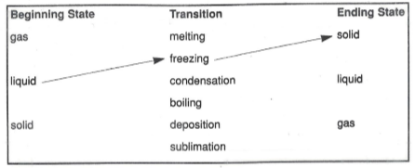

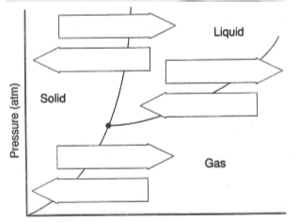
- In the phase diagram to the right, correctly label the x-axis and the triple point with a star. Write the names of all six phase transitions below:
B
A
C
A. ____________________________________
D
B. ____________________________________
C. ____________________________________
E
D. ____________________________________
F
E. ____________________________________
F. ____________________________________

- List two unique properties of water and explain why water has these properties.

- List the three phase changes that are endothermic.

PHASES OF MATTER AND ENERGY REVIEW, Test #10, Page Two
- Give four characteristics of a substance that has strong IMF and then given an example.

- When does a substance boil?

- When is there a dynamic equilibrium? (What must be going on?)

- On the graph of the heating curve for water given below, label 0°C and 100°C on the temperature axis. On the lines provided, indicate the states of matter presented for all the letters.

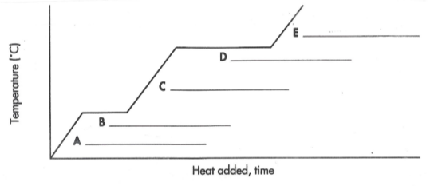

- Explain what is happening to the average kinetic energy of the molecules during the changes of state marked by B and D on the graph.

- What is vapor pressure? List a substance that has high vapor pressure and a substance that has low vapor pressure.

- Given that the temperature at which water changes from a liquid to a gas is at 100ºC, how can a puddle of water completely evaporate at 28ºC?

- When dry ice is placed in an open container at room temperature, it changes directly from a solid to a vapor. What is this process called and why does it happen?

- A liquid boils at a very low temperature and evaporates rapidly at room temperature. Describe this substance in terms of IMF, volatility, evaporation rate, vapor pressure, and boiling point.

- The temperature above which no amount of pressure will liquefy a gas is called the ___________________________________________ of the gas.
- Calculate how much energy is needed to heat 52.0g of ice from –20.0°C to 25.0°C. (The specific heats of water are ice=2.06 J/g°C, water=4.18J/g°C, and vapor=2.02J/g°C). Show all work including formulas.

- Calculate the energy needed to melt 52.0g of ice. (The enthalpy of fusion is 334 J/g.). Show all work including formulas.

