Name ______________________________________________ Period _____ Test date ___________________________
Test Review Unit 1: EARTH’S ORIGINS

Turn this in on the day of the test – complete and correct - for a chance to earn points towards a test redo. Each review counts as one point. You need four points to redo a test.
- The Solar System formed ___________________ years ago
- _____________________ is the process found in stars where heavier elements are formed by squeezing smaller nuclei together.
- Planets formed from a nebular cloud of ___________________ and ___________________ .
- Evidence for Earth’s age:
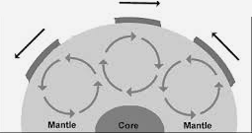
  - ___________________ subject to extensive erosion.
  - Meteorites
  - Radioactive ___________________
- ___________________ drives plate tectonics.
  - in the graphic to the right, the circular arrows indicate ___________________ .
  - Heat inside the Earth is from ___________________ decay.
  - Understand the difference between conduction and convection .
    - ___________________ — the passage of energy, by direct contact .
    - ___________________ - the transfer of energy through fluids in which heat rises and cool material sinks.
- ___________________ planets are less than (< ) 2 AUs from the Sun.  - Formed from materials with high condensation temperatures.  - Metals, silicates, and rocky materials.  - ___________________ planets are greater than (>)3 AUs from the Sun and are formed from gaseous ice.  - Their average density is less than terrestrial worlds due to composition.  - Composed of various types of ice like water and ammonia.  - Be able to answer questions from the chart to the right – explains how temperature of solar nebula(sun) influenced planet formation … the graph will be on the test, you will just need to be able to read it and answer questions. | 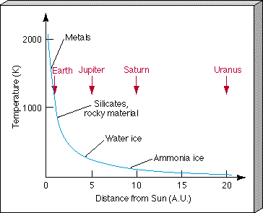

- Earth’s layers include: ___________________ core, ___________________ core, mantle ___________________  - Be able to label the diagram to the right.  - Formed by ______________________________ – process of settling by density. | 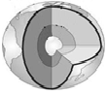
- Scientists have learned about Earth’s composition by:  - Using ___________________ data - recordings of seismic waves show waves travel through layers at different speeds. Be able to answer questions based on the chart to the right.  - Earth’s _________________________________ is evidence for its spinning, liquid metal outer core.  - ___________________________ – composition similar to Earth – three types of meteorites match the density of Earth’s three layers.  - Volcanoes | 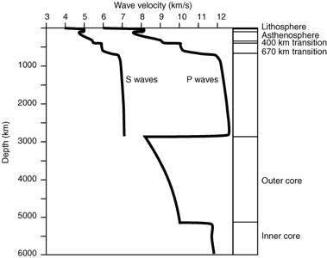
- There are four terrestrial planets in our solar system.
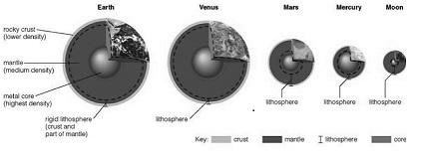
  - Mercury,
  - ___________________ ,
  - ___________________ ,
  - ___________________
- Be able to compare them using the picture to the right.

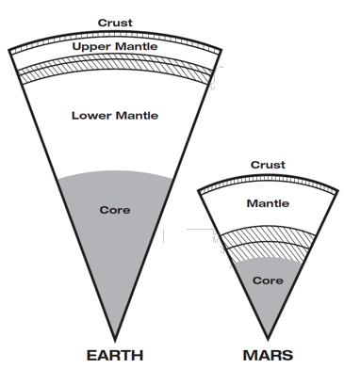
- Earth’s layers are similar to those of ___________________ yet Mars is no longer
geologically active.
  - It is smaller and cooled much ___________________ .
- Be able to answer questions based on illustration to the right.

- Three elements in an atom  - ___________________ —positive charge and is same as atomic number  - ___________________ —negative charge –same numbers as protons  - ___________________ —no charge – it is the sum of neutrons and protons is ____________________  - Be able to label other elements in similar way as illustration to the right  - Be able to identify what each number represents:  - The atomic number is ___________________, the atomic mass is __________________________, and the mass number is ________________________. |  |  | 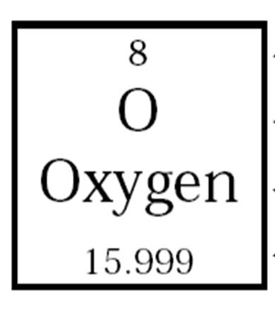
- Understand the half-life graph to the right and be able to answer  questions based on this information.  What percent of a parent / daughter isotope is present after  - The first half-life? ___________________  - The second half-life? ___________________  - The third half-life? ___________________  - Radioactive decay occurs when the nucleus of an atom is ___________________ and it breaks apart releasing ___________________ | 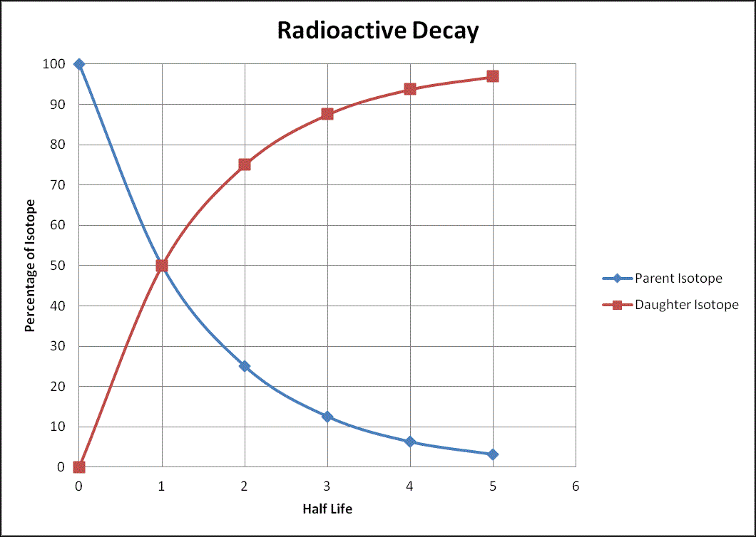
- First atmosphere: Helium and Hydrogen gases were ___________________ because Earth’s ___________________ was too weak.  - Second atmosphere – ___________________ from out gassing  - Third atmosphere: ___________________ responsible for buildup of free oxygen (O₂) in Earth’s atmosphere.  - Increased photosynthesis indicates increased ___________________ life.  - O₂ levels decreased as life forms utilizing O₂ ___________________  - Be able to answer questions based on the graph to the right about increase of O₂ in Earth’s atmosphere.  - Early fresh water oceans became salty as water carried salty ___________________ to the deltas and then the oceans. |  | 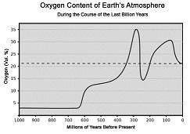

- There are three types of variables in scientific inquiry
- ___________________ Variable- held constant in order to determine the relationship between two other variables
- ___________________ Variable- the variable in an experiment that is measured
- ___________________ Variable- the variable in an experiment that scientist alters
- Be able to answer questions about the experiment based on the information in the chart below:
