Earth Systems Unit 10 Study Guide
SES6. Students will explain how life on Earth responds to and shapes Earth systems.
Fig. A
Using Figure A, identify the following layers of this industrial metals mining location
- _____ - Rock Layer
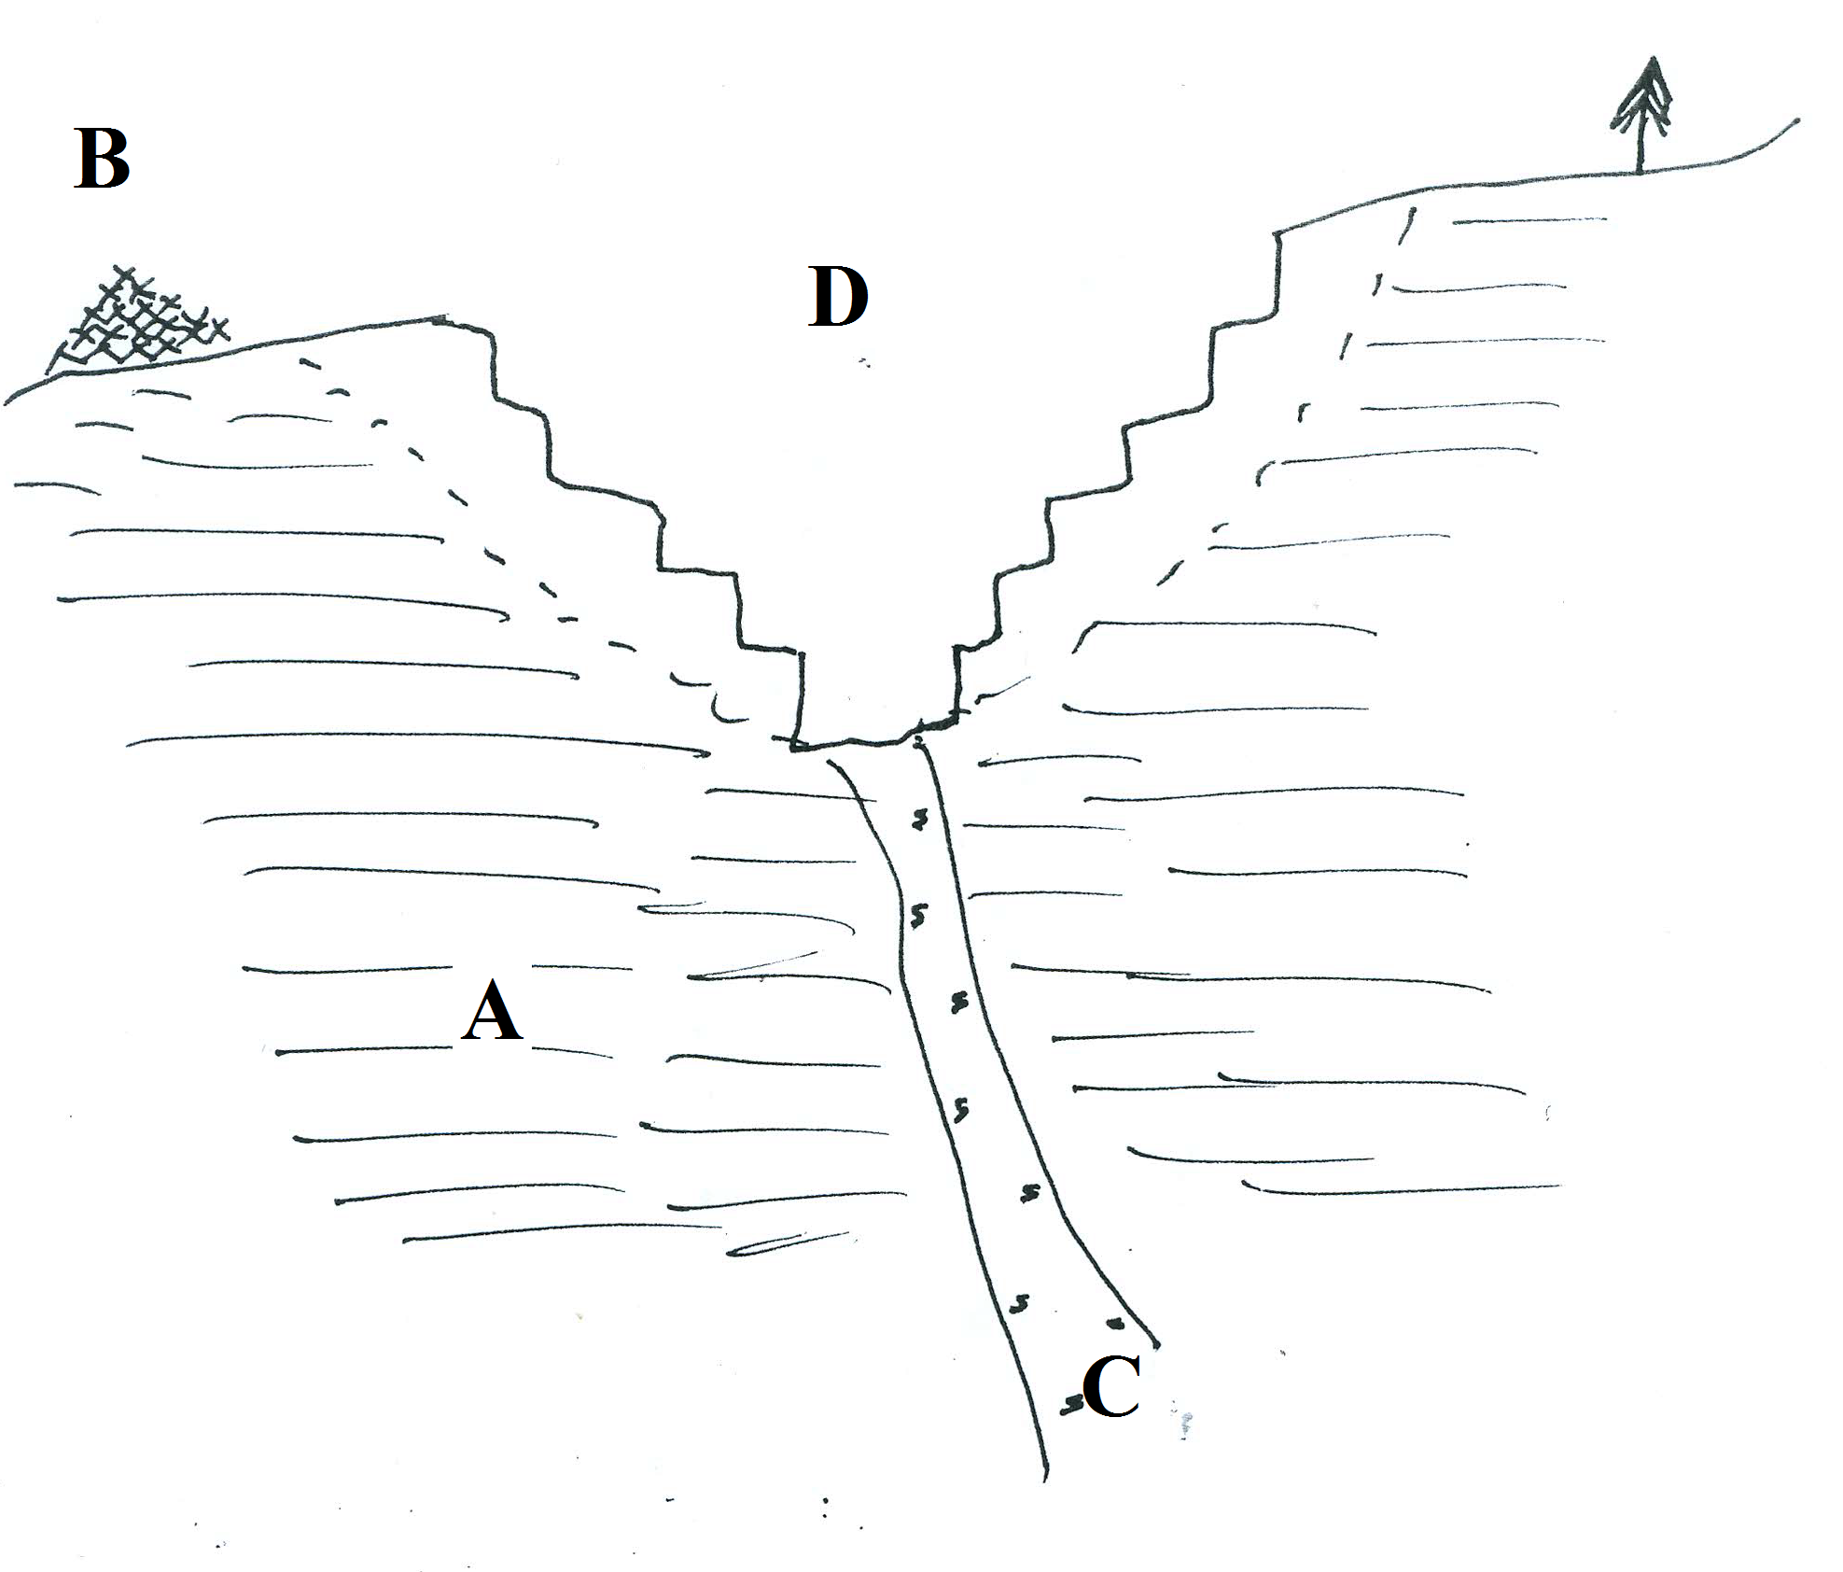
- _____ - Recycled Metals—we need to recycle more of these to stop additional mining activities. Also the most _________________________ way to obtain additional metals.
- _____ - Original or Primary Ores-we must dig deeper into the Earth which is more _____________________ the deeper the dig and it destroys more of the land. Also this is more expensive as sulfur must be removed from the ore which is an expensive process that adds the removed sulfur to atmosphere contributing to acid rain.
- _____ - Weathered “Supergene” area—This is the rock layer next to what was the primary ore vein near the surface. Some of the ore is still present in the supergene area and much of the sulfur has been leached out. This will destroy more land but is less expensive than mining the primary ore.
- Define the following terms:
- ________________ —a mineral deposits formed by hot mineral solutions in cracks in rock
- ___________________________________- The process of returning land to its original or better condition before mining
- ___________________________________ - the dumping heated water into lakes and rivers by industry and factories

SES6a. Relate the nature and distribution of life on Earth, including humans, to the chemistry and availability of water.
Our fresh water resources are important. Understand the following
- To make drinking water safe for us, ____________________ is added to kill _________________________ present in the water and prevent additional bacteria growth.
- Most of the pollutants come from activities on ____________ such as industrial, farm and human sources.
- The increase of _________________ pollution has a negative impact on many of our water species who cannot live in elevated temperatures.
- An increase in human population could have serious consequences for our drinking water by _____________________ demand, _____________________ pollution, and _____________________ waste.
- There are two sources of pollution:
  - ____________________________________ - such as factory waste and sewage treatment plants.
  - ____________________________________ - such as acid rain, runoff which cannot be traced to a single source.
- We need to keep our groundwater as pure as possible because cleaning and filtering dirty, polluted water is difficult because:
- Groundwater is ___________ in the ground and dispersed through large areas of ___________.
- _____________________________ cling to the materials that make up the aquifer and contaminate the clean water.
- The recycling process of groundwater can take ____________________________________________ of years.
- We clean the effluent that we release into the environment because ___________________________________________.
- Dams, such as Hoover Dam and Buford Dam have been built to provide _________________ electricity and ______________ for fresh water.
- The problem with drilling for fresh water near coastal areas is the risk of _____________________________ into the aquifers.

SES6C. Explain how geological and ecological processes interact through time to cycle matter and energy, and how human activity alters the rates of these processes (e.g., fossil fuel formation and combustion).
- Our air is also important to keep as pollution-free as possible.
- Pollutants such as nitrous oxide, carbon dioxide and VOCs combine in the presence of sunlight to form ________________ in the _____________________________________ which can cause severe respiratory problems.
- Although the Earth is still creating Fossil Fuels today, coal, petroleum and other fossil fuels are still considered ________________________________________ resources because we are ___________________________ fossil fuels much faster than they _______________________.
- ___________________________________________ - means that the resource is not depleted when used.
- ___________________________________________ - means that the resource cannot be replaced naturally at the same pace it is being used.
- Know the advantages and disadvantages of the following energy sources
- _____________- Inexpensive but the burning for fuel is a major contributor to acid rain.
- ____________________________- can be used to directly heat buildings or to provide hot water. It can also be converted to electricity. The problem is the photocells currently used are very expensive and produce only a small amount of electricity. Also, solar power is not always available depending on the weather or the climate.
- ____________________________- Burns cleaner than oil and the United States does have an abundant supply but obtaining it through drilling runs the risk of contaminating ground water.
- ____________________________- this does not produce carbon dioxide (CO₂) but it does produce radioactive waste.
- ____________________________ - there is an unlimited supply of wind and wind power produces no air or water pollution, but the turbines can kill birds and some people do not like the noise or visual pollution.
- ____________________________ - there is no shortage of heat energy in the Earth, but not all places on Earth are able to tap into the Earth to use it.
- ________________________ - there is always available organic material to burn and the methane generated from landfills does not become a greenhouse gas, but it does produce air pollution when burned.
- ________________________ - no air pollution is produced and this is the cheapest way to produce electricity once the dam is built. However, damming a river can disrupt the wildlife and natural resources.

