Name: ________________________________________________________
Unit 2: Plate Tectonics Test Review

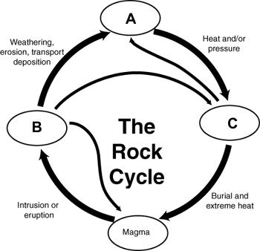
- Igneous Rock
  - Formed by the cooling and hardening of _______________ or any type of rock
  - Extrusive – formed _______________ ground
  - Intrusive – formed _______________ ground
- Sedimentary Rock
  - Occurs when rock is weathered, eroded, _______________ and cementation occurs.
  - Formed when sediment is deposited and becomes tightly _______________.
  - _______________, remains of an animal or plant, are found in this type of rock.
  - Can be Clastic, Chemical or Organic.
- Metamorphic Rock
  - Formed when igneous, sedimentary, or other metamorphic rocks undergo a physical and/or chemical change due to extreme ______________________________.
- Large _______________ in rocks indicate formations under higher pressure and temperature and a slow cool rate.
- Can be Foliated or _______________
- Rocks often contain minerals called geothermometers
  - Their presence defines a minimum _______________ a rock must have achieved in order to complete the metamorphic process.
  - Staurolite and hornblende are two examples of these.
A. C.
B.
- Be able to answer questions based on the rock cycle diagram on the upper right and determine which rock type goes where
- Divergent Boundary (Be able to answer questions about Figure A)
A
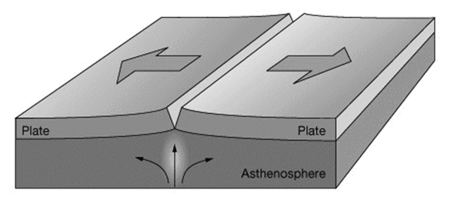
  - Plates are ______________________________________ from each other
  - Constructive force – __________________________________ forms
  - _________________________ stress associated with this boundary
  - Rift Valleys, Fault Block Mountains and Mid-ocean ridges are features associated with _______________________________ boundaries.

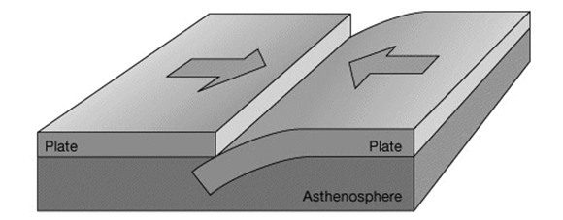
- Convergent Boundary (Be able to answer questions about Figure B)
B
  - Crust Interactions:
    - Oceanic crust ____________________ under a continental crust.
    - Ocean-ocean crust – one ______________________ under the other.
    - Continental-continental crust ______________________ to form mountains.
  - Destructive force – plates ________________________ as they subduct.
  - __________________________ stress associated with this boundary.
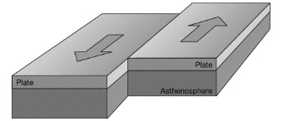
  - Folded Mountains, Island arcs and Ocean Trenches are features associated with _____________________________________ boundaries.
C

- Transform Boundary (Be able to answer questions about Figure C)
  - Two plates _____________________________ past each other in opposing directions.
  - _____________________ stress associated with this boundary.
  - Neither a constructive or destructive force.
  - Offset Spreading (or Offset Geology) is a feature associated with a _________________________ boundary.
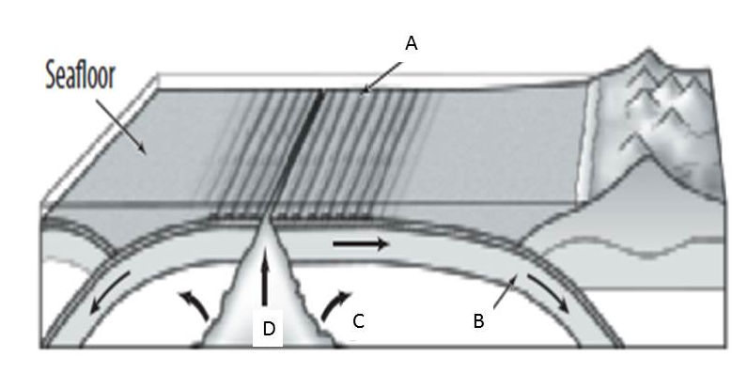
- Understand the geological formations found in the figure to the right (Seafloor Spreading) Match the letters with the description below:
- _____ - Hot, molten rock is forced upward toward the seafloor at mid-ocean ridge.
  - _____ - Molten rock pushes sideways in both directions as it rises, moving outward from the ocean ridge.
  - _____ - Old crust collides with other plates, sinking into the Earth’s interior at ocean trenches.
  - _____ -New seafloor moves away from the ridge.
- _______________________________ is evidence for this – parallel bands of rock on each side of a ridge of alternating magnetism.
- ***Expect to see letters in different places on your test
E
- SES2b. Relate modern and ancient geologic features to each kind of plate tectonic setting.
- Be able to answer questions based on figure E – what are the plates doing? Circle one.
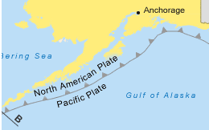
Diverging Converging Sliding Past
- What two types of plates are they? Circle one.
Oceanic-Oceanic Oceanic-Continental Continental-Continental
- ________________________________ Boundary
  - Rift Valleys, Fault Block Mountains and mid-ocean ridges are features associated with this boundary.
- ________________________________ Boundary
  - Folded Mountains, Volcanic island arcs and Ocean Trenches are features
associated with this boundary.
- _________________________________ Boundary
  - Offset Spreading (or Offset Geology) is a feature associated with this boundary.
- The shape and appearance of mountains are clues to their _______________.
  - Appalachian Mountains
    - Rounded and weathered peaks indicate ______________________________ age.
    - They formed around 480 million years ago when ancient plates collided.
  - Rocky Mountains
    - High, jagged peaks indicate _____________________________ mountains.
    - Formed between 55-80 million years ago at divergent boundary.
  - Himalayan Mountains
    - _________________________________ mountain range on planet—still forming.
    - Result of collision of Eurasian Plate and Indo-Australian Plate.
- Be able to identify the four types of mountains in the illustrations below—label (A) dome, (B) fault block, (C) fault-block, (D) volcano
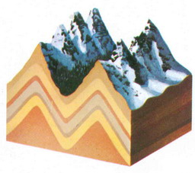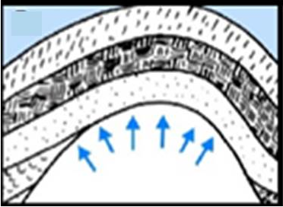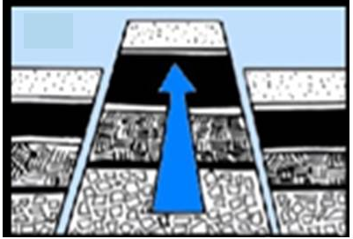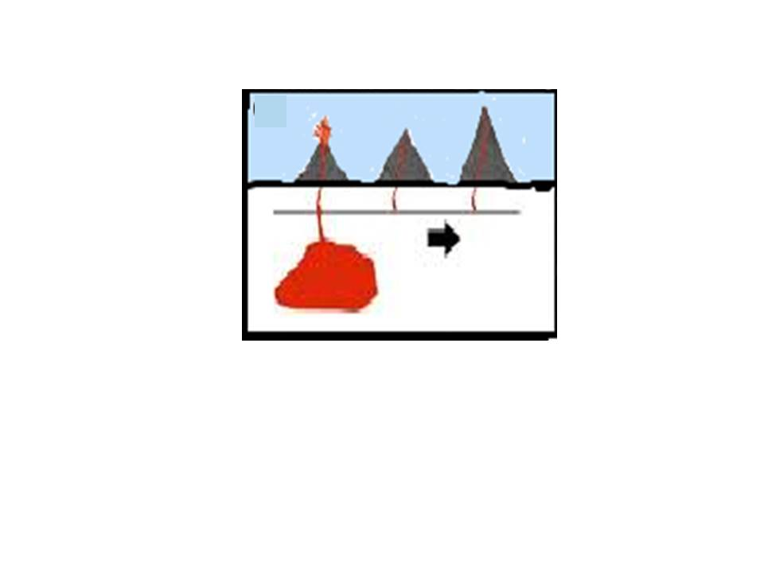

_______________
_______________
_______________ _______________
_______________

- Understand the diagram F below with respect to the colliding of continental and oceanic plates. Pay careful attention to arrows and names of the plates.
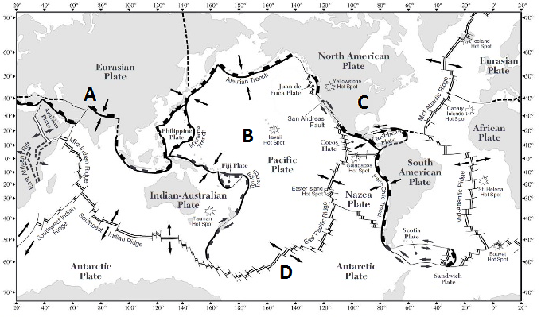
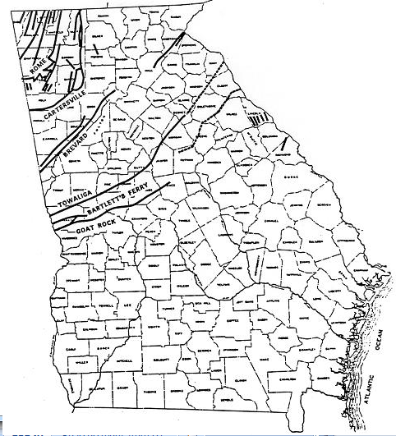
G
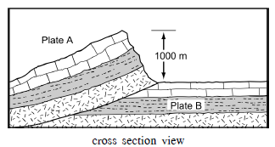
F
H
gG
- In diagram G above you must understand
  - The plates are moving ____________________________
  - This is an example of a _______________________________ boundary.
  - Features formed include _______________________________ Mountains.
  - Stress associated with this is ____________________________________.
- The faults shown in the northwest part of Georgia on the map H are convergent and we have the foothills of the Appalachian Mountains.
- If the faults were ___________________________ we would have a rift valley and/or fault block mountains.
- If the faults were ___________________________ we would have offset geological features.
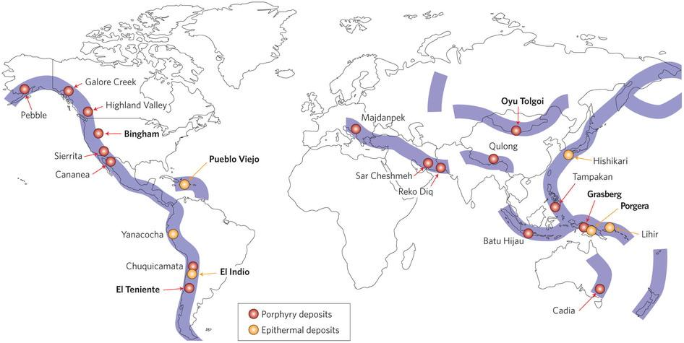
- Earth's major ore deposits occur at _________________________ boundaries.
  - These are destructive forces.
I
- Metamorphism most often occurs along a _______________________ boundary
- Manganese nodules are most often found along a _____________________________ boundary on oceanic crusts
- Using figure J be able to answer the following questions. Pay attention
to the arrows indicating the movement of the plates
- _________________________ Boundaries ( )
J

  - Most likely place to find gold and __________________ minerals.
- _________________________________ Boundaries ( )
  - Most likely place to find sulfur and _________________ minerals.
- _____________________________ Boundaries ( )

  - San Andreas Fault in _________________________ is an example.

