Name: _________________________________________________ Period ______
Unit 4 Test Study Guide: Weathering
- Correctly label the diagram of the Hydrologic Cycle  - Evaporation _____  - Precipitation ______  - Run off _____  A  - Infiltration _____  - Which part of the cycle is NOT affected by gravity?  - What is the source of energy for the hydrologic cycle? |  | 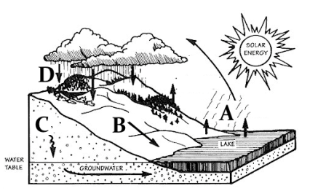
- There are two types of Weathering
  - ____________________________________________ rocks break down into smaller pieces by a physical means; the chemical composition of a rock does not change
    - ____________________________ -water can freeze in small openings in rock and as it expands it breaks the rock
    - ____________________________ - roots and plants break rock into smaller pieces and animals burrow exposing more rock.
    - ____________________________ – force of water (ex. waves) breaks down rock
    - ____________________________ - The movements of water and wind can expose rocks to friction and abrasion from other rocks
    - ____________________________ - avalanches or rock slides can expose new rock surfaces for weathering.
- ____________________________________________ - the process by which rock is broken down because of chemical interactions with the environment. This happens most commonly in hot, wet climates.
- ______________________ - a chemical reaction that involves an atom or a molecule losing electrons in a chemical reaction.
    - ______________________ - process of rock minerals reacting with carbonic acid dissolves or breaks down minerals in the rock.
    - ______________________ - a chemical reaction caused by water which changes the chemical composition of minerals in rock.
    - ______________________ - compounds that combine with water in the atmosphere to produce weak acids and fall to Earth.

- ______________________________________________ - the process by which softer, less weather resistant rocks wear away at a faster rate than harder, more weather resistant rocks do. Weathering at a _____________________________ rate.  - Using the figure, understand Confined vs. Unconfined Aquifers  - _____________________________________-water infiltrates easily from surface  - _____________________________________– water trapped by impermeable rock or clay– between layers of rock |  |  | 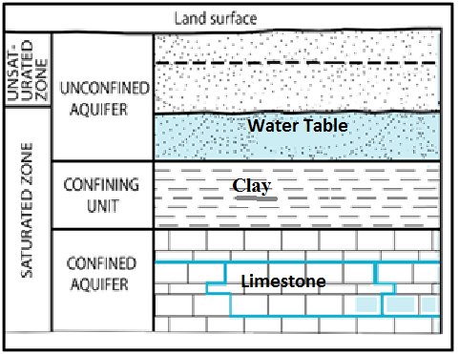
- ______________________- determines the total amount of water a material will hold depends on the number and size of pores in soil  - Sandy soils drain well but do not ______________________.  - Clay soils hold water but do not ______________________.  - Using figures A-D, compare the sizes and understand:  - Porosity is the percent of rock or sediment that consists of ______________________  - Porosity depends on the ____________________________________of pores in soil.  - The ______________________ the greater the porosity  - Be able to determine which sample has the greatest porosity and which sample has the least porosity  - ___________________________________– the ease at which water passes through material – affected by sorting. |  |  | 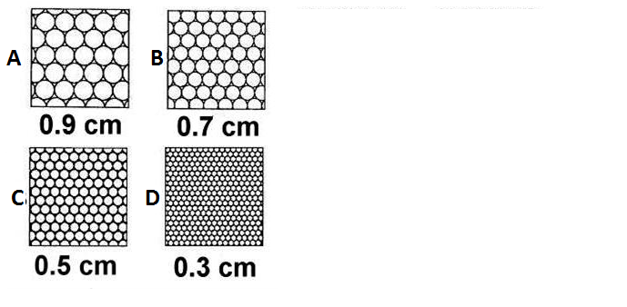
- The figure shows how sharp, angular rocks become smooth and rounded as they are subjected to greater __________________________________________ over time.  - Chalk and limestone dissolve in rainwater because rainwater contains a weak acid, __________________________________________  - ______________________ turns iron minerals a brown-red color because the minerals react with oxygen in the air. |  |  | 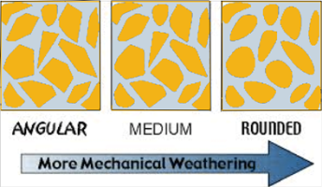
- Due to the nature of water and ice, the cracks in rocks get wider because of ________________________________.  - Chemical weathering may cause the _______________________________________ of rocks to change.  - What type of chemical weathering is F? ______________________________________  - What type of mechanical weathering is occurring in Figure E: _____________________________________________________  - Factors that increase the rate of chemical weathering include:  Increasing __________________________, increasing organic activity, exposure and increasing __________________________.  - The chemical weathering rate is increased by acids, the most common is ___________________________. |  |  | 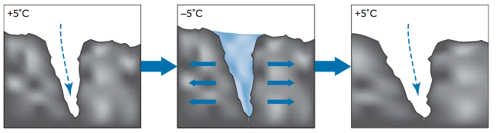 E
 |  |  | 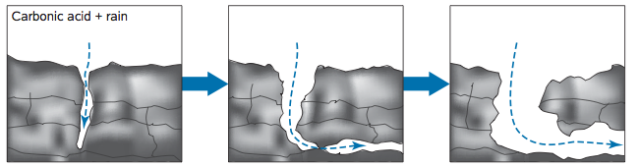 F
- Chemical weathering is most rapid in _____________________________ climates.  - Mechanical weathering increases the rate of chemical weathering by breaking rocks  into smaller fragments and exposing more ____________________________.  - Use the graph to determine the weathering most likely to occur in in the following climates:  - Cold (0°C) and dry (25cm) __________________________________________  - Warm (30°C) and dry (50cm) ________________________________________  - 20°C and 100cm precipitation _______________________________________ |  |  | 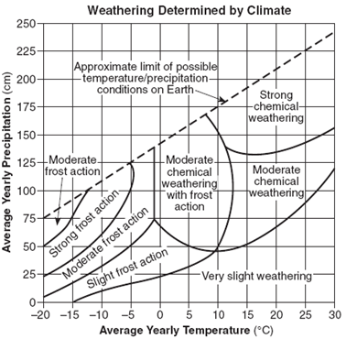
Use the triangle graph to determine types of soil described based on percentages of sand, silt and clay.  20% sand and10% silt and 70% clay __________________________________________  60% sand and10% silt and 30% clay __________________________________________  10% sand and70% silt and 20% clay __________________________________________ |  |  | 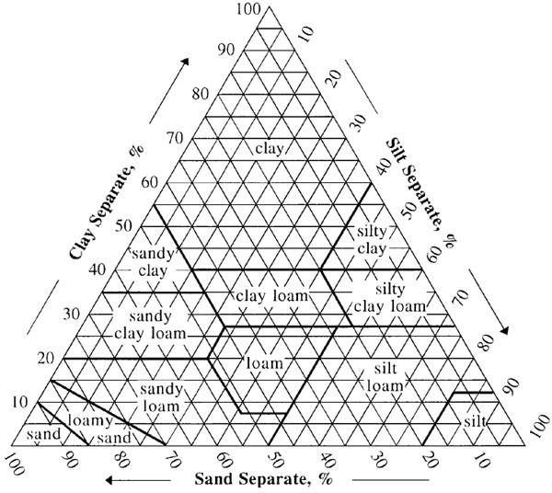
- Using the figure, be able to label the layers properly  - A Horizon - ______________________—organic matter and living organisms  - B Horizon – ______________________- Zone of leaching-dissolved are  pulled down by gravity  - C Horizon – ______________________________________  - D ______________________-solid rock layer at the bottom |  |  | 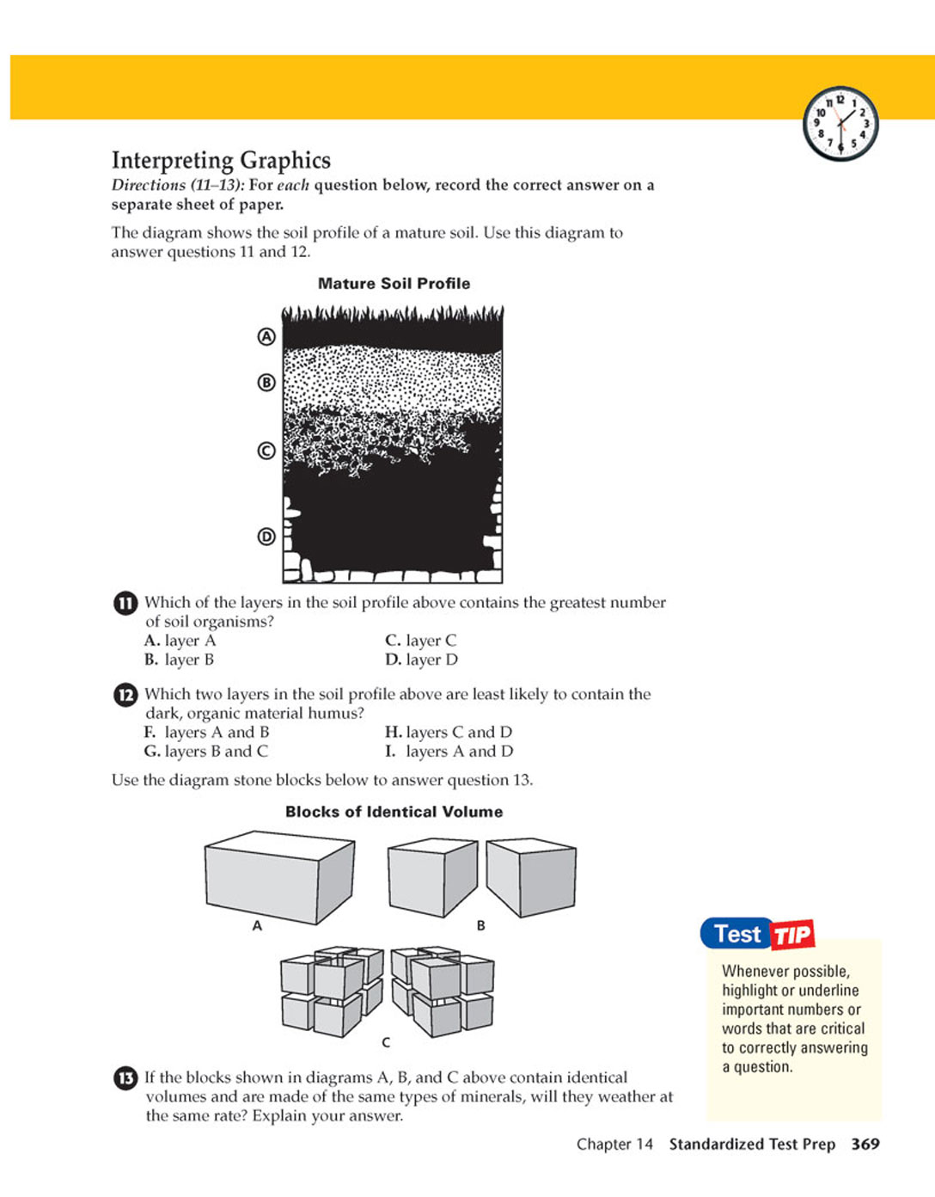
- Using the figure to the right, determine which of the samples (A, B, or C) is  - ______________________– largest particles - porous  - ______________________– medium size  - ______________________– smallest particles – retains water well  - Which particle was at the bottom of the soil test tube? __________________ |  |  | 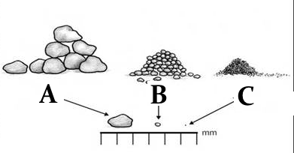
- Characteristics of ____________________________have the greatest impact on soil composition.
- Iron Oxide is the cause of the __________________________________of Georgia clay.
- Caves are most often formed in ______________________ rock.
- Understand in Figure K the most probable reason for the sea cliff erosion is weathering by __________________________________.
- What is Karst Topography? ______________________________________________________________________________________________
K
- Why does it form? _________________________________________________________________________________________________
- List some evidence of it from Figure L. ________________________________________________________________________________
- Use Figure M to explain what type of mechanical weathering took place to form the features present in the illustration: _____________________
- Label: Sea Arch ________ Sea Cave ________ Headland ________ Sea Stack ________

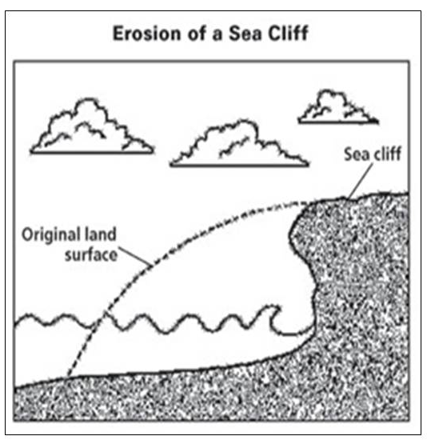  K | 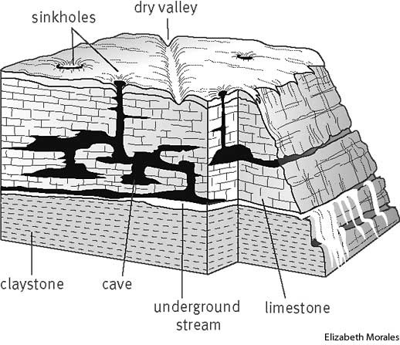  L |  |  | 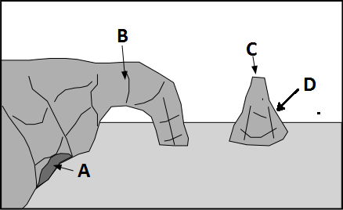  M

