Name: ____________________________________________________________Period:_____
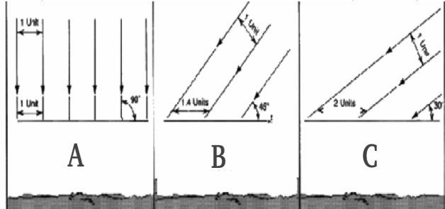
EARTH SYSTEMS UNIT 8: STUDY GUIDE

- ___________________________________are primarily responsible for the transfer of energy by air currents within the Earth’s atmosphere.
- The sunlight hits the Earth at a ________ angle at the equator. As you move to the poles, the sunlight becomes more __________________
- Using Figure A distinguish which illustration indicates how the sun’s rays hit:
  - Atlanta – approximately 30ºNorth = _____________ A
  - The Equator – 0º = __________
  - Anchorage, Alaska – approximately 60ºN = __________
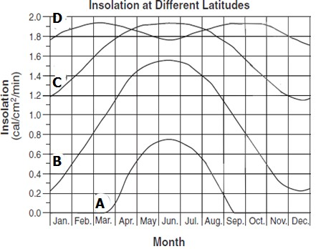
- _________________________, solar radiation received at the earth's surface, is different at different latitudes. Using Figure B, identify which lines represent: B
  - Atlanta – approximately 30ºNorth = _______
  - The Equator – 0º = _______
  - North Pole – 90º North = _______
  - Anchorage, Alaska – approximately 60ºN = ____________
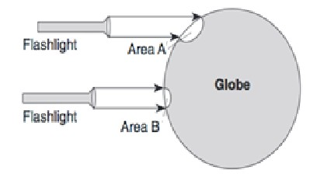
- The position for the North Pole has ______________ to ___________ insolation during the _______________________ months. This is because the sun is below the horizon and there is practically _______ sunlight during the day.
- Using Figure C, understand that the temperature of area B _______________________ at a faster rate than the temperature of area A because Area _______ receives rays that are more direct and concentrated at the surface.

- As we compare Area A to Area B, the amount of sunlight in both areas in the _______________, but it is more spread out in Area ______.
- Describe a low pressure system: air ______________, temperature of air is ______________. Weather is _____________________.
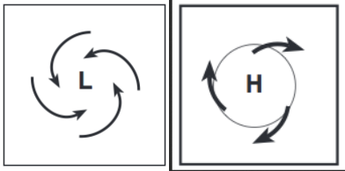
- Describe a high pressure system: air ______________, temperature of air is ______________. Weather is _____________________.
Using Figure F:
- L represents a ____________________ - air flows in and up and (circle one) F counter-clockwise / clockwise. Weather is

- H represents a ____________________ - air flows down and out and (circle one) counter-clockwise / clockwise. Weather is
- Using Figure E, what is the symbol on the map indicating? _________________________________ It also indicates the air mass is moving from the ______________-probably Canada- to the _______________________.
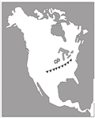 E
- Understand the Coriolis Effect and how it affects the winds and ocean currents.
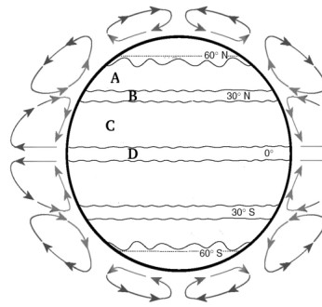
  - The winds and currents are ____________________________________
  - This is due to the Earth’s ____________on its axis
- Using Figure D, be able the prevailing winds
  - Prevailing Westerlies= _______
  - Sub tropic high or Horse Latitudes= _______
  - Northeast Trade Winds= _______
  - Equatorial low or Doldrums= _______

- Ocean currents are responsible for transporting and distributing __________
  - The __________is a current that caries warm water to the northeast
from the United States to Ireland

•
_________________________________________
_
o

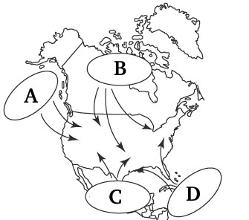
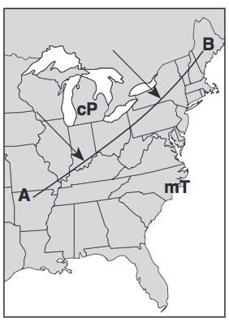
- In Figure G be able to label the different air masses
  - Maritime __________ (mP)
  - __________ Polar (cP)
  - Continental __________ (cT)
  - __________ Tropical (mT)

H
- Understand line A-B in Figure H
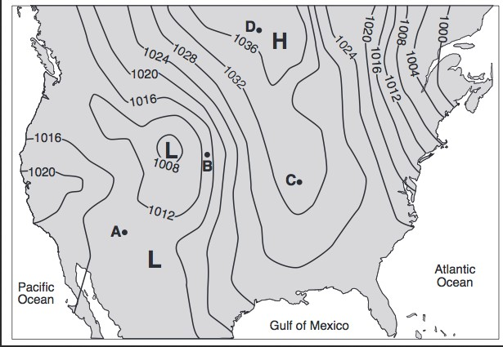
represents a __________Using Figure I, understand
  - Lines shown on the map that connect lines of
equal pressure are called __________ I
  - The closer the isobars, the more __________ a location
  - The farther apart the isobars, the __________ the winds
  - The lower the pressure- the greater the chance
of __________
- Know surface winds are caused by differences in air __________ due to unequal __________ of Earth's surface
Know that air always flows from __________ to __________ pressure
- Know cloud formation is likely to occur in rising air because rising air __________ and cools
- Sea breezes are formed when __________ heats up faster than the __________ during the day
- Understand that when air absorbs __________ it gets lighter because water vapor weighs __________ than oxygen and nitrogen gas

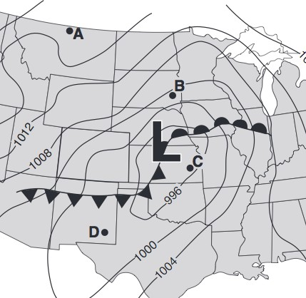
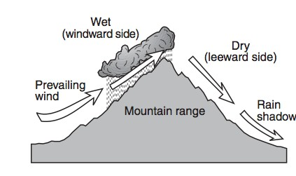
- Using Figure J, be able to tell the most probable direction of the winds.
- Remember that air flows counterclockwise __________ Low Pressure areas, and clockwise __________ of High Pressure areas.
- Remember to use the symbols and the isobars on the map to make this determination.
- Understand why the land surface is usually warmer than an J
adjoining body of water on a clear, sunny, summer day

- Use Figure K to understand the cross section and how prevailing winds have caused different __________ on the windward and leeward sides of a mountain range
- Know what happens when an air mass encounters a mountain range: Air rises on the windward side,
and __________ form. As air sinks on the leeward side it is clear and warmer.

K

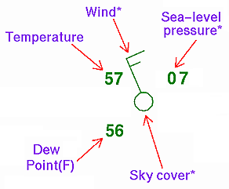

- Understand the symbols used in a Station Model using Figure L and what they tell you about the weather.
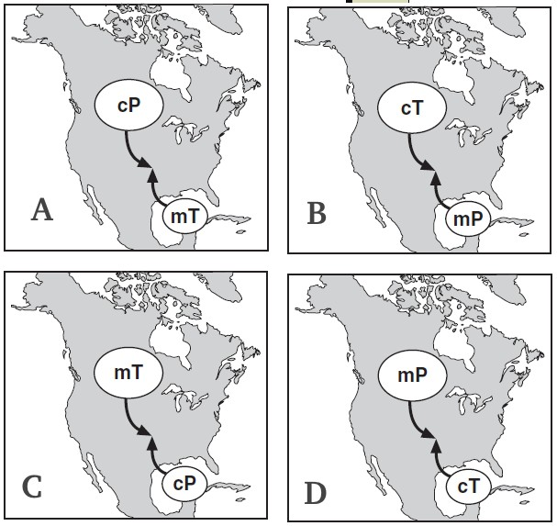
- Be able to identify the type of weather caused by the meeting of different air masses as seen in Figure M. Which is most likely to occur? ______ Froms? ___________

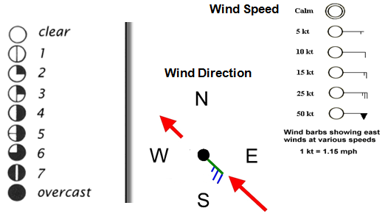
L M

