Name: ____________________________________________________________Period:_____
EARTH SYSTEMS UNIT 8: STUDY GUIDE

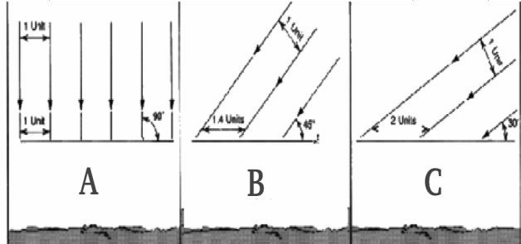
- ___________________________________are primarily responsible for the transfer of energy by air currents within the Earth’s atmosphere.
- The sunlight hits the Earth at a ________ angle at the equator. As you move to the poles, the sunlight becomes more __________________
- _____________________________ affects the angle at which the sun’s rays hit Earth.
- Using Figure A distinguish which illustration indicates how the sun’s rays hit:
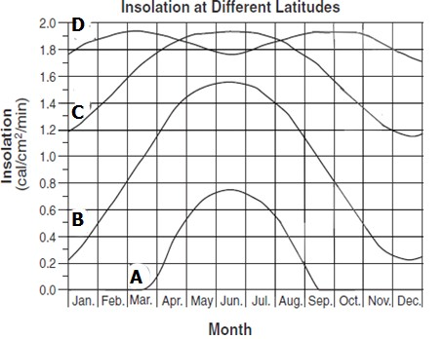
  - Atlanta – approximately 30ºNorth = _____________ A
  - The Equator – 0º = __________
  - Anchorage, Alaska – approximately 60ºN = __________
- _________________________, solar radiation received at the earth's surface, is different at different latitudes. Using Figure B, identify which lines represent:
  - Atlanta – approximately 30ºNorth = _______
  - The Equator – 0º = _______
  - North Pole – 90º North = _______
  - Anchorage, Alaska – approximately 60ºN = ____________
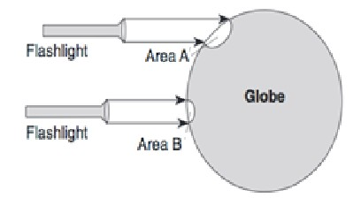
- The position for the North Pole has ______________ to ___________ insolation during the _______________________ months. This is because the sun is below the horizon and there is practically _______ sunlight during the day.
- Using Figure C, understand that the temperature of area B _____________________ at a faster rate than the temperature of area A because Area _______ receives rays that are more direct and concentrated at the surface.
- As we compare Area A to Area B, the amount of sunlight in both areas is the __________________, but it is more spread out in Area _____ because the angle of the sun is ____________________.
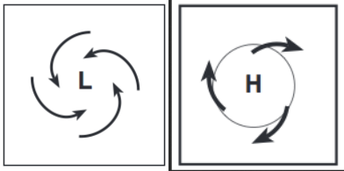
- Describe a low pressure system: air ______________, temperature of air is ______________. Weather is _____________________.
- Describe a high pressure system: air ______________, temperature of air is ______________. Weather is _____________________.
Using Figure F:
- L represents a ____________________ - air flows in and up and (circle one) F counter-clockwise / clockwise. Weather is
- H represents a ____________________ - air flows down and out and (circle one) counter-clockwise / clockwise. Weather is
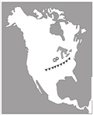 E
- Using Figure E, what is the symbol on the map indicating? ______________________________ It also indicates the air mass is moving from the ______________ - probably Canada - to the _______________________.
- Understand the Coriolis Effect and how it affects the winds and ocean currents.
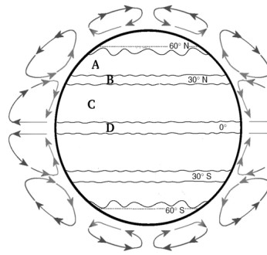
  - The winds and currents are ____________________________________
  - This is due to the Earth’s ____________on its axis
- Using Figure D, be able the prevailing winds
  - Prevailing Westerlies= _______
  - Sub tropic high or Horse Latitudes= _______
  - Northeast Trade Winds= _______
  - Equatorial low or Doldrums= _______

- Ocean currents are responsible for transporting and distributing __________
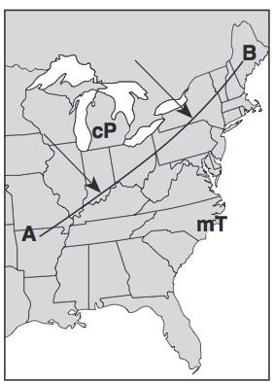
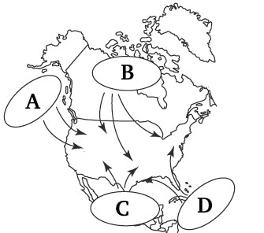
  - The _______________________________is a current that caries warm water to the northeast from the United States to Ireland.
H
G
- In Figure G be able to label the different air masses
  - ___________________________________________
  - ___________________________________________
  - ___________________________________________
  - ___________________________________________
- Understand line A-B in Figure H represents a ______________
- Using Figure I, understand
  - Lines shown on the map that connect lines of
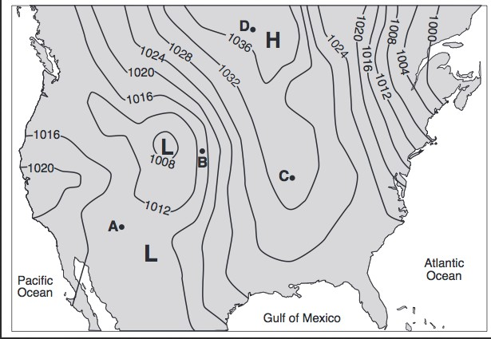
equal pressure are called _______________
  - The closer the isobars, the more ___________________ a location .
  - The farther apart the isobars, the ___________________ the winds.
  - The lower the pressure- the greater the chance of ________________________________.
- Know surface winds are caused by differences in air __________________ due to unequal ______________________ of Earth's surface.
Know that air always flows from __________ to __________ pressure.
- Know cloud formation is likely to occur in rising air because rising air expands and _____________________.
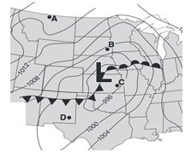J
- Sea breezes are formed when ________________ heats up faster than the _________________ during the day.
- When air absorbs __________________ it gets lighter because water vapor weighs __________ than oxygen and nitrogen gas.
- Using Figure J, be able to tell the most probable direction of the winds.

- Air flows counterclockwise ____________ Low Pressure areas, and clockwise ____________ of High Pressure areas.
- Land surface is usually __________________________ than an adjoining body of water on a clear, sunny, summer day.
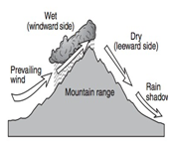
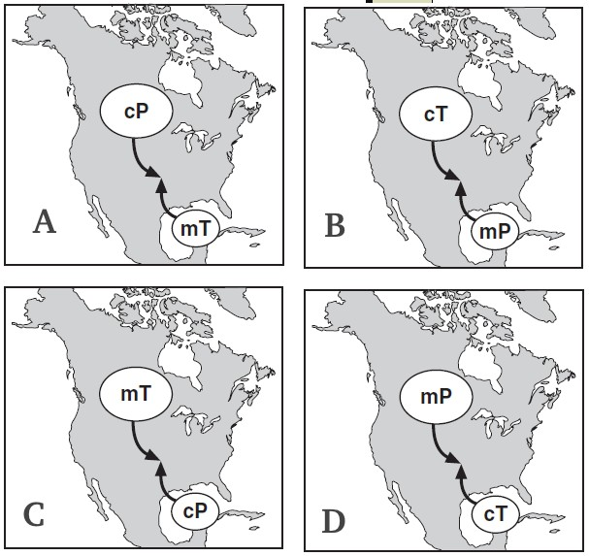
- Using Figure K, indicate which side of the mountain has which kind of weather:

K

  - Wet, cooler weather:

  - Dry, warmer weather:

- When an air mass encounters a mountain range:
Air rises on the windward side and _________________ form. As air sinks on the _______________________, it is clear and warmer.
- Identify the symbols used in a Station Model using Figure L and what they tell you about the weather.
- Identify the type of weather caused by the meeting of different air masses as seen in Figure M. Which is most likely to occur? ______
M
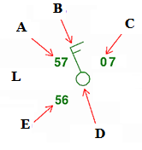
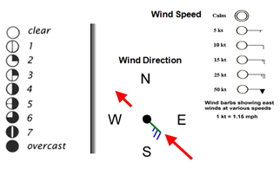

A. D.
B. E.
C.

