Name ________________________________________ Period ______

Unit 9 Climate - Study Guide
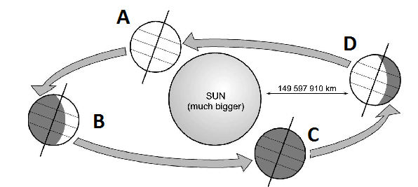
A
- Understand the following general characteristics about latitudes
- The __________ climates are found between 30˚ N and 30 ˚ S
- The _______________________________ is located between 60˚N and 70˚N
- The _______________________________ begin at ~77˚N and 77˚S
- Understand the relationship of latitudes and elevations
  - high elevation and high latitude result in __________ temperatures B
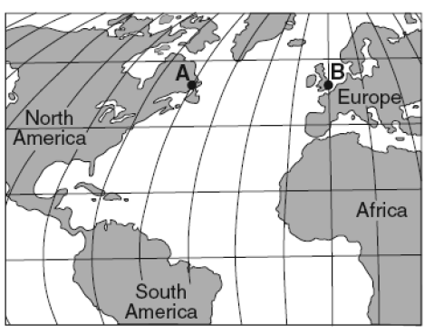

  - low elevations and low latitudes result in __________ temperatures
- Using Figure A, identify the seasons in the Northern Hemisphere
Spring – ________ Summer – ________ Fall – ________ Winter – ________
- Understand the three major climate zones
- __________________ - average monthly temperature of at least 18˚ C year round, rainforests with highest average precipitation.
- _____________________________ -average monthly temperatures of between 8˚ - 10˚C, rainfall varies
- _____________________ -largest temp range—as much as 63˚C difference summer to winter & temp is often below 0˚C.
- Know how the oceans influence the global climate by storing and transporting heat.
- _______________________ - a periodic occurrence in the eastern Pacific Ocean when the surface water is warmer than in the western Pacific. The effect on climate - wet ______________________ in the Southeastern US.
- ______________________ - a periodic occurrence in the western Pacific Ocean when the surface water is warmer than in the eastern Pacific. The effect on climate - greater ____________________________ activity in the Atlantic.
- _____________________________ - The swift, warm current that flows along the east coast of the United States and carries warm, tropical water northward . Using Figure B, why does city B have a warmer climate than City A?

- __________________________ —a seasonal wind that blows toward land in the summer bringing heavy rains and away from land in the winter bringing dry weather.
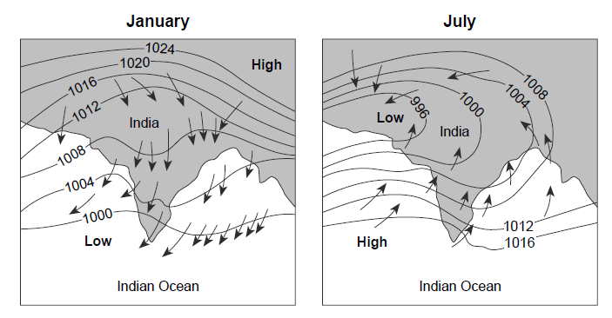

- Using the monsoon illustration in Figure C – what season is wet? ________
What season is dry?_______ How can you tell? C
- Identify the correct climate charts in Figure D.
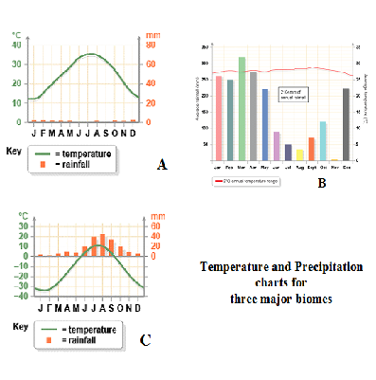
- __________________
- __________________
- __________________
- Answer questions based on the chart in Figure E. If it is winter in the Northern Hemisphere, which is farthest north? __________ South? __________
 | Photoperiod | Latitude | Longitude
City A | 8 hr. 26 min | 48 N | 122 W
City B | 14 hr. 25 min | 35 S | 18 E
City C | 4 hr. 12 min | 64 N | 21 E
City D | 18 hr. 57 min | 53 S | 70 W

.
E

D

- Recognize the chart in Figure F represents the relationship between latitudes and annual precipitation. Where are deserts located? ___________________________________
- Understand that more __________________ in the atmosphere can affect global warming.

- ______________ heat from condensation of water vapor is the force driving _____________
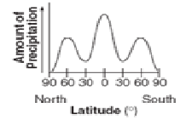
  - The ___________________ associated with hurricanes are responsible for most deaths.
  - Ocean temperatures must be at least __________ for tropical storm formation.
  - Warmer ocean temps from global warming means more _______________________
- The Fujita scale quantifies and classifies _____________________ , based on the extent of damages caused by wind. F
  - The warm moist air of the Gulf of Mexico meeting the cool dry air from Canada is the reason the ____________________________ has more tornadoes than the rest of the world and they are often embedded in severe _____________________________________ .
- Thunderstorms occur mostly in the summer due to the greater amount of _____________________________ —daytime storms occur because land heats and cools _________________ than water.
- _______________________ , lifting mechanisms and atmospheric instability are the three factors needed for thunderstorm formation.
G
- Use the chart in Figure G to answer questions using the Saffir-Simpson Scale of Hurricane Intensity.
- What determines each classification of hurricane?
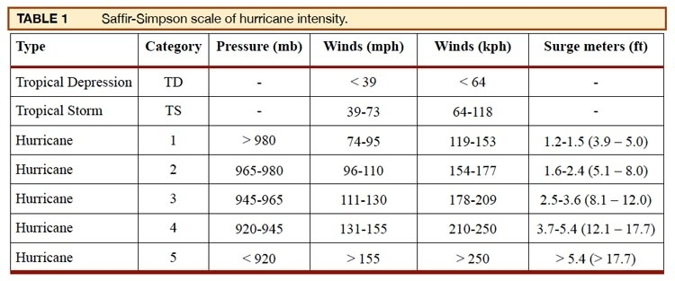

- What category is a storm with a storm surge of 3.0m and winds of 120mph?
- Understand that wind erosion is a problem as a climate changes from wet and humid to __________ and arid.
- Volcanic activity may decrease temperatures by reflecting ______________________ back into space.
- Understand the relationship between the burning of ___________________________ and global warming.
- Using the three graphs in Figure H, what is the relationship between increased CO$₂$ and temperature?
H

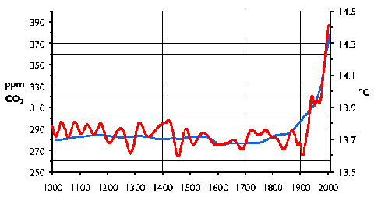
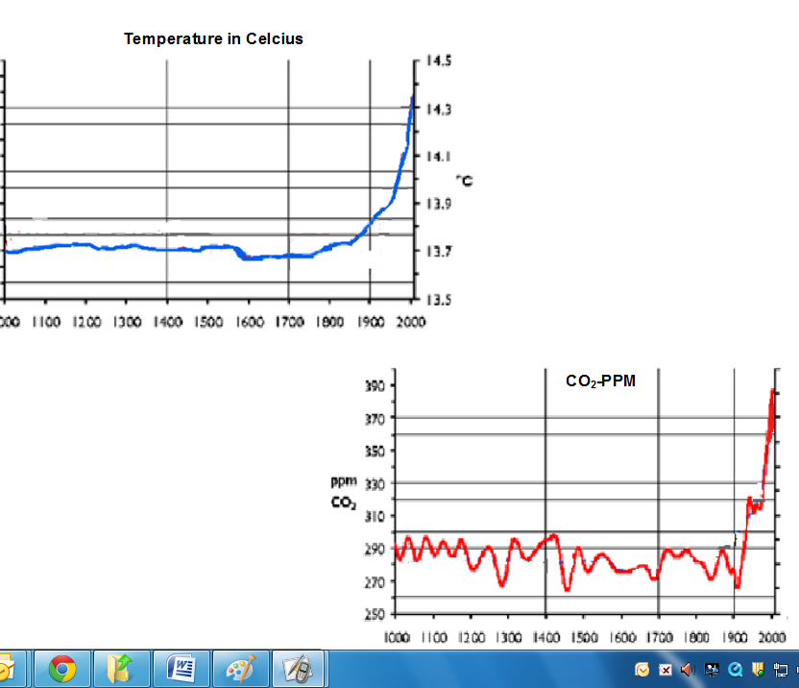

- Understand the Milankovitch theory is the theory that cyclical changes in Earth’s __________ and in the tilt of Earth’s __________ occur over thousands of years can cause climactic changes. Know this provides for cyclical changes in global climate. Understand Earth’s ________________ and ______________________________ do not affect climate.
- What is a greenhouse gas?
    - One that occurs in nature is _________________ and one that is anthropogenic (________________) is ___________.
- Understand that the ___________________________________ (also known as the "prolonged sunspot minimum", is the name used for the period starting in about 1645 and continuing to about 1715 when sunspots became exceedingly rare). Know that _______ sunspots leads to a _________________________ Earth.
- Realize Earth’s climate changes as a result of both natural and human processes.
  - Increased CO₂ levels in the atmosphere retains ________________ and increased CO₂ levels in the ocean cause _____________________________________ .

