Name ________________________________________ Period ______

REVIEW #10

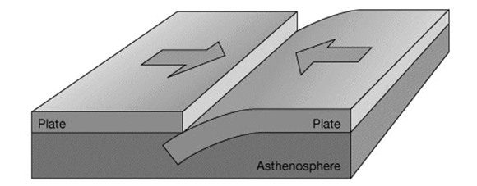
- Convergent Boundary (Be able to answer questions about drawing to the right)
  - Crust Interactions:
    - Oceanic crust _______________ under a continental crust
    - Ocean-ocean crust – one _______________ under the other
    - Continental-continental crust _______________ to form mountains
  - Destructive force – plates _______________ as they subduct
  - _______________ stress associated with this boundary
  - Folded Mountains, Island arcs and Ocean Trenches are features associated with _______________ boundaries

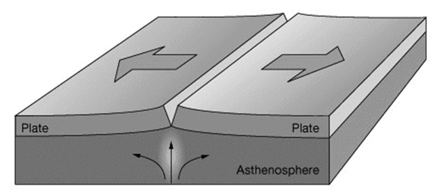
- Divergent Boundary (Be able to answer questions about drawing to the right.)
  - Plates are _______________ from each other
  - Constructive force – _______________ forms
  - _______________ stress associated with this boundary
  - Rift Valleys, Fault Block Mountains and Mid-ocean ridges are features associated with _______________ boundaries
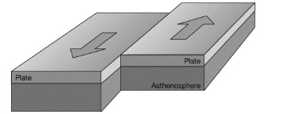
- Transform Boundary (Be able to answer questions about drawing to the right.)
  - Two plates _______________ past each other in opposing directions
  - _______________ stress associated with this boundary
  - Neither a constructive or destructive force
  - Offset Spreading (or Offset Geology) is a feature associated with a _______________ boundary

Name ________________________________________ Period ______

REVIEW #10

- Convergent Boundary (Be able to answer questions about drawing to the right)
  - Crust Interactions:
    - Oceanic crust _______________ under a continental crust
    - Ocean-ocean crust – one _______________ under the other
    - Continental-continental crust _______________ to form mountains
  - Destructive force – plates _______________ as they subduct
  - _______________ stress associated with this boundary
  - Folded Mountains, Island arcs and Ocean Trenches are features associated with _______________ boundaries

- Divergent Boundary (Be able to answer questions about drawing to the right.)
  - Plates are _______________ from each other
  - Constructive force – _______________ forms
  - _______________ stress associated with this boundary
  - Rift Valleys, Fault Block Mountains and Mid-ocean ridges are features associated with _______________ boundaries
- Transform Boundary (Be able to answer questions about drawing to the right.)
  - Two plates _______________ past each other in opposing directions
  - _______________ stress associated with this boundary
  - Neither a constructive or destructive force
  - Offset Spreading (or Offset Geology) is a feature associated with a _______________ boundary

