Name ____________________________________________ Period _______

REVIEW #11
In the figures below, list the rocks in their correct order, oldest to youngest.
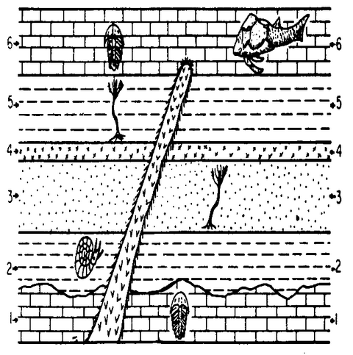
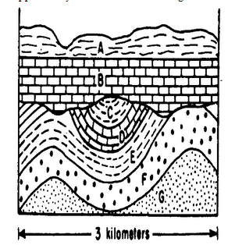

- Oldest _____________________________ 3. Type of unconformity between B and ___________________________ Youngest C? ______________________________
- What is #7 called? _____________________ 4. Is the arrow pointing to a syncline or an
anticline? __________________________

Name ____________________________________________ Period _______

REVIEW #11
In the figures below, list the rocks in their correct order, oldest to youngest.

- Oldest _____________________________ 3. Type of unconformity between B and ___________________________ Youngest C? ______________________________
- What is #7 called? _____________________ 4. Is the arrow pointing to a syncline or an
anticline? __________________________

