Name _____________________________________________ Period ______

REVIEW #12
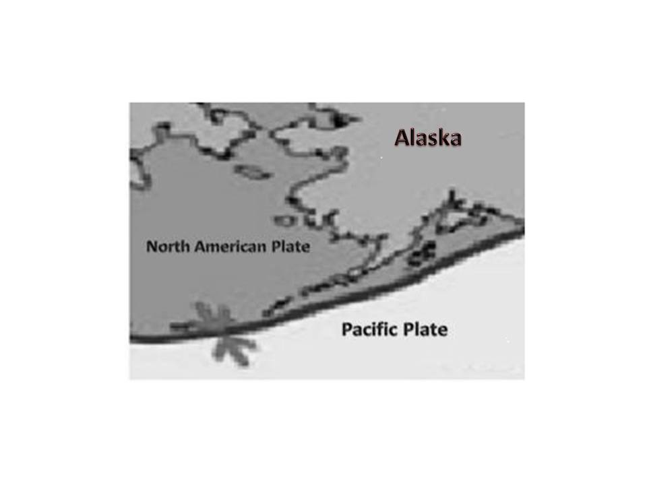

- Be able to answer questions based on figure to the right – what are the plates doing?

- Understand the diagram below right with respect to the colliding of continental and oceanic plates. Pay careful attention to arrows and names of the plates. Name two sets of plates that are converging, two sets of plates that are diverging, and two sets of plates that are transforming.

Converging plates:
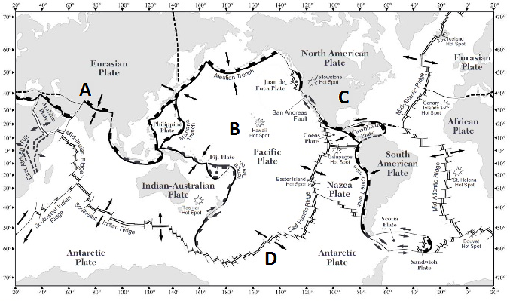

Diverging plate pairs:

Transforming plate pairs:

Name _____________________________________________ Period ______

REVIEW #12

- Be able to answer questions based on figure to the right – what are the plates doing?

- Understand the diagram below right with respect to the colliding of continental and oceanic plates. Pay careful attention to arrows and names of the plates. Name two sets of plates that are converging, two sets of plates that are diverging, and two sets of plates that are transforming.

Converging plates:

Diverging plate pairs:

Transforming plate pairs:

