Name ___________________________________________ Period _______

REVIEW #12

Using Figures G and H, answer the following questions:
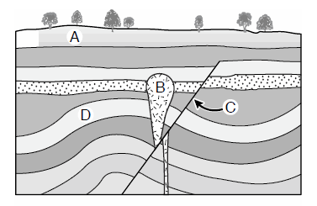G
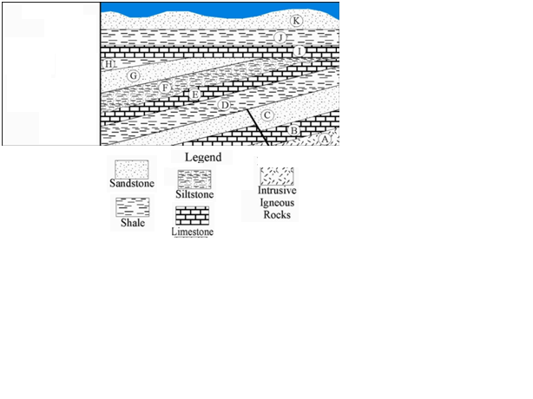H

- List at least four layers in Figure H that were covered by water.

- Which layer in Figure G saw a period of uplifting?

- Which layers in Figure H saw a period of uplifting?

- When did faulting occur in Figure G? after layer _______

- Which is older in Figure G, intrusion B or Fault C? ________________

Name ___________________________________________ Period _______

REVIEW #12

Using Figures G and H, answer the following questions:
G
H

- List at least four layers in Figure H that were covered by water.

- Which layer in Figure G saw a period of uplifting?

- Which layers in Figure H saw a period of uplifting?

- When did faulting occur in Figure G? after layer _______

- Which is older in Figure G, intrusion B or Fault C? ________________

