Name ______________________________________________ Period _____

REVIEW #13

- The shape and appearance of mountains are clues to their _______________
  - Appalachian Mountains
    - Rounded and weathered peaks indicate _______________ age
    - They formed around 480 million years ago when ancient plates collided
  - Rocky Mountains
    - High, jagged peaks indicate _______________ mountains
    - Formed between 55-80 million years ago at divergent boundary
  - Himalayan Mountains
    - _______________ mountain range on planet—still forming
    - Result of collision of Eurasian Plate and Indo-Australian Plate
- Be able to identify the four types of mountains in the illustrations below—label (A) dome, (B) fault block, (C) dome, (D) volcano
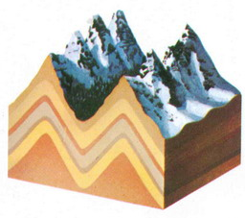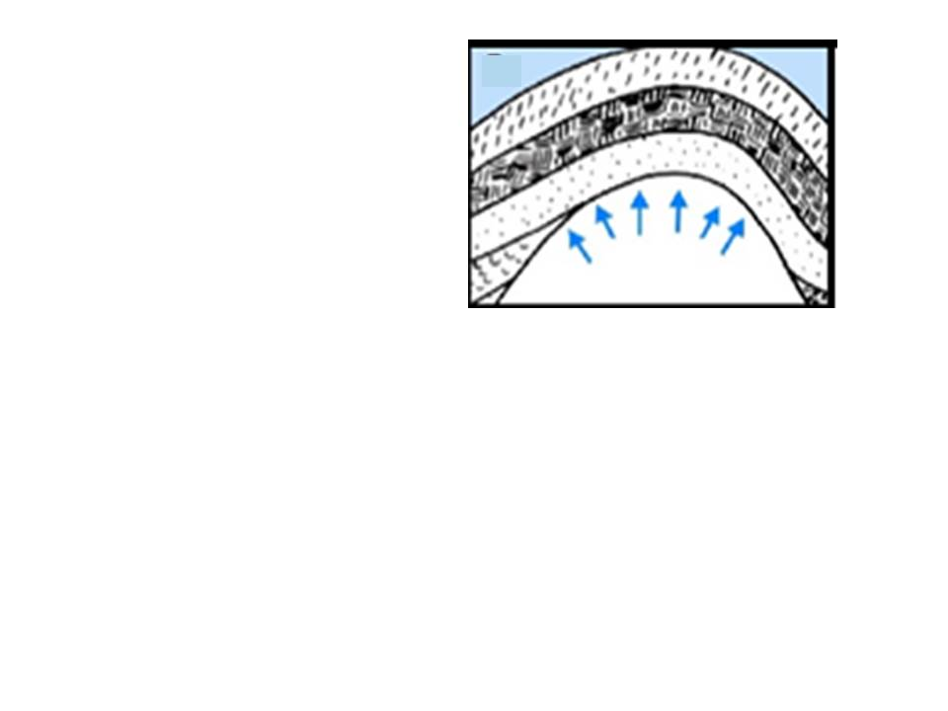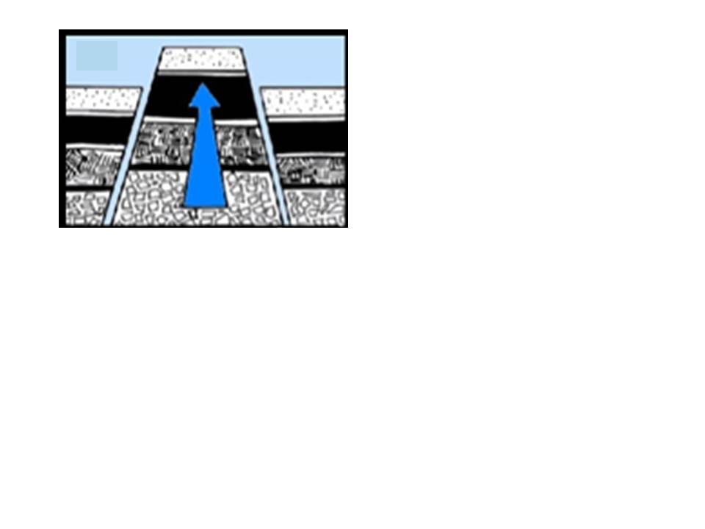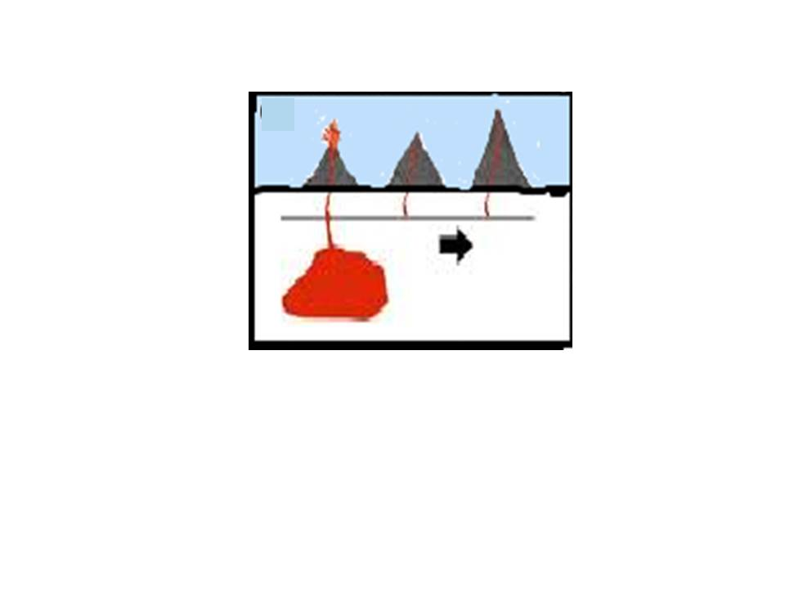

Name ______________________________________________ Period _____

REVIEW #13

- The shape and appearance of mountains are clues to their _______________
  - Appalachian Mountains
    - Rounded and weathered peaks indicate _______________ age
    - They formed around 480 million years ago when ancient plates collided
  - Rocky Mountains
    - High, jagged peaks indicate _______________ mountains
    - Formed between 55-80 million years ago at divergent boundary
  - Himalayan Mountains
    - _______________ mountain range on planet—still forming
    - Result of collision of Eurasian Plate and Indo-Australian Plate
- Be able to identify the four types of mountains in the illustrations below—label (A) dome, (B) fault block, (C) dome, (D) volcano

