Name ______________________________________________ Period ______
REVIEW #14
A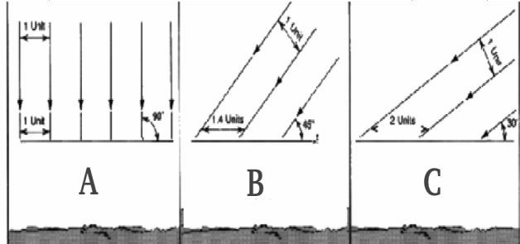
- Using Figure A, distinguish which illustration indicates how the Sun’s rays hit:
  - Atlanta – approximately 30ºNorth = _______
  - The Equator – 0º = _______
  - Anchorage, Alaska – approximately 60ºN = _______
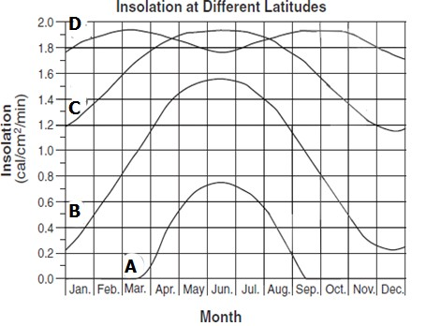B
- _____________________________(solar radiation received at the earth's surface) is different at different latitudes. Using Figure B identify which lines represent:
  - Atlanta – approximately 30ºNorth = _______
  - The Equator – 0º = _______
  - North Pole – 90º North = _______
  - Anchorage, Alaska – approximately 60ºN = _______
- Define ALTITUDE:

- Define AZIMUTH:

Name ______________________________________________ Period ______
REVIEW #14
A
- Using Figure A, distinguish which illustration indicates how the Sun’s rays hit:
  - Atlanta – approximately 30ºNorth = _______
  - The Equator – 0º = _______
  - Anchorage, Alaska – approximately 60ºN = _______
B
- _____________________________(solar radiation received at the earth's surface) is different at different latitudes. Using Figure B identify which lines represent:
  - Atlanta – approximately 30ºNorth = _______
  - The Equator – 0º = _______
  - North Pole – 90º North = _______
  - Anchorage, Alaska – approximately 60ºN = _______
- Define ALTITUDE:

- Define AZIMUTH:

