Name ____________________________________________ Period ______

REVIEW #20

- Correctly label the diagram of the Hydrologic Cycle.
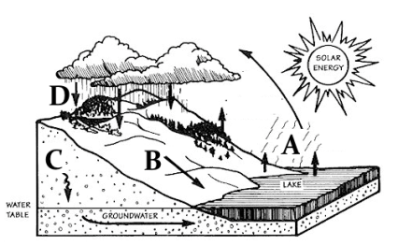
Evaporation _____ Precipitation _____
Run off _____ Infiltration _____
- Which part of the cycle is NOT affected by gravity? _____

- What is the source of energy for the hydrologic cycle?
- Name the five types of reservoirs.
1. ________________________________________
2. ________________________________________
3. ________________________________________
4. ________________________________________
5. ________________________________________
- Which one of the reservoirs accounts for most of the FRESHWATER?

Name ____________________________________________ Period ______

REVIEW #20

- Correctly label the diagram of the Hydrologic Cycle.
Evaporation _____ Precipitation _____
Run off _____ Infiltration _____
- Which part of the cycle is NOT affected by gravity? _____
- What is the source of energy for the hydrologic cycle?

- Name the five types of reservoirs.
1. ________________________________________
2. ________________________________________
3. ________________________________________
4. ________________________________________
5. ________________________________________
- Which one of the reservoirs accounts for most of the FRESHWATER?

