Name ____________________________________________________ Period ______

REVIEW #23

- Chemical weathering is most rapid in __________________ climates
- Mechanical weathering increases the rate of chemical weathering by breaking rocks into smaller fragments and exposing more ______________________
Use the graph to determine the weathering most likely to occur in each the wet, warm rainforest:

- The figure below shows how sharp, angular rocks become smooth and rounded as they are subjected to greater ______________________ over time
- Chalk and limestone dissolve in rainwater because rainwater contains a weak ______________________
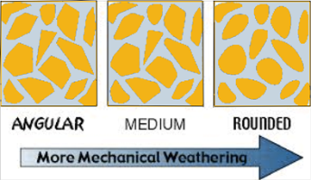
- ______________________ turns iron minerals a brown-red color because the minerals react with oxygen in the air.

Name ____________________________________________________ Period ______

REVIEW #23

- Chemical weathering is most rapid in __________________ climates
- Mechanical weathering increases the rate of chemical weathering by breaking rocks into smaller fragments and exposing more ______________________
Use the graph to determine the weathering most likely to occur in each the wet, warm rainforest:

- The figure to the right shows how sharp, angular rocks become smooth and rounded as they are subjected to greater ______________________ over time
- Chalk and limestone dissolve in rainwater because rainwater contains a weak ______________________
- ______________________ turns iron minerals a brown-red color because the minerals react with oxygen in the air.

