Name ____________________________________________________ Period ______

REVIEW #24
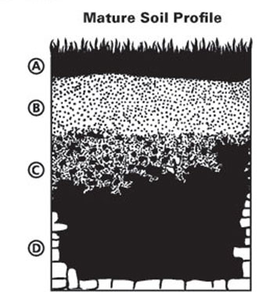

- Using the figure, be able to label the layers properly
- A Horizon - ______________________—organic matter and living organisms
- B Horizon – ______________________- Zone of leaching-dissolved are
pulled down by gravity
- C Horizon – ______________________
- D ______________________-solid rock layer at the bottom

- Determine which of the following are clay particles, sand particles, or silt particles.
  - ______________________– largest particles - porous
  - ______________________– medium size
  - ______________________– smallest particles – retains water well

Name ____________________________________________________ Period ______

REVIEW #24

- Using the figure, be able to label the layers properly
- A Horizon - ______________________—organic matter and living organisms
- B Horizon – ______________________- Zone of leaching-dissolved are
pulled down by gravity
- C Horizon – ______________________
- D ______________________-solid rock layer at the bottom

- Determine which of the following are clay particles, sand particles, or silt particles.
  - ______________________– largest particles - porous
  - ______________________– medium size
  - ______________________– smallest particles – retains water well

