Name _______________________________________________ Period ______

REVIEW #24
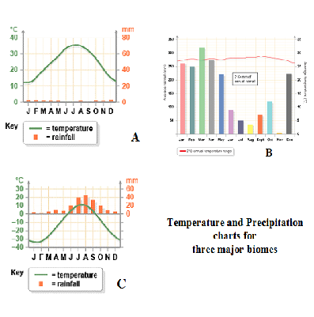
- Identify the correct climate charts in Figure D
- ____________________________
- ____________________________
- ____________________________
- Recognize the chart below represents the relationship between latitudes and annual precipitation. Where are deserts located?

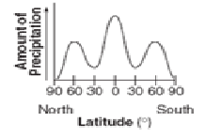

Name _______________________________________________ Period ______

REVIEW #24
- Identify the correct climate charts in Figure D
- ____________________________
- ____________________________
- ____________________________
- Recognize the chart below represents the relationship between latitudes and annual precipitation. Where are deserts located?

