Name ____________________________________________ Period ________

REVIEW #25

- ______________________- determines the total amount of water a material will hold; depends on the number and size of pores in soil
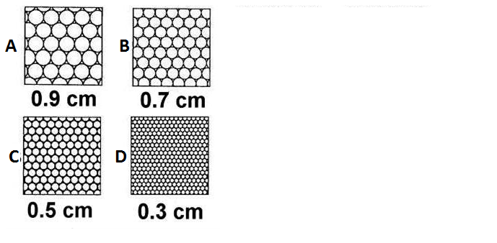
- Sandy soils drain well but do not ______________________.
- Clay soils hold water but do not ______________________.
- Using figures A-D, compare the clasts sizes and understand:
  - Porosity is the percent of rock or sediment that consists of ______________________
  - Porosity depends on the ______________________of pores in soil.
  - The _______________________________ the greater the porosity.
- Determine which sample has the greatest porosity _________and which sample has the least porosity _________.
- _____________________________– the ease at which water passes through material – affected by sorting

Name ____________________________________________ Period ________

REVIEW #25

- ______________________- determines the total amount of water a material will hold; depends on the number and size of pores in soil
- Sandy soils drain well but do not ______________________.
- Clay soils hold water but do not ______________________.
- Using figures A-D, compare the clasts sizes and understand:
  - Porosity is the percent of rock or sediment that consists of ______________________
  - Porosity depends on the ______________________of pores in soil.
  - The _______________________________ the greater the porosity.
- Determine which sample has the greatest porosity _________and which sample has the least porosity _________.
- _____________________________– the ease at which water passes through material – affected by sorting

