Name ____________________________________________ Period ________
K
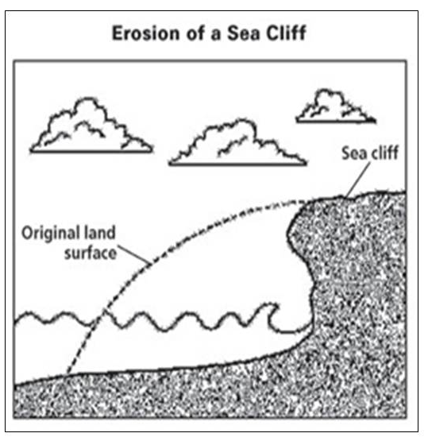
REVIEW #26
K

- Caves are most often formed in ____________________________ rock.
- Look at Figure K. The most probable reason for the sea cliff erosion is weathering by ________________________________.
- Explain why Karst Topography forms:
K

- Where is it evident in Figure L?

- Use Figure M to explain what type of mechanical weathering took place to form the features present in the illustration. ____________________________
L
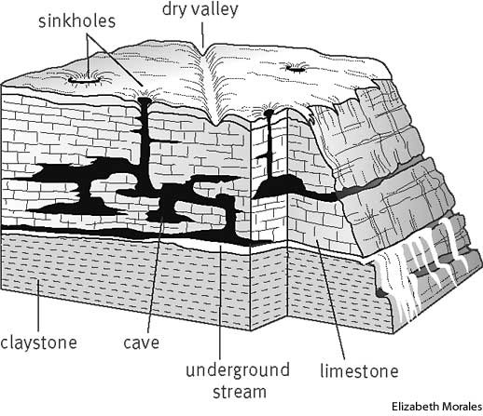
- Label:
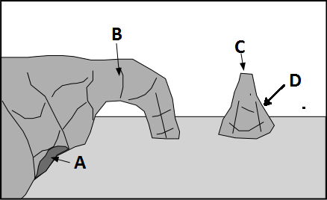
- Sea Arch _______
- Sea Cave _______
- Headland _______
- Sea Stack _______

Name ____________________________________________ Period ________
K
REVIEW #26

- Caves are most often formed in ____________________________ rock.
- Look at Figure K. The most probable reason for the sea cliff erosion is weathering by ________________________________.
- Explain why Karst Topography forms:
K

- Where is it evident in Figure L?

- Use Figure M to explain what type of mechanical weathering took place to form the features present in the illustration. ____________________________
L
- Label:
- Sea Arch _______
- Sea Cave _______
- Headland _______
- Sea Stack _______

