Name ____________________________________________ Period _____

REVIEW #26
- Understand that wind erosion is a problem as a climate changes from wet and humid to __________ and arid.
- Volcanic activity may decrease temperatures by reflecting ______________ back into space
- What is the relationship between the burning of fossil fuels and global warming?

- Using the three graphs in below, what is the relationship between CO₂ concentration (ppm) and temperature in Celsius?

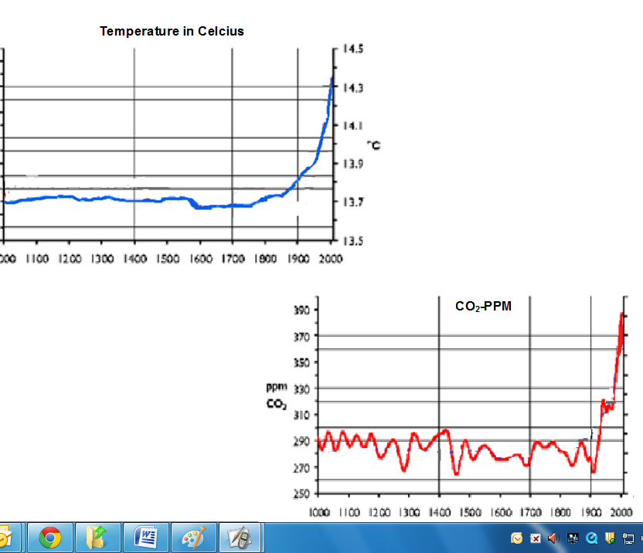
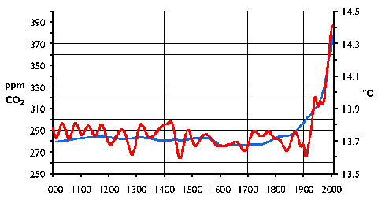
H

- Name two pieces of evidence for climate change.

Name ____________________________________________ Period _____

REVIEW #26
- Understand that wind erosion is a problem as a climate changes from wet and humid to __________ and arid.
- Volcanic activity may decrease temperatures by reflecting ______________ back into space
- What is the relationship between the burning of fossil fuels and global warming?

- Using the three graphs in below, what is the relationship between CO₂ concentration (ppm) and temperature in Celsius?

H

- Name two pieces of evidence for climate change.

