Name ______________________________________________ Period _______

REVIEW #30

Know the 4 stages of river development by identifying them in the illustrations in Figure I

Youthful _____
Beginning mature ______
Mature ______
Old Age ______

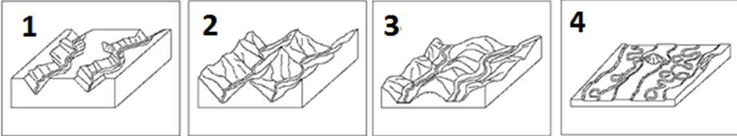
I

  - A delta forms on _______________ and forms a ________________________________ shape.
  - An alluvial fan forms on ______________.
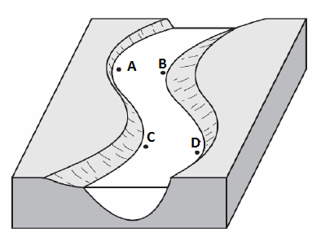
- In Figure C, indicate which points will have the fastest moving water _________
- In Figure C, indicate where the most deposition will occur _______
- In Figure C, indicate where the least deposition will occur _______

Name ______________________________________________ Period _______

REVIEW #30

Know the 4 stages of river development by identifying them in the illustrations in Figure I

Youthful _____
Beginning mature ______
Mature ______
Old Age ______

I

  - A delta forms on _______________ and forms a ________________________________ shape.
  - An alluvial fan forms on ______________.
- In Figure C, indicate which points will have the fastest moving water _________
- In Figure C, indicate where the most deposition will occur _______
- In Figure C, indicate where the least deposition will occur _______

