Name _________________________________________________ Date ____________
REVIEW #32
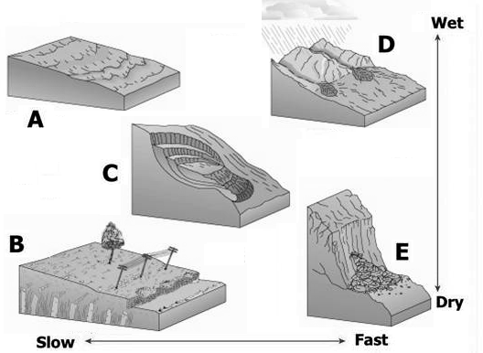

Match the term with the correct illustration to the right.

- Rock Fall: _____
- Soliflucation: _____
- Slump: _____
- Creep: _____
A
- Mudslide: _____

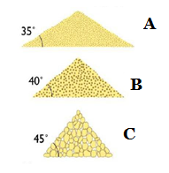
- Define Angle of Repose.

- As sediment becomes finer, the angle of repose will become _____________.
- The angle of repose is ___________________________ for angular pebbles because there is more friction between the pebbles.
- Name the materials whose angles of repose are listed in the illustration to the right.
- _______________________ B. _______________________ C. _______________________

Name _________________________________________________ Date ____________
REVIEW #32

Match the term with the correct illustration to the right.

- Rock Fall: _____
- Soliflucation: _____
- Slump: _____
- Creep: _____
A
- Mudslide: _____

- Define Angle of Repose.

- As sediment becomes finer, the angle of repose will become ________________________.
- The angle of repose is ___________________________ for angular pebbles because there is more friction between the pebbles.
- Name the materials whose angles of repose are listed in the illustration to the right.
- _______________________ B. _______________________ C. _______________________

