Name ______________________________________________ Period _______

REVIEW #35
Match the glacial features with their definitions below.
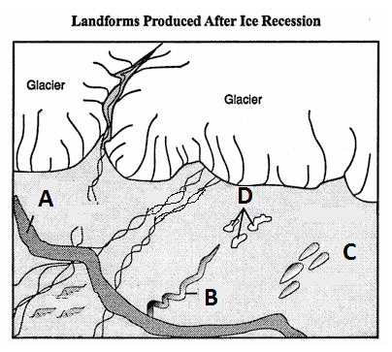

  - Drumlins ______ depressions – can form lakes.

  - Eskers ______ long, winding ridges of gravel and sand - like raised roadways
  - Kettles ______ ridge of deposits – like wall - can be at
leading edge of glaciers.
  - Moraines ______ sediment mounds

Now match the features above with the letters in the drawing above.
Drumlin ______ Esker ______ Kettles ______
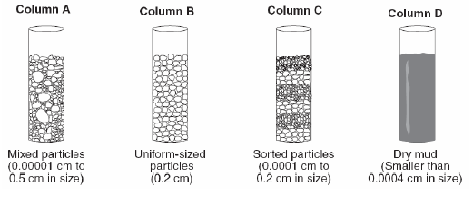
Moraines _____
Using the figure to the right, identify which samples will create the following (you may not use all the letters):
shale _____ sandstone _____
breccia _____ conglomerate _____

Which would have been deposited by a glacier? _____

Name ______________________________________________ Period _______

REVIEW #35
Match the glacial features with their definitions below.

  - Drumlins ______ depressions – can form lakes.

  - Eskers ______ long, winding ridges of gravel and sand - like raised roadways
  - Kettles ______ ridge of deposits – like wall - can be at
leading edge of glaciers.
  - Moraines ______ sediment mounds

Now match the features above with the letters in the drawing above.
Drumlin ______ Esker ______ Kettles ______
Moraines _____
Using the figure to the right, identify which samples will create the following (you may not use all the letters):
shale _____ sandstone _____
breccia _____ conglomerate _____

Which would have been deposited by a glacier? _____

